VIETNAM NATIONAL UNIVERSITY – HO CHI MINH CITY

THE INTERNATIONAL UNIVERSITY

SCHOOL OF COMPUTER SCIENCE AND ENGINEERING



**ETHEREUM BLOCKCHAIN FOR REAL-ESTATE**

**Advisor: Dr. Tran Thanh Tung**

**Student name: Huynh Le Minh Thinh**

A thesis submitted to the School of Computer Science and Engineering

in partial fulfilment of the requirements for the degree of

Bachelor of Computer Science

Ho Chi Minh city, Vietnam

2020**ETHEREUM BLOCKCHAIN FOR REAL-ESTATE**

APPROVED BY:

Tran Thanh Tung, Ph.D.

THESIS COMMITTEE

# ACKNOWLEDGMENTS

I would like to express my very great appreciation to Dr. Tran Thanh Tung for his valuable and constructive suggestions and guidance during the planning and development of this thesis work. His constant encouragement and support helped me to achieve my goal.   
In addition, I also appreciate teachers who have conveyed valuable knowledge for me during my study period.

# LIST OF ABBREVIATIONS

ABI Application Binary Interface

API Application Programming Interface

CLI Command Line Interface

DOM Document Object Model

EOA Externally Owned Account

ERD Entity Relationship Diagram

EVM Ethereum Virtual Machine

I/O Input / Output

JSX JavaScript Syntax Extension

NPM Node Package Management

P2P Peer-to-Peer

RPC Remote Procedure Call

SPA Single Page Application

UI User Interface

# TABLE OF CONTENTS

ACKNOWLEDGMENTS 3

LIST OF ABBREVIATIONS 4

TABLE OF CONTENTS 5

LIST OF TABLES 9

LIST OF FIGURES 10

CHAPTER 1. INTRODUCTION 15

1.1. Problem Statement 15

1.2. Motivation 15

1.3. Objective 15

1.4. Assumption 15

CHAPTER 2. BACKGROUND / APPLIED TECHNOLOGIES 17

2.1. Overview of web 2.0 technologies 17

2.1.1. NodeJS (Running Environment) and NPM 17

2.1.1.1. NodeJS 17

2.1.1.2. NPM 19

2.1.2. ReactJS with Babel and Webpack (Front-End / Client Side) 21

2.1.2.1. ReactJS 21

2.1.2.2. Babel 22

2.1.2.3. Webpack 23

2.1.3. ExpressJS with Nodemon (Back-End / Server Side) 24

2.1.3.1. ExpressJS 25

2.1.3.2. Nodemon 26

2.2. Overview of Ethereum Blockchain technologies 27

2.2.1. Blockchain' fundamental background 27

2.2.1.1. Hash Function 28

2.2.1.2. Merkle Tree 29

2.2.1.3. Block's Structure 31

2.2.1.4. Blockchain' structure and Mining mechanism 33

2.2.2. Asymmetric Key Pair 37

2.2.2.1. Cryptographic Proof-of-identity 37

2.2.2.2. Asymmetric Encryption / Decryption 38

2.2.3. Peer-to-peer Network 39

2.2.3.1. Introduction to P2P Network 39

2.2.3.2. How P2P Network Works 40

2.2.3.3. Examples of P2P Network 40

2.2.3.4. Comparison to Server Based Network 41

2.2.4. Ethereum Platform 43

2.2.4.1. History 44

2.2.4.2. Introduction to Ethereum 44

2.2.4.3. Ethereum Virtual Machine (EVM) 45

2.2.4.4. Ethereum Nodes 49

2.2.4.5. Ethereum Networks 53

2.2.4.6. Ethereum' Currency System 54

2.2.4.7. Ethereum Accounts 55

2.2.4.8. MetaMask Extension 56

2.2.4.9. Introduction to Solidity Smart Contracts 58

2.2.4.10. Solidity Programming Language 60

2.2.4.11. Ethereum' Workflow 61

2.2.4.12. Ethereum Decentralized Application (DApp) 64

CHAPTER 3. SYSTEM REQUIREMENT 68

3.1. System Description 68

3.2. System Use Cases 69

3.3. System Functionality 70

3.4. System Workflow 71

CHAPTER 4. SYSTEM ARCHITECTURE 79

4.1. Overall Architecture 79

4.2. Front-End / Client Side Architecture 80

4.3. Back-End / Server Side Architecture 81

4.4. Blockchain / Database Architecture 82

CHAPTER 5. SYSTEM DESIGN 83

5.1. Front-End / Client Side 83

5.1.1. User Interface (UI) 83

5.1.2. Ethereum Interaction 87

5.2. Back-End / Server Side 90

5.2.1. Application Programming Interface (API) 91

5.2.2. Ethereum Interaction 93

5.3. Ethereum Configuration 94

5.3.1. Ethereum Network 94

5.3.2. Ethereum Accounts 95

5.3.3. Smart Contracts' Structure 96

CHAPTER 6. IMPLEMENTATION 97

6.1. Setup Environments 97

6.1.1. Operating System 97

6.1.2. Required Tools 98

6.1.2.1. NodeJS and NPM 98

6.1.2.2. ReactJS with Babel and Webpack 99

6.1.2.3. ExpessJS with Nodemon 103

6.1.2.4. Metamask 107

6.1.2.5. Truffle (Solidity Smart-Contract's Compiler and Deployer) 109

6.1.2.6. Remix IDE with Remix Daemon 111

6.1.2.7. Ganache (Private Testing Blockchain for Developers) 116

6.2. Implementation 121

6.2.1. Front-End / Client Side 122

6.2.1.1. NPM Scripts in Client's Configuration. 122

6.2.1.2. Module Workflow in Client Side Architecture. 123

6.2.1.3. ReactJS Code Structure and JSX Page. 130

6.2.2. Back-End / Server Side 134

6.2.2.1. NPM Scripts in Server's Configuration. 135

6.2.2.2. Module Workflow in Server Side Architecture. 136

6.2.2.3. ExpressJS Code Structure and Router. 138

6.2.3. Ethereum Smart Contracts 141

6.2.3.1. Compile Contracts 142

6.2.3.2. Deploy Contracts 143

6.2.3.3. Contract's Interaction 147

6.2.3.4. Contract's Implementation 148

CHAPTER 7. CONCLUSION & FUTURE DISCUSSION 149

7.1. Summary 149

7.1.1. Work done 149

7.1.2. Conclusion 153

7.2. Future work (Promising improvements) 154

LIST OF REFERENCES 155

Bibliography 155

# LIST OF TABLES

Table 2.2‑1. Server-Based compared to Peer-to-Peer Network Model 42

Table 2.2‑2. Advantages and Disadvantages of Peer-to-Peer Network Model 43

Table 2.2‑3. Ethereum's Public Networks 54

Table 2.2‑4. Externally Owned Accounts & Contract Accounts 55

Table 3.3‑1. System's Functional Description 71

Table 5.3‑1. Server Side customs Ropsten Network 95

Table 6.1‑1. Ganache CLI and Ganache Desktop UI 117

# LIST OF FIGURES

Figure 2.1‑1. Web2.0 System with REST API 17

Figure 2.1‑2. NodeJS Runtime Environment - Full Explanations 18

Figure 2.1‑3. NodeJS Runtime Environment - Simple 19

Figure 2.1‑4. NodeJS Local Dependencies Managed by NPM in package.json 20

Figure 2.1‑5. ReactJS with Babel and Webpack 21

Figure 2.1‑6. Click Button with Vanilla JS 21

Figure 2.1‑7. Click Button with React JS 22

Figure 2.1‑8. Babel Transpiler I/O 23

Figure 2.1‑9. How Webpack Works 23

Figure 2.1‑10. REST API with ExpressJS 24

Figure 2.1‑11. Introduction to ExpressJS 25

Figure 2.1‑12. ExpressJS Workflow 26

Figure 2.1‑13. Nodemon Automatically Reload API 27

Figure 2.2‑1. Fundamental Technologies of Blockchain 27

Figure 2.2‑2. Hash Function 28

Figure 2.2‑3. Abstract Merkle Tree 29

Figure 2.2‑4. Transactions Merkle Tree 29

Figure 2.2‑5. Semantic Merkle Tree 30

Figure 2.2‑6. Abstract Bitcoin Block Components 31

Figure 2.2‑7. Semantic Bitcoin Block Components 33

Figure 2.2‑8. Bitcoin Blockchain Structure 33

Figure 2.2‑9. Miners Collect Transactions 34

Figure 2.2‑10. Proof-of-work Mechanism 35

Figure 2.2‑11. Blockchain Mining Mechanism 36

Figure 2.2‑12. Abstract Keypair Generator 37

Figure 2.2‑13. Asymmetric Keypair with Proof-of-identity 38

Figure 2.2‑14. Asymmetric Keypair with Encryption and Decryption 38

Figure 2.2‑15. Peer-to-peer Network Model 39

Figure 2.2‑16. Server-Based Network Model 41

Figure 2.2‑17. Ethereum Platform 43

Figure 2.2‑18. Peer-to-peer Network model with EVMs 45

Figure 2.2‑19. EVM's Implementation 46

Figure 2.2‑20. EVM’s Simple Stack-Based Architecture 47

Figure 2.2‑21. EVM’s Execution Model 48

Figure 2.2‑22. EVM Node's Broadcasting Work Flow 50

Figure 2.2‑23. Ethereum Node's Interaction 52

Figure 2.2‑24. Ethereum Blockchain Network 53

Figure 2.2‑25. Conversion from Ether to Wei Unit 54

Figure 2.2‑26. Unit Conversion in Ethereum Blockchain 55

Figure 2.2‑27. Creating MetaMask Wallet 56

Figure 2.2‑28. MetaMask Accounts & Networks 57

Figure 2.2‑29. MetaMask Signing Transaction 58

Figure 2.2‑30. Solidity Smart Contract 60

Figure 2.2‑31. Compile & Deploy Solidity Smart Contract with Remix IDE 60

Figure 2.2‑32. Ethereum Smart Contract Interaction 61

Figure 2.2‑33. Interaction Between Accounts and Blockchain network 63

Figure 2.2‑34. Core Components of Ethereum Decentralized Applications 65

Figure 2.2‑35. Ethereum Fully Decentralized Applications 67

Figure 3.2‑1. System Use Cases 69

Figure 3.3‑1. System's Entity Relationship 70

Figure 3.4‑1. System's Workflow 72

Figure 3.4‑2. Searching Houses - Sequence Diagram 73

Figure 3.4‑3. Selling Houses - Sequence Diagram 74

Figure 3.4‑4. Renting Houses - Sequence Diagram 75

Figure 3.4‑5. Buying Houses - Sequence Diagram 76

Figure 3.4‑6. Buying Houses by Installment - Sequence Diagram 77

Figure 3.4‑7. Updating House's Status - Sequence Diagram 78

Figure 4.1‑1. System Overall Architecture 79

Figure 4.2‑1. Front-End / Client Side Architecture 80

Figure 4.3‑1. Back-End / Server Side Architecture 81

Figure 4.4‑1. Blockchain / Database Architecture 82

Figure 5.1‑1. Home Page 83

Figure 5.1‑2. Listing Page 84

Figure 5.1‑3. Selling Page 85

Figure 5.1‑4. Contact Page 86

Figure 5.1‑5. House's Detail Page 87

Figure 5.1‑6. Browser with MetaMask 88

Figure 5.1‑7. Client-Side Interaction with Blockchain Network 89

Figure 5.2‑1. Node-Server's Main Flow 90

Figure 5.2‑2. Node-Server as Compiler 91

Figure 5.2‑3. Node-Server as Deployer 92

Figure 5.2‑4. Node-Server as Storage for Client Request 93

Figure 5.3‑1. MetaMask customs Ropsten Network 94

Figure 5.3‑2. HD Wallet Keys 95

Figure 5.3‑3. Smart Contracts' Relationship 96

Figure 6.1‑1. Windows Command Prompt 97

Figure 6.1‑2. Thesis Folder 98

Figure 6.1‑3. Node & NPM Version 99

Figure 6.1‑4. NPM Initialization for CLIENT 99

Figure 6.1‑5. CLIENT Package JSON (1) 100

Figure 6.1‑6. NPM Install --save-dev for CLIENT 100

Figure 6.1‑7. NPM Install --save for CLIENT 101

Figure 6.1‑8. CLIENT Package JSON (2) 101

Figure 6.1‑9. CLIENT Package JSON (3) 102

Figure 6.1‑10. NPM Install for CLIENT 103

Figure 6.1‑11. NPM Initialization for API 103

Figure 6.1‑12. API Package JSON (1) 104

Figure 6.1‑13. NPM Install --save-dev for API 104

Figure 6.1‑14. NPM Install --save for API 105

Figure 6.1‑15. API Package JSON (2) 105

Figure 6.1‑16. API Package JSON (3) 106

Figure 6.1‑17. NPM Install for API 107

Figure 6.1‑18. Installed Metamask Extension Icon 107

Figure 6.1‑19. Metamask Creating Accounts and Back-Up Code 108

Figure 6.1‑20. Installed Metamask Extension Home Page 109

Figure 6.1‑21. Real-Estate-API Folder (1) 110

Figure 6.1‑22. Truffle Initialization for API 110

Figure 6.1‑23. Real-Estate-API Folder (2) 111

Figure 6.1‑24. Remix Online IDE 112

Figure 6.1‑25. NPM Install Remidx --global 113

Figure 6.1‑26. Installed Global Dependencies 113

Figure 6.1‑27. Change Directory to Contract Folder 114

Figure 6.1‑28. Remix Daemon with Web Socket 114

Figure 6.1‑29. Remix Connect to Local Web Socket 115

Figure 6.1‑30. Localhost Solidity Files in Remix IDE 116

Figure 6.1‑31. NPM Install Ganache-CLI --global 117

Figure 6.1‑32. Run Ganache-CLI at Localhost --Port 7545 118

Figure 6.1‑33. Ganache Home Page UI 119

Figure 6.1‑34. Ganache Quick Started 120

Figure 6.1‑35. Ganache Creates New Workspace 121

Figure 6.2‑1. Project Structure - CLIENT 122

Figure 6.2‑2. NPM Scripts - CLIENT 122

Figure 6.2‑3. NPM Run Start - CLIENT 123

Figure 6.2‑4. NPM Run Dev - CLIENT 123

Figure 6.2‑5. Webpack Bundling Files Workflow - <NPM Run Build> 124

Figure 6.2‑6. Babel as Webpack Module Workflow - <NPM Run Build> 125

Figure 6.2‑7. HTML Webpack Plug-in Workflow - <NPM Run Build> 126

Figure 6.2‑8. NodeJS Rendering Client Side for Development - <NPM Run Start> 127

Figure 6.2‑9. NodeJS Rendering Client Side for Production - <NPM Run Start> 128

Figure 6.2‑10. NodeJS Rendering Client Side for Development - <NPM Run Dev> 129

Figure 6.2‑11. HTML Index Page 130

Figure 6.2‑12. JavaScript Index File 130

Figure 6.2‑13. React Router Component 131

Figure 6.2‑14. React Basic Component 133

Figure 6.2‑15. React Children Property 134

Figure 6.2‑16. Project Structure - API 134

Figure 6.2‑17. NPM Scripts - API 135

Figure 6.2‑18. NPM Run Nodemon - API 135

Figure 6.2‑19. NPM Run Truffle Deploy - API 136

Figure 6.2‑20. NPM Run Start - API 136

Figure 6.2‑21. ExpressJS API Workflow - <NPM Run Nodemon> 137

Figure 6.2‑22. Server File for ExpressJS API 139

Figure 6.2‑23. ExpressJS Router for API Services 140

Figure 6.2‑24. Truffle Configuration File 142

Figure 6.2‑25. Truffle Compiles All Contracts - <NPM Run Compile> 143

Figure 6.2‑26. Compiled Contracts Folder 143

Figure 6.2‑27. Truffle Deploys Contracts Workflow 144

Figure 6.2‑28. Truffle Deployer Configuration 145

Figure 6.2‑29. Truffle Deploys Contract at Ganache - <NPM Run Test Deploy> 145

Figure 6.2‑30. Truffle Deploys Contract at Ropsten - <NPM Run Deploy> 146

Figure 6.2‑31. JavaScript Index File - CLIENT 148

Figure 7.1‑1. Home Page 149

Figure 7.1‑2. Listing Page 150

Figure 7.1‑3. Sell Page 151

Figure 7.1‑4. Contact Page 152

Figure 7.1‑5. House Detail Page 153

# INTRODUCTION

## Problem Statement

The government now wants to apply 4.0 technologies into properties' management. One of the most considered issue remained is trading real-estate properties. Since scamming in exchanging real-estate brings severe damage for traders, as scammers performing multiple transactions from a single house, to be more specific, selling a house many times.

Moreover, sellers always commit to pay rewards for buyers if some conditions have been reached. However, this need the verification of 3rd party, such as bank. This lead to the more extensive procedure. Buying a house is never easy !

## Motivation

Thus, a proposed solution is using Ethereum Blockchain technology, which provided smart contracts to solve the above issues without interference of legal agents.

Since smart contracts only execute as they are programmed, this eliminate all of the third party involved, scamming issues and fake commitments from sellers.

## Objective

The main goal of this thesis paper is to provide the fundamental knowledge of Ethereum technology, and show blockchain capabilities compared to traditional Web Application Development.

This paper contains system requirement, which shows some system criterion that must be fulfilled, then showing system architecture and system design. Last but not least, shows all implementation how to construct a demonstration for this thesis.

In this thesis, I'll create the first version of Ethereum Application in real-estate management aspect that perform all transaction using Ethereum blockchain platform.

## Assumption

However, the usage of Blockchain in trading real properties is not yet widely and legally, the government still have not applied this house exchange system in the real world.

In conclusion, this thesis paper assumes all of house properties in blockchain system are legal and exchangeable as they are deployed by the sellers.

# BACKGROUND / APPLIED TECHNOLOGIES

## Overview of web 2.0 technologies

A dynamic website, or web 2.0 with REST API is the most common web structure nowadays. The main advantage of a dynamic website is that you can easily update any data in an organized & structured way to create the various product pages or categories according to the user’s requirements.

* Dynamic Websites are much more functional website.
* It is much easier to update.
* It allows to update the new content which brings people back to the site and helps in the search engines.

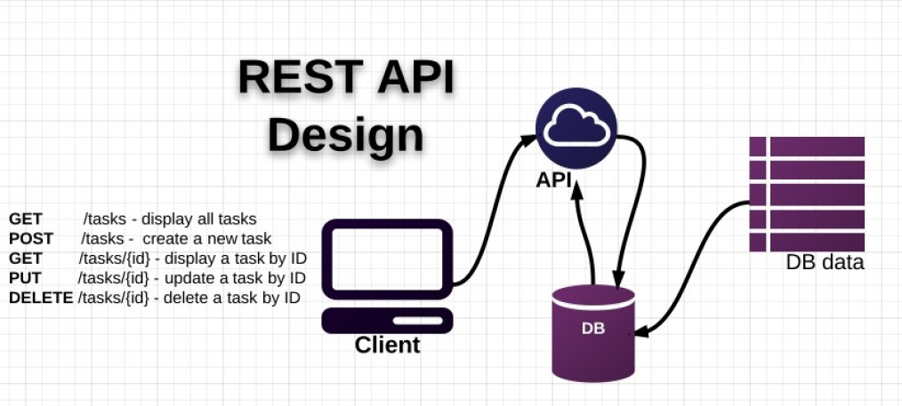

Figure 2.1‑1. Web2.0 System with REST API

### NodeJS (Running Environment) and NPM

#### NodeJS

Node.js is a platform built on Google Chrome's JavaScript Engine (V8 Engine) or Chrome's JavaScript runtime for easily building fast and scalable network applications. Node.js uses an event-driven, non-blocking I/O [1] model that makes it lightweight and efficient, perfect for data-intensive real-time applications that run across distributed devices.

Node.js is an open source, cross-platform runtime environment for developing server-side and networking applications. Node.js applications are written in JavaScript, and can be run within the Node.js runtime [2] on OS X, Microsoft Windows, and Linux.

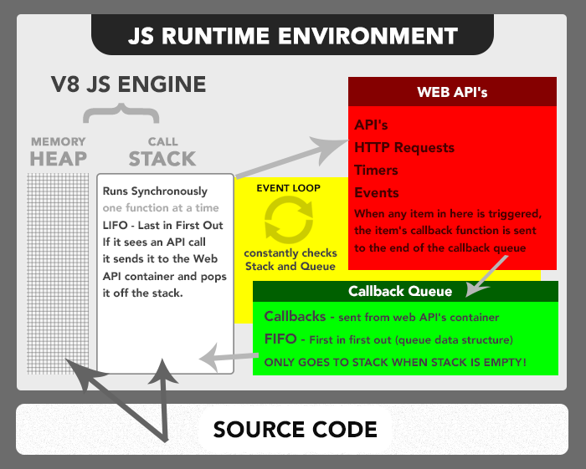

Figure 2.1‑2. NodeJS Runtime Environment - Full Explanations

Node.js also provides a rich library of various JavaScript modules which simplifies the development of web applications using Node.js to a great extent.

The below figure shows the introduction of JavaScript Engine in a fundamental perspective: Call Stack, Event Loop, and Task Queue [3].

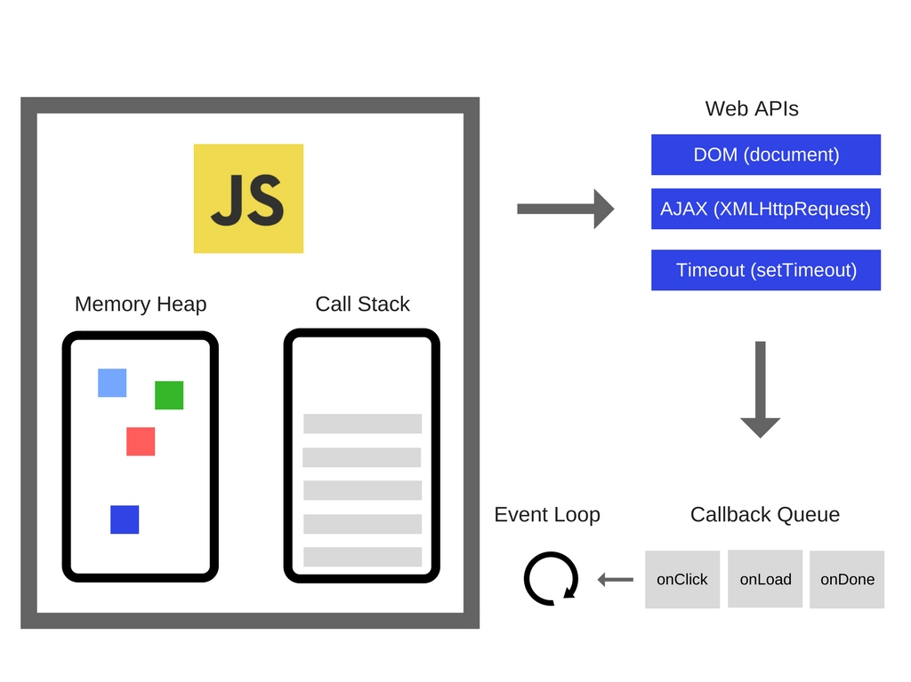

Figure 2.1‑3. NodeJS Runtime Environment - Simple

#### NPM

When you install Node.js it comes with NPM [4] which translates to “Node Package Manager”. NPM ends up being an online registry hosting packages for you to download and a manager of those packages and their dependencies on your machine so that you can use them whenever needed on your project.

After you install Node.js if you want to track your project package dependencies you have to create a file named package.json , you can do that by just doing <npm init> and answering the prompted questions.

There are 2 main ways to use NPM, which is installing the packages globally or locally. The main difference between local and global packages is this:

* Local packages are installed in the directory where you run npm install <package-name>, and they are put in the node_modules folder under this directory.
* Global packages are all put in a single place in your system (exactly where depends on your setup), regardless of where you run npm install -g <package-name>.

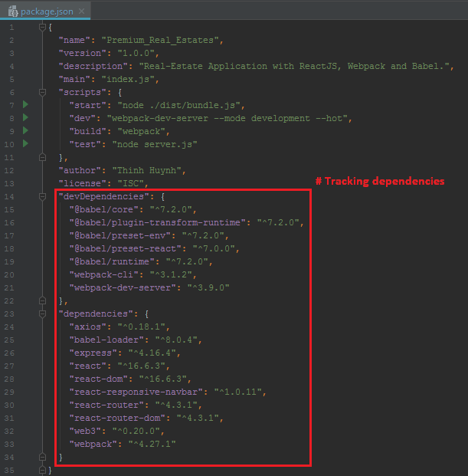

Figure 2.1‑4. NodeJS Local Dependencies Managed by NPM in package.json

### ReactJS with Babel and Webpack (Front-End / Client Side)

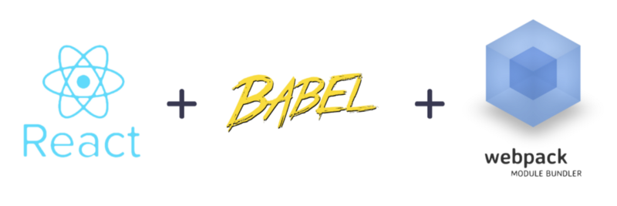

Figure 2.1‑5. ReactJS with Babel and Webpack

#### ReactJS

React is a JavaScript library primarily meant for the hairy problem of measuring **state**.

React is "declarative", in that the main goal of your logic is telling the program "it should look like this" as opposed to "imperative", which is more like saying "you should do this".

Let's say I want to update the contents of an element based on a user clicking a button.

##### **Vanilla JS (Imperative)**

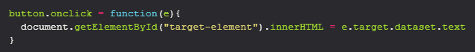

Figure 2.1‑6. Click Button with Vanilla JS

##### **React JS (Declarative)**

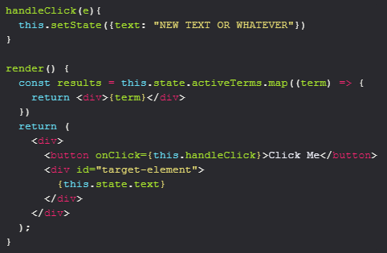

Figure 2.1‑7. Click Button with React JS

In React HTML is always re-rendered when the state is changed so the app always has a concept of what "text" is. In plain JS, you explicitly tell the component what its text should be. This example itself is probably easier to do in plain JS (or jQuery), but as an interface grows in complexity it pays dividends to follow this way of handling state.

#### Babel

Babel is a JavaScript Transpiler !

Babel is a toolchain that is mainly used to convert ECMAScript 2015+ code into a backwards compatible version of JavaScript in current and older browsers or environments. Here are the main things Babel can do:

* Transform syntax.
* Polyfill features that are missing in your target environment (through @babel/polyfill).
* Source code transformations (codemods).

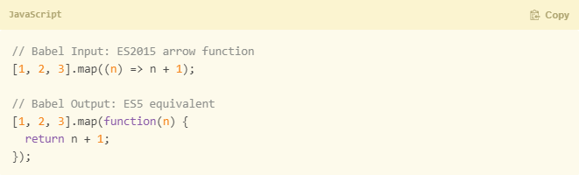

Figure 2.1‑8. Babel Transpiler I/O

#### Webpack

At its core, webpack is a static module bundler for modern JavaScript applications. It takes disparate dependencies, creates modules for them and bundles the entire network up into manageable output files. This is especially useful for Single Page Applications (SPAs), which is the standard web page for Web Applications today.

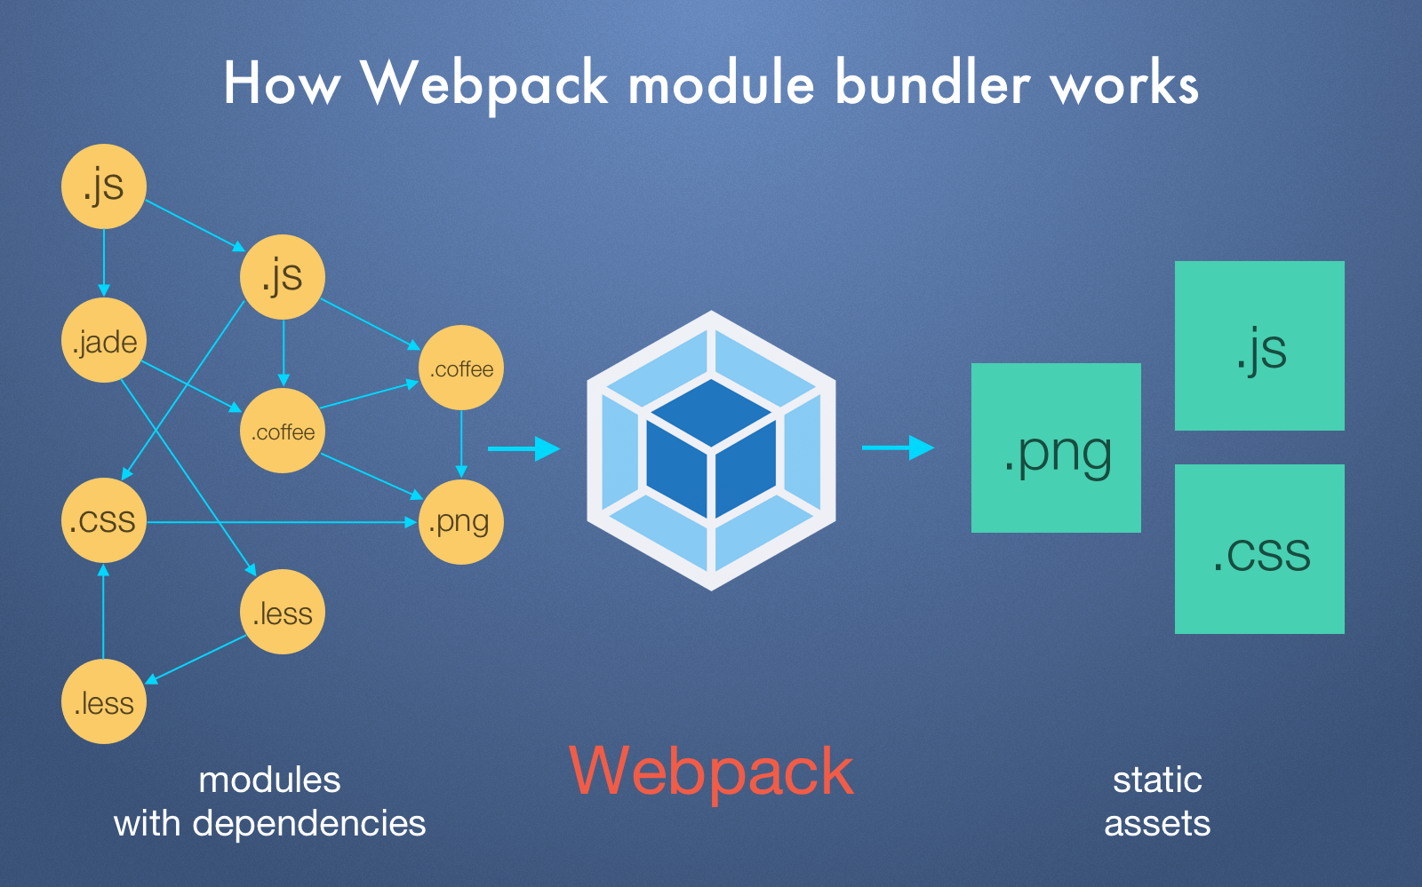

Figure 2.1‑9. How Webpack Works

### ExpressJS with Nodemon (Back-End / Server Side)

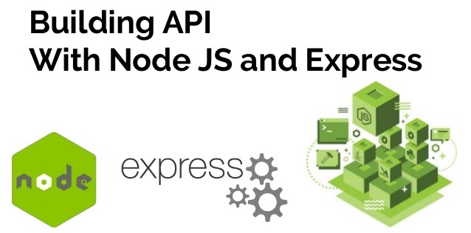

Figure 2.1‑10. REST API with ExpressJS

#### ExpressJS

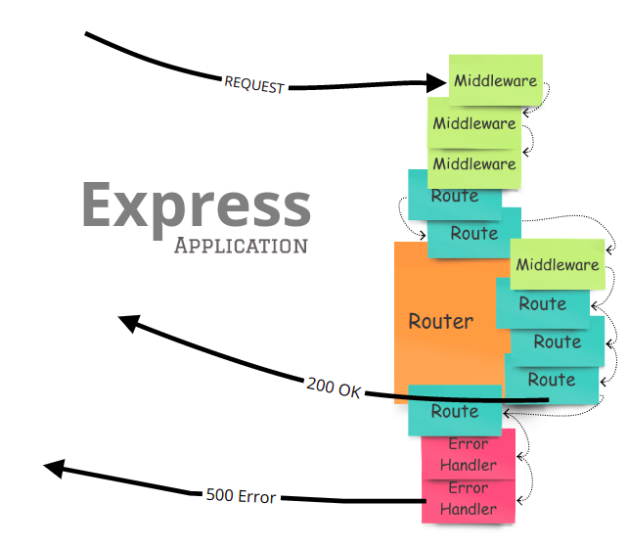

Figure 2.1‑11. Introduction to ExpressJS

Express is the most popular Node web framework, and is the underlying library for a number of other popular Node web frameworks. It provides mechanisms to:

* Write handlers for requests with different HTTP verbs at different URL paths (routes).
* Integrate with "view" rendering engines in order to generate responses by inserting data into templates.
* Set common web application settings like the port to use for connecting, and the location of templates that are used for rendering the response.
* Add additional request processing "middleware" at any point within the request handling pipeline.

While Express itself is fairly minimalist, developers have created compatible middleware packages to address almost any web development problem. There are libraries to work with cookies, sessions, user logins, URL parameters, POST data, security headers, and many more. You can find a list of middleware packages maintained by the Express team at Express Middleware (along with a list of some popular 3rd party packages).

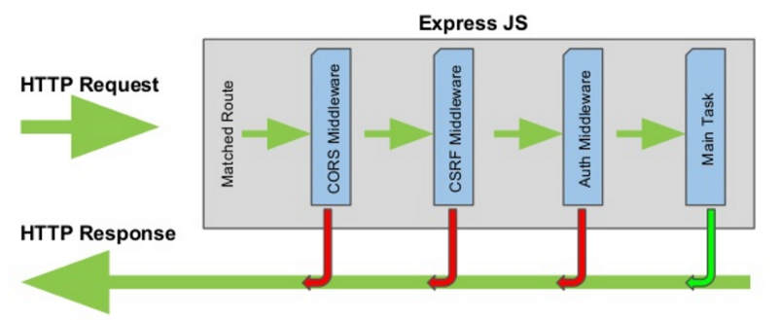

Figure 2.1‑12. ExpressJS Workflow

#### Nodemon

Nodemon is a tool that helps develop node.js based applications by automatically restarting the node application when file changes in the directory are detected.

Nodemon does not require any additional changes to your code or method of development. Nodemon is a replacement wrapper for node, to use Nodemon replace the word node on the command line when executing your script.

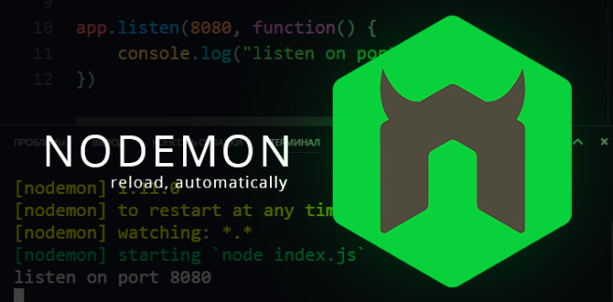

Figure 2.1‑13. Nodemon Automatically Reload API

## Overview of Ethereum Blockchain technologies

### Blockchain' fundamental background

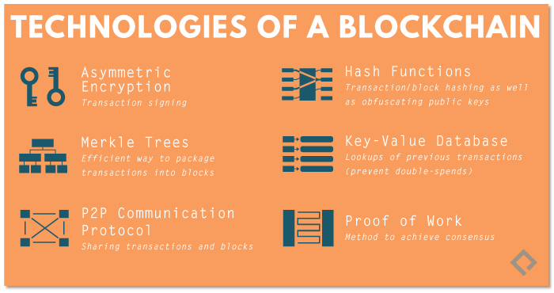

Figure 2.2‑1. Fundamental Technologies of Blockchain

Blockchain' precursor was authentically described in 1991 and its goal was to marking digital documents with timestamp in order to prevent contents from being tampered or to set the signed day before it was written.

The most fundamental theorem of Blockchain is Hashing and Merkle Tree.

#### Hash Function

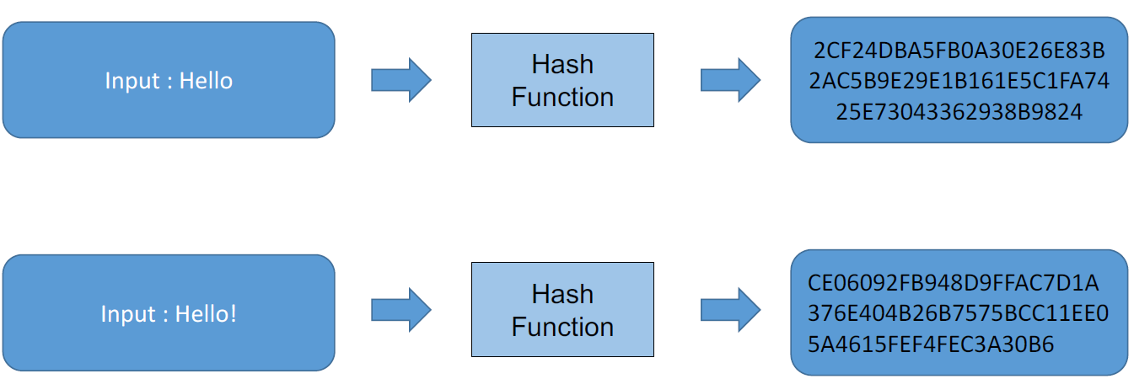

Figure 2.2‑2. Hash Function

Hashing is a one-way function, which takes input and produces a fixed size output, that cannot be reversed after running. Moreover, if the data in type of binary is changed 1 bit only, the result would be significantly replaced. Last but not least, there is no case to figure out the input if we only have output string.

This cryptographic hashing must satisfy 3 properties:

* Collision-free: There's almost no case that 2 different inputs will produce the same output
* Hiding: It's hard to find out what's the input even if the output has been published.
* Puzzle-friendly: The only way to match the output is to randomly use as much as possible input.

#### Merkle Tree

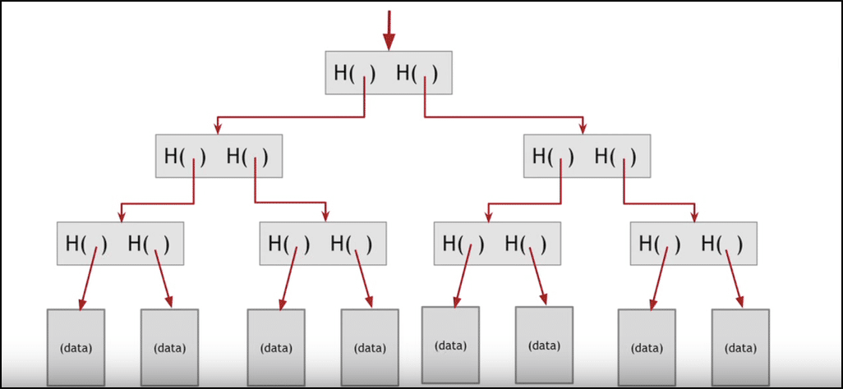

Figure 2.2‑3. Abstract Merkle Tree

Merkle Tree is a hash tree with multiple layer of blocks, which represents a type of data structure. And each block on the upper layers will be constructed by combining 2 blocks from the lower layers.

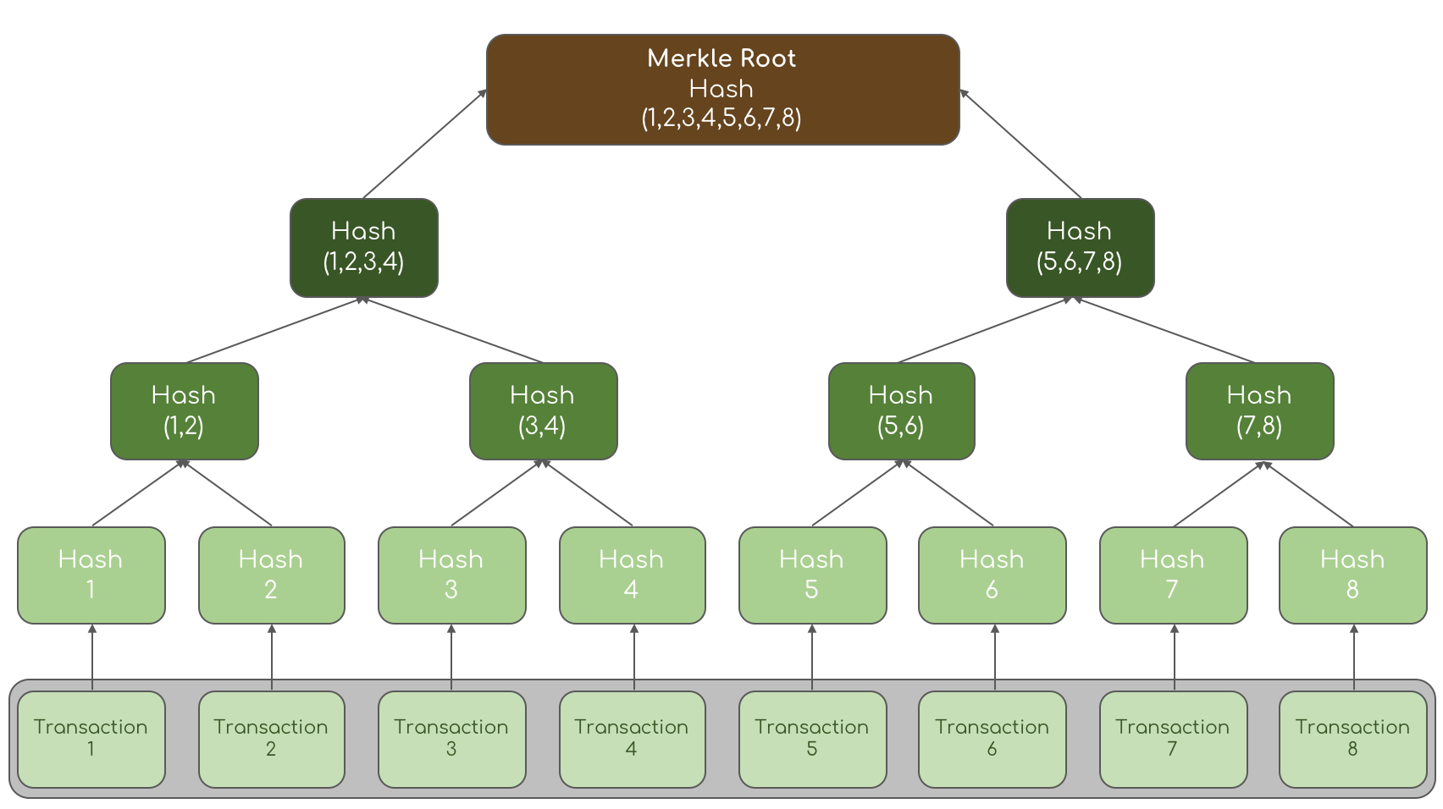

Figure 2.2‑4. Transactions Merkle Tree

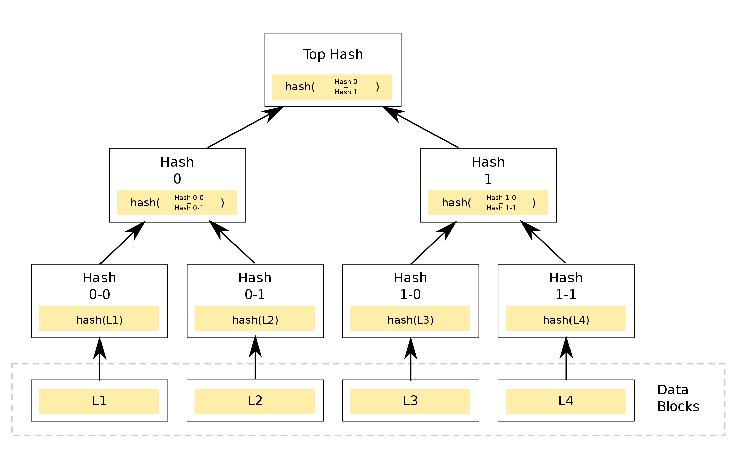

Figure 2.2‑5. Semantic Merkle Tree

Constructing Merkle Tree requires hashing all the data block, resulted in all different string of hashed values. Then each two adjacent of hashed value are hashed once again to make the hash value for the higher layer. Keep iterating until reaching the top of the tree, where the number hashed values in the highest layer is equal to 1.

The root hash will verify all the data blocks in the lowest layer, since a small change of data in any block will cause different hashed value on root hash.

Into details, a Blockchain is a distributed computing architecture, which uses peer-to-peer network protocol. Anyone is allowed to join and became a node of the network. When someone runs as a full-node, they must gets the full copy of the Blockchain' data, specifically in this case which is the main ledger. By this protocol, every node executes and records similar transactions to keep the Blockchain holds consensus mechanism across the whole network. Any interactions with Blockchain are resulted in adding transactions into a block. At a time, only one block can be generated and every block contains a hash of the previous block, which makes the chain become unbreakable.

#### Block's Structure

The component of an abstract Bitcoin block is illustrated as in the Figure 2.2‑6 below.

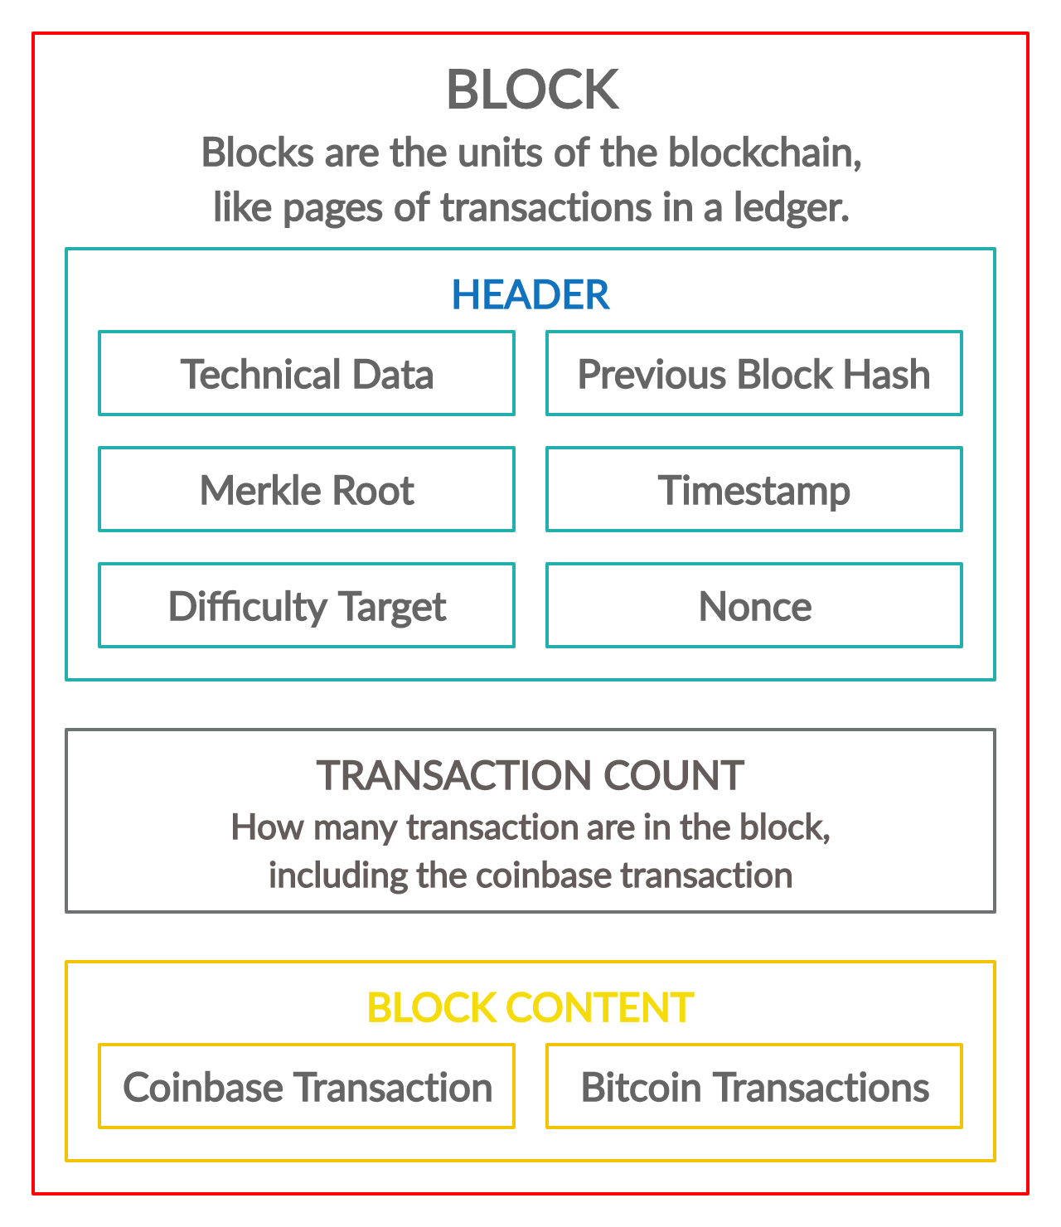

Figure 2.2‑6. Abstract Bitcoin Block Components

Each block included 3 main parts, which are header, transaction count and block content.

* + **Header**: The block header is hashed twice to create the fingerprint which is referred to in the next block.
* *Technical data*: Included a Magic ID, a version number (to specify which set of protocol rules a block conforms to), the size of a block.
* *Merkel Root*: Distills all the transactions in the block into a single hash (the root of transactions Merkel Tree).
* *Timestamp*: Approximate timestamp of when a block was created. Use to figure out mining difficulty re-target, if the network is making blocks too quickly or too slowly, for example.
* *Previous block hash*: 2x SHA256 has of previous block header (excluding magic ID & block size). This is the link that creates the chain of blocks.
* *Difficulty target*: Related to mining and how hard it is successfully mine the block.
* *Nonce*: A random number. One of the things that miner can change when mining to create different hashes, while search for a suitable hash.
  + **Transaction count**: How many transactions are in the block.
  + **Block content**: Holding a list of transactions.

The Figure 2.2‑7 below illustrates the detail information of a Bitcoin Block.

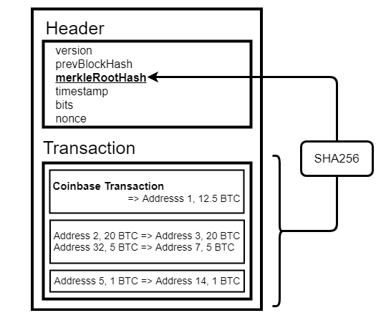

Figure 2.2‑7. Semantic Bitcoin Block Components

#### Blockchain' structure and Mining mechanism

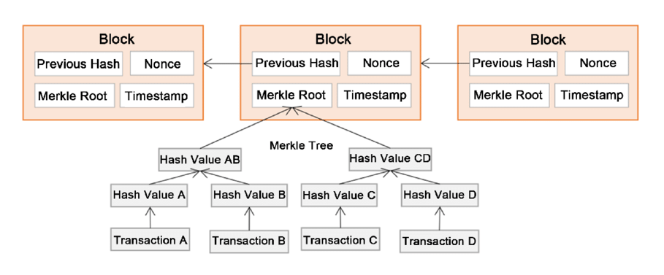

Figure 2.2‑8. Bitcoin Blockchain Structure

To create a new block and add it to a chain, Blockchain network has its own workers called miner. A miner start constructing a candidate block by gathering the transactions in the “*transaction pool*”, a pool of new or unconfirmed transactions. This candidate block arrangement is same to a normal block structure. See Figure 2.2‑9 below.

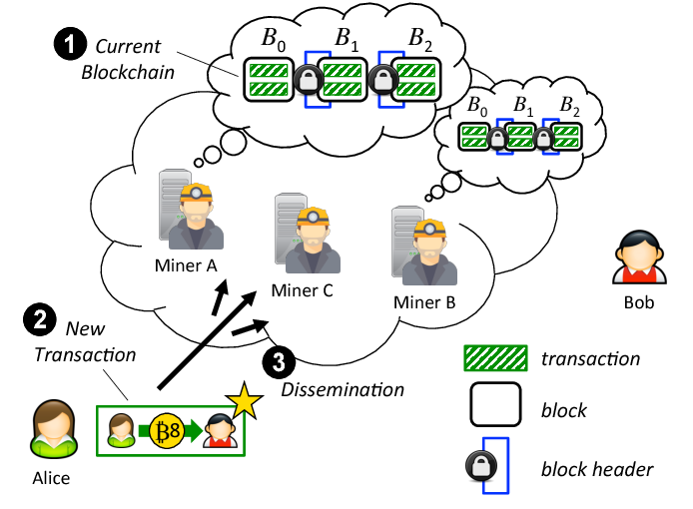

Figure 2.2‑9. Miners Collect Transactions

Then, miner spends resources (dedicate hardware and electricity) to compute the hash of the block’s header. If the output is fulfil the *Difficulty target,* new block is created and linked to the top of the chain*.* Otherwise, that miner has to change the *Nonce* until an appropriated hash output is found. By this way, miner is “mining” for a new block. Since the computational process of solving for the solution to create a new block is costly and time-consuming, the output is literally called Proof-of-work. See Figure 2.2‑10 below.

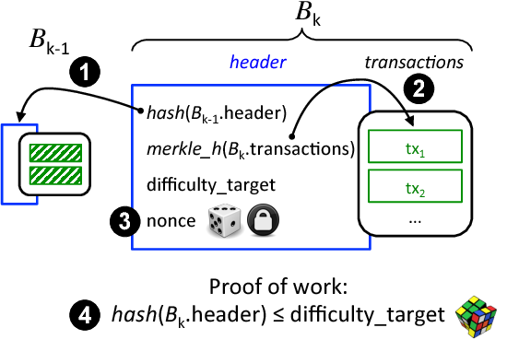

Figure 2.2‑10. Proof-of-work Mechanism

After a mining process is done, that new block is sent to every nodes on the network. Each node then verifies the block to make sure it is valid by hashing again the block data along with the miner's nonce to check the appropriated Difficulty target. After that, all the node in this network create a consensus protocol. They make agreement about which blocks are valid and which are not by following those criterion:

* Block header hash is appropriated to the block target.
* Block size is within acceptable limits.
* Block timestamp is less than a *T* time in the future.
* All transactions within the blocks are valid (also have a checklist on their own).

After successfully mining a new block, miner get a total of reward for mining block and transactions fees. See Figure 2.2‑11 below.

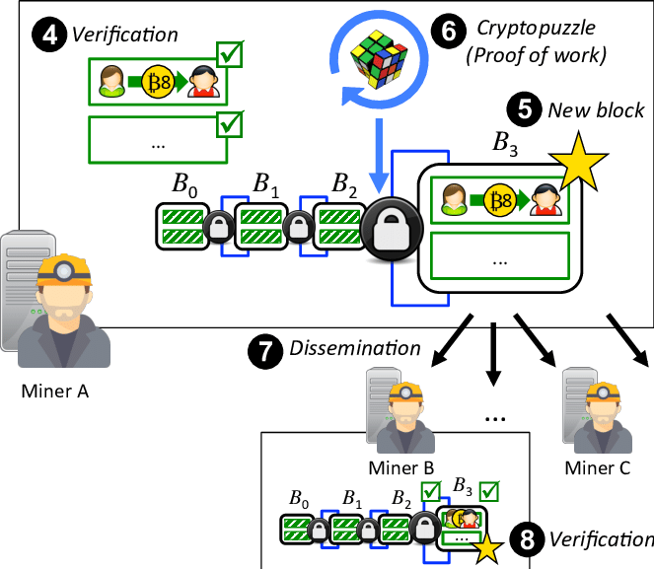

Figure 2.2‑11. Blockchain Mining Mechanism

### Asymmetric Key Pair

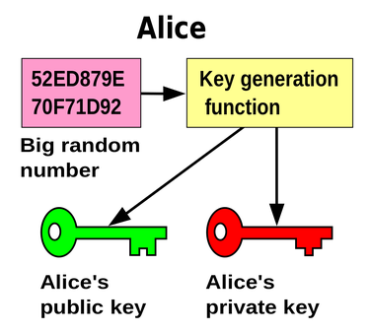

Figure 2.2‑12. Abstract Keypair Generator

#### Cryptographic Proof-of-identity

Cryptographic Proof of identity in simply means proving one’s identity without revealing it. It use the cryptography techniques to generate a digital signature. This will make a person become anonymous since they does not need providing personal information, but still can prove the privileged possession of a property.

Here is what a cryptographic system can do. It generate a key pair, one is public key and another one is called private key. They are a set of long characters that are mathematically connected. A public key is public like a username, and the private key is a secret like a password. Once a property of a person is encrypted with his or her public-private key pair by the cryptographic algorithm, only that person can prove the ownership of that property. Since, it would take 1000’s of years to break the cryptographic algorithm because of the computational limits nowadays. Quantum computers in the future might be a concern, but hopefully developers could find a way to deal with that technology.

Figure 2.2‑13 below is an example of using key pair in cryptographic proof-of-identity.

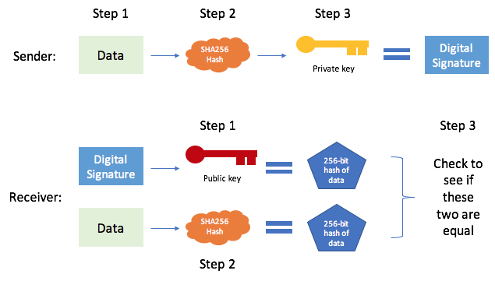

Figure 2.2‑13. Asymmetric Keypair with Proof-of-identity

#### Asymmetric Encryption / Decryption

Figure 2.2‑14 below is an example of using key pair in cryptographic proof-of-identity.

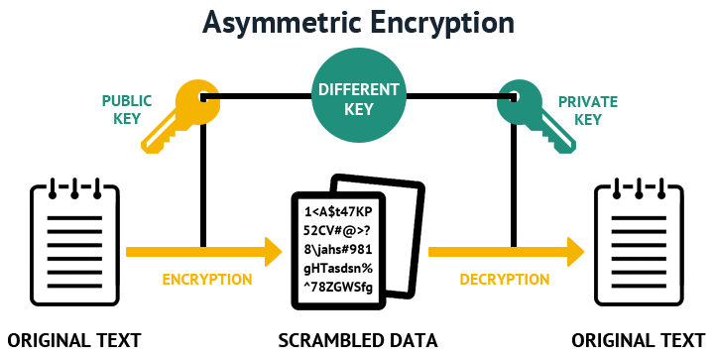

Figure 2.2‑14. Asymmetric Keypair with Encryption and Decryption

Rivest–Shamir–Adleman (RSA) — an asymmetric cryptographic algorithm, basically uses two different keys to Encrypt and Decrypt the Data. Public Key is used to encrypt while Private key to decrypt.

### Peer-to-peer Network

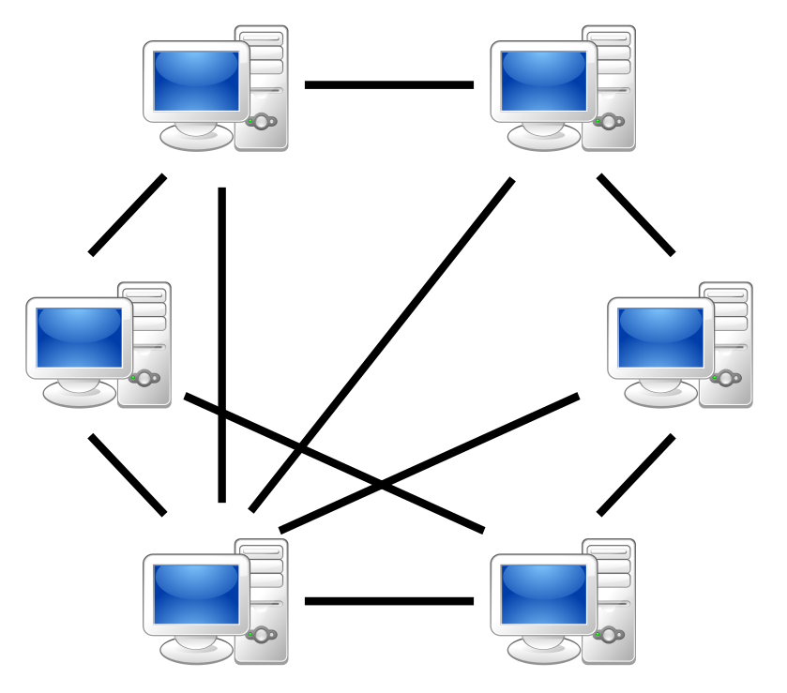

Figure 2.2‑15. Peer-to-peer Network Model

#### Introduction to P2P Network

In simplest terms, a peer to peer network is two or more computing devices connected to each other to accomplish a task or set of tasks.

A P2P network can be an ad-hoc network where two computers are connected by USB to transfer files. It can also be a permanent network where all the computers in an organization are connected.

Every connected computer or computing device in a P2P network is called a node and serves as a client and server at the same time. There is no presence of a centralized server.

#### How P2P Network Works

Whenever a user wishes to download a file hosted on a P2P network, he will need to join the network via a client application called as “leech”. This client will then search for the file on the network called as “seeds”.

#### Examples of P2P Network

* Bit Torrent – Needs no introduction, this is the most popular peer-to-peer.
* DistriBute – World’s first P2P desktop deployment product for business use.
* Tor – Application that shields user information by sending traffic through a P2P network of relays set up by volunteers across the world.

#### Comparison to Server Based Network

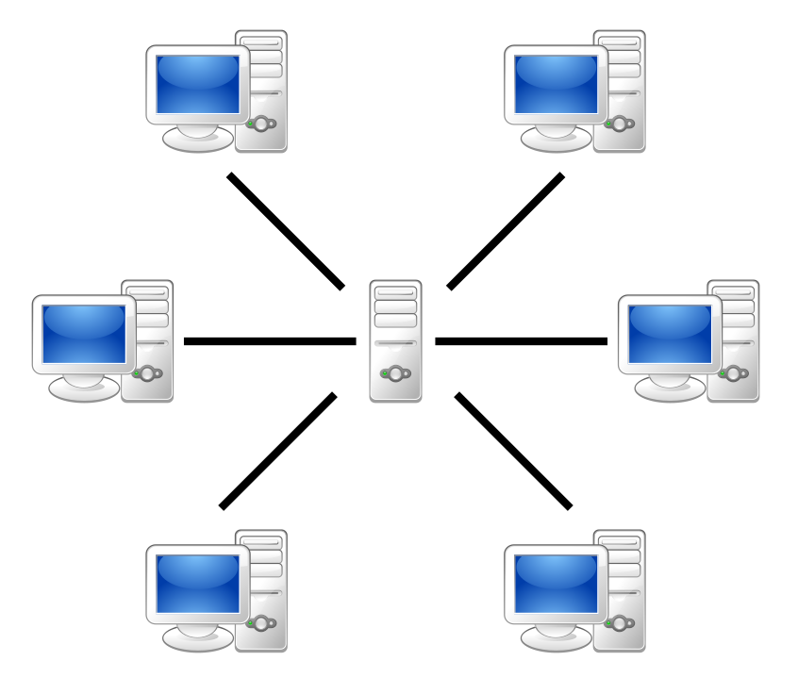

Figure 2.2‑16. Server-Based Network Model

|  |  |  |
| --- | --- | --- |
|  | Server-Based Network | Peer-to-Peer Network |
| Description | A server-based network has a centralized server that stores, manages, and communicates data from one computer to another. Users use local systems/computers to access, create, modify data which are stored on a server present at a remote location. | P2P network does not have any servers. Data management happens on the computers or peers in the network. |
| Cost | Setting up a server based network require larger teams, complex architecture as compared to a P2P network |  |
| Scope and magnitude of use | Server based network are pre-dominantly used for large organizations that handle and process complex data every hour, round the year | P2P networks are suitable for smaller organizations with dozens of employees performing relatively easier or less complex tasks like sharing files, printer access, etc |
| Robustness and Availability | A server-based network is robust, scalable and set-up to be always available. If a computer crashes or becomes unavailable, the network is still up. There are back up servers to take over in case the primary server fails | Most P2P networks are however not as robust and scalable. If a node crashes, the system may collapse and become dysfunctional. However, most P2P network these days are set up to ensure that the network is up and running even though a couple of peers go offline..Similarly, there is no setup for data back up |
| Efficiency | In a server based network, as the number of users grow, the efficiency decreases (unless more servers are added to the existing set up) | P2P network sees an increased efficiency as the number of users connected to the network increase |

Table 2.2‑1. Server-Based compared to Peer-to-Peer Network Model

Thus from the comparison above, we defined some Cons and Pros of Peer-to-Peer Network Model as in the Table 2.2‑2 below.

|  |  |
| --- | --- |
| Advantages | Disadvantages |
| * Easy to set up and maintain, adding new peers is easy as configuration on a central server is not required * Reduces cost by eliminating the need of setting up and managing server * P2P networks are available even if one or more peers crash out. To bring down a P2P network, every peer in the network needs to be closed down. * Faster file sharing as a download request is served by multiple peers at the same time. The larger the network, the faster is the download. | * Absence of centralized server makes it difficult to back up and archive data, data is located in different machines * Weaker security features as every machine is in charge of securing itself from external threats * P2P networks make decentralization a reality. However P2P networks can become a security scare at times if one or more peers turn hostile. Most networks take security seriously these days and so the security is maintained, as in the case of blockchain. |

Table 2.2‑2. Advantages and Disadvantages of Peer-to-Peer Network Model

### Ethereum Platform

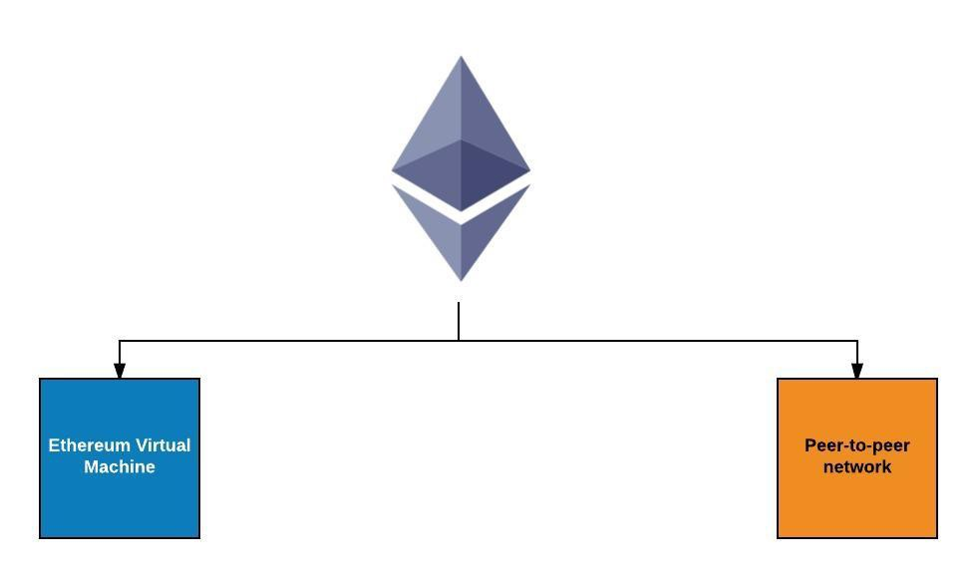

Figure 2.2‑17. Ethereum Platform

#### History

A new generation of Blockchain that had the ambitions to implement a general, fully trust-less smart contract platform called Ethereum, which is a combination of Blockchain, Cryptography and Smart Contract technologies.

In 2014, Vitalik Buterin, Gavin Wood and Jeffrey Wilcke became the founders of Ethereum, which contains an Ethereum Virtual Machine and a peer-to-peer network protocol. The Ethereum Blockchain database is maintained and updated by numerous nodes connected to the network. Each and every node of the networks runs the Ethereum Virtual Machine and executes the same instructions. For this reason, Ethereum can be described as a “World Computer”.

#### Introduction to Ethereum

As has been said, Ethereum is a programmable Blockchain. Instead of providing users a set of predefined operations (like Bitcoin did with its transactions), Ethereum furnish them a friendly language running on a “Virtual Machine”- called an Ethereum Virtual Machine (EVM). At the heart of Ethereum, Ethereum Virtual Machine (EVM) can execute code of arbitrary algorithmic complexity, which makes it to be “Turing complete” – a system that can understand a set of instructions and execute them in some logical order, just like a computer does. Using Solidity as its programming languages, Ethereum serves as a platform for various types of decentralized Blockchain applications, including but not limited to crypto currencies.

The fundamental network consists of nodes (or computers) connected in a decentralized, peer-to-peer network through P2P protocol. Each node runs an Ethereum Virtual Machine (EVM), and process the same instructions to make sure that consensus across the whole network is achieved on any particular transaction.

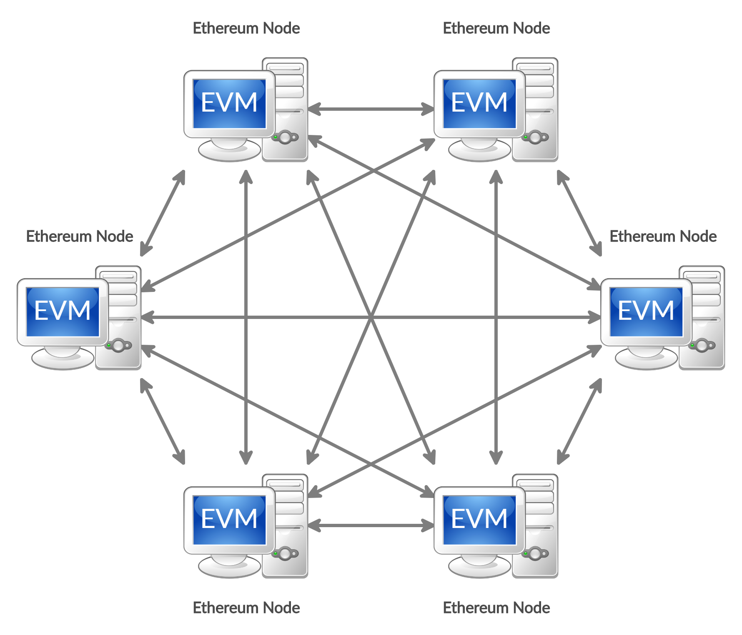

Figure 2.2‑18. Peer-to-peer Network model with EVMs

#### Ethereum Virtual Machine (EVM)

The Ethereum Virtual Machine (EVM) [5] is a powerful, sandboxed virtual stack embedded within each full Ethereum node, responsible for executing contract bytecode. Contracts are typically written in higher level languages, like Solidity, then compiled to EVM bytecode.

This means that the machine code is completely isolated from the network, system's file or any processes of the host computer. Every node in the Ethereum network runs an EVM instance which allows them to agree on executing the same instructions. The EVM is Turing complete, which refers to a system capable of performing any logical step of a computational function. JavaScript, the programming language which powers the worldwide web, widely uses Turing completeness.

Ethereum Virtual Machines have been successfully implemented in various programming languages including Go, Rust, C++, Java, JavaScript, Python, Ruby, and many others.

The 2 most popular implementation of EVM are:

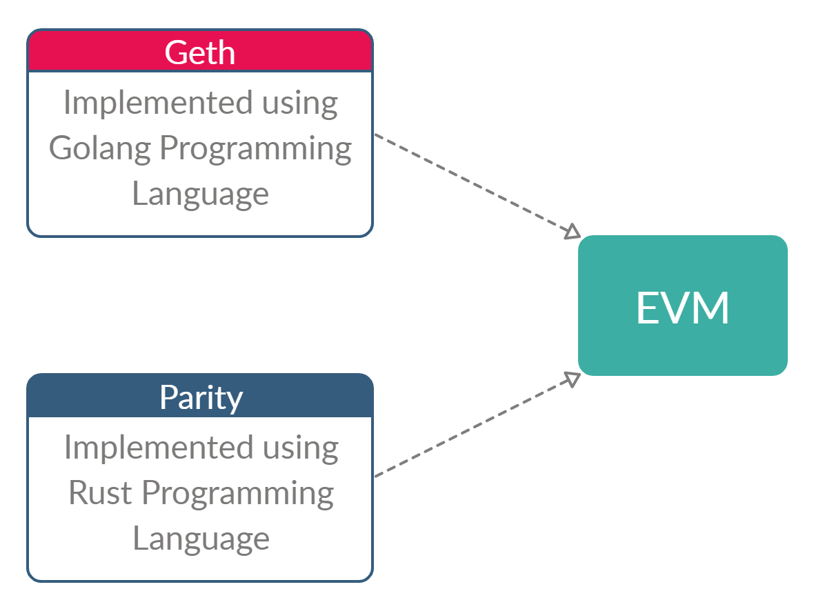

Figure 2.2‑19. EVM's Implementation

* Geth (Go Ethereum): Geth is the official client software provided by the Ethereum Foundation. It is written in the Go programming language. This software packages a few components which is worth understanding:
* Client Daemon: When you start this client daemon, it connects to other clients (also called nodes) in the network and downloads a copy of the blockchain. It will constantly communicate with other nodes to keep it’s copy of the blockchain up to date. It also has the ability to mine blocks and add transactions to the blockchain, validate the transactions in the block and also execute the transactions. It also acts as a server by exposing APIs you can interact with through RPC.
* Geth console: This is a command line tool which lets you connect to your running node and perform various actions like create and manage accounts, query the blockchain, sign and submit transactions to the blockchain and so on.
* Mist Browser: This is a desktop application used to communicate with your node. Anything you can do using the geth console can be accomplished through this Graphical User Interface.
* Parity: Parity-Ethereum is another good implementation of the Ethereum protocol and is written in the sophisticated and cutting-edged Rust programming language. It is an unofficial client and is maintained by a company called Parity Inc. Anyone can implement the client software and join the Ethereum network. Parity-Ethereum’s aim is to be the fastest, lightest, and most secure Ethereum client.

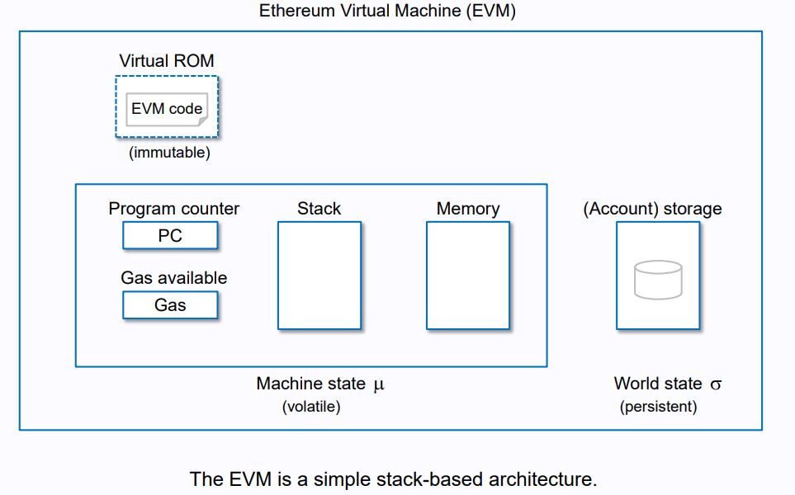

Figure 2.2‑20. EVM’s Simple Stack-Based Architecture

The EVM is essential to the Ethereum Protocol and is instrumental to the consensus engine of the Ethereum system. It allows anyone to execute code in a trustless ecosystem in which the outcome of an execution can be guaranteed and is fully deterministic (i.e.) executing smart contracts.

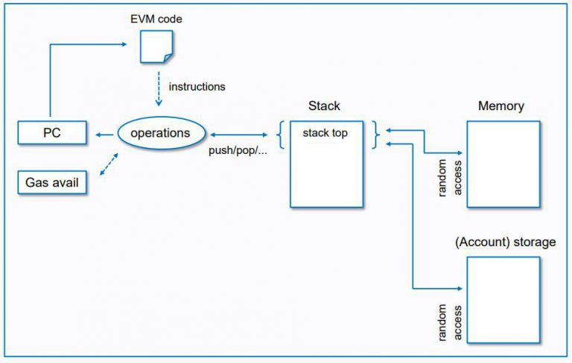

Figure 2.2‑21. EVM’s Execution Model

For every instruction implemented on the EVM [6], a system that keeps track of execution cost, assigns to the instruction an associated cost in Gas units. When a user wants to initiate an execution, they reserve some Ether, which they are willing to pay for this gas cost.

By using the Gas mechanism, two major issues are solved: A validator is guaranteed to receive the initial pre-paid amount, even if the execution fails. An execution cannot run longer than the pre-paid amount would allow. Instead of looping indefinitely the execution would run until it runs out of Gas.

When a transaction is sent to the network, validators may take the transaction, executing the associated code. The validator will ensure that:

* All information on the transaction is valid.
* The sender has enough funds to pay for the execution of the transaction.
* The EVM didn’t run into any exceptions during the execution.

The EVM achieves Turing Completeness [7] by enabling an economy that charges per software instruction executed instead of per financial transaction executed like Bitcoin does. Instead of a transaction fee, you have a kind of fee for running programs.

Being Turing complete means that Ethereum is technically a peer-to-peer general purpose worldwide computer, and could even assume the functions of the internet as we know it. Ethereum could enable us to create file-sharing economies, peer-to-peer crowd-funding events, smart contracts, markets for renting out the unused hard-drive space on your laptop, a dis-intermediated Uber or Facebook (the products without the companies), etc. It’s basically like the internet in 1994: no-one knows what the future will bring.

#### Ethereum Nodes

A node is simply a computer that participates in the Ethereum network. This participation can be in three ways:

* By keeping a shallow-copy of the blockchain aka a Light Client.
* By keeping a full-copy of the blockchain aka a Full Node.
* By verifying the transactions aka Mining.

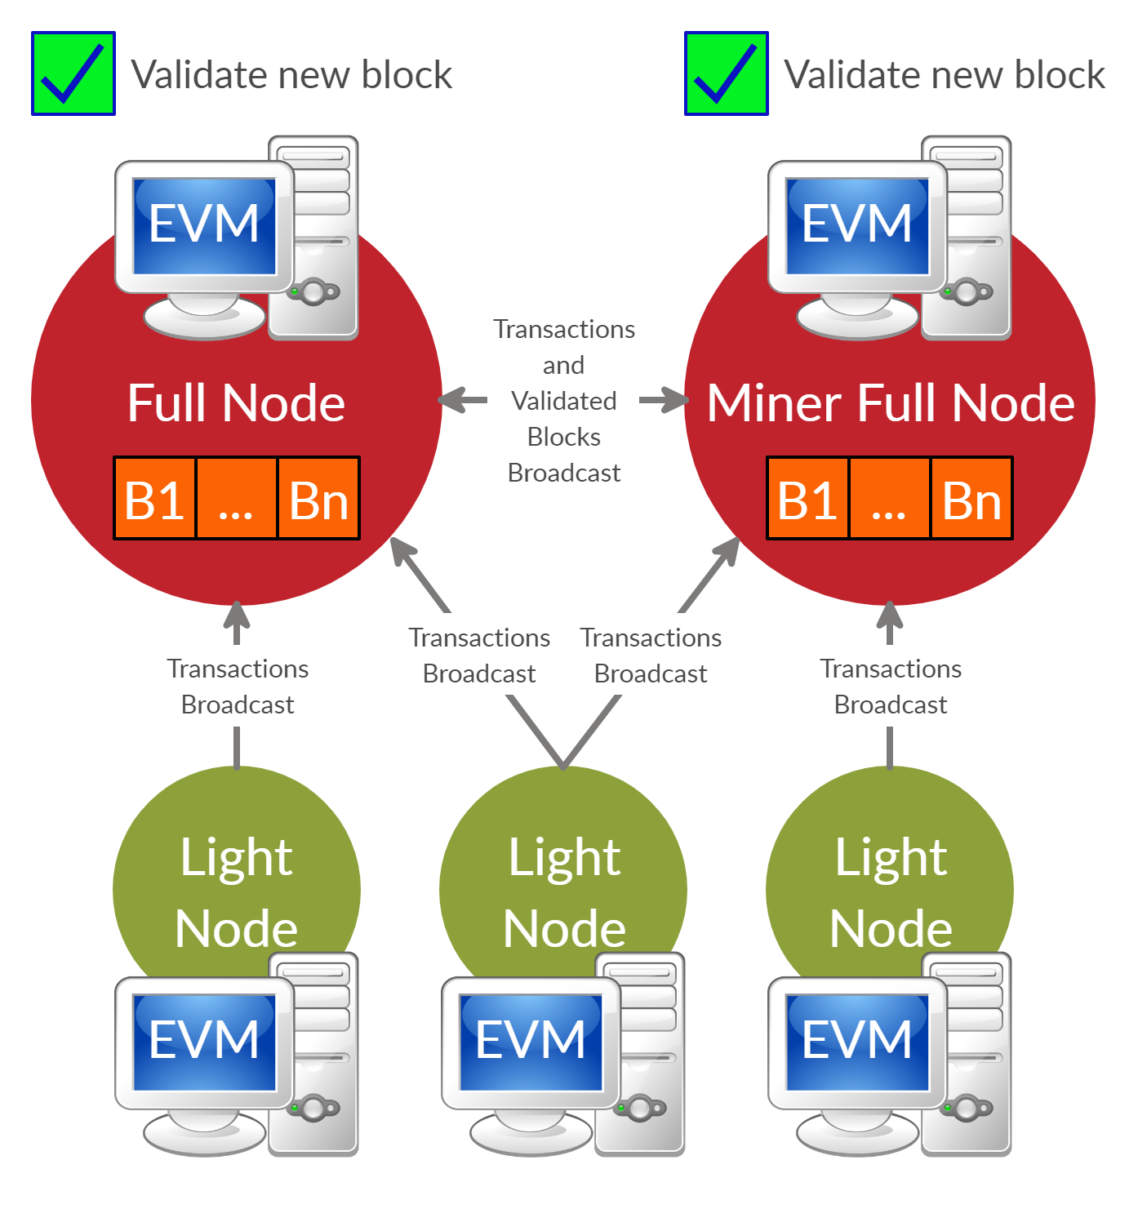

Figure 2.2‑22. EVM Node's Broadcasting Work Flow

##### **Full Node**

Any computer, connected to the Ethereum network, which fully enforces all the consensus rules of Ethereum is called a Full Node. A full node downloads the entire blockchain in the user’s desktop. Full nodes form the backbone of the Ethereum system and keep the entire network honest. Some of the consensus rules that full nodes enforce are:

* Making sure that the correct block reward is given out for each block mined (5 ETH)
* Transactions have the correct signatures
* Transactions and blocks are in the correct data format
* No double spending is occurring in any of the blocks
* The full nodes basically validate the nodes and transactions and relay the information to the other nodes (using the gossip protocol).

To keep it simple, all miners are full nodes, but not all full nodes are miners. Miners need to be running full nodes to access the blockchain. Anyone who runs a full node need not mine for blocks.

##### **Light Node (Light-Client)**

As we have mentioned before, the idea of a peer-to-peer system is to distribute network responsibilities among nodes called “peers”. No preference is given to any one of them. However, what about people who want to take part in the network but don’t have the system resources to download and maintain the full blockchain in their system? They can choose to become “Light clients”. By being a Light Client, they get high-security assurances about certain states of Ethereum and also the power to verify the execution of a transaction.

##### **Interacting with EVMs Node**

Interacting with Ethereum Virtual Machine requires RPCs (Remote Procedure Calls) from Client using Web3 library (which was implemented using various programming languages, such as Web3JS using JavaScript, Web3Py using Python, etc.)

On the other hand, for miners and developing purposes, interacting with EVMs using Personal Console is more preferable. Since the Console commands the Virtual Machine (or Daemon) directly without using RPCs, which is more secure.

The Figure 2.2‑23 below illustrates the ways to interact with an Ethereum Node, or else, an Ethereum Virtual Machine.

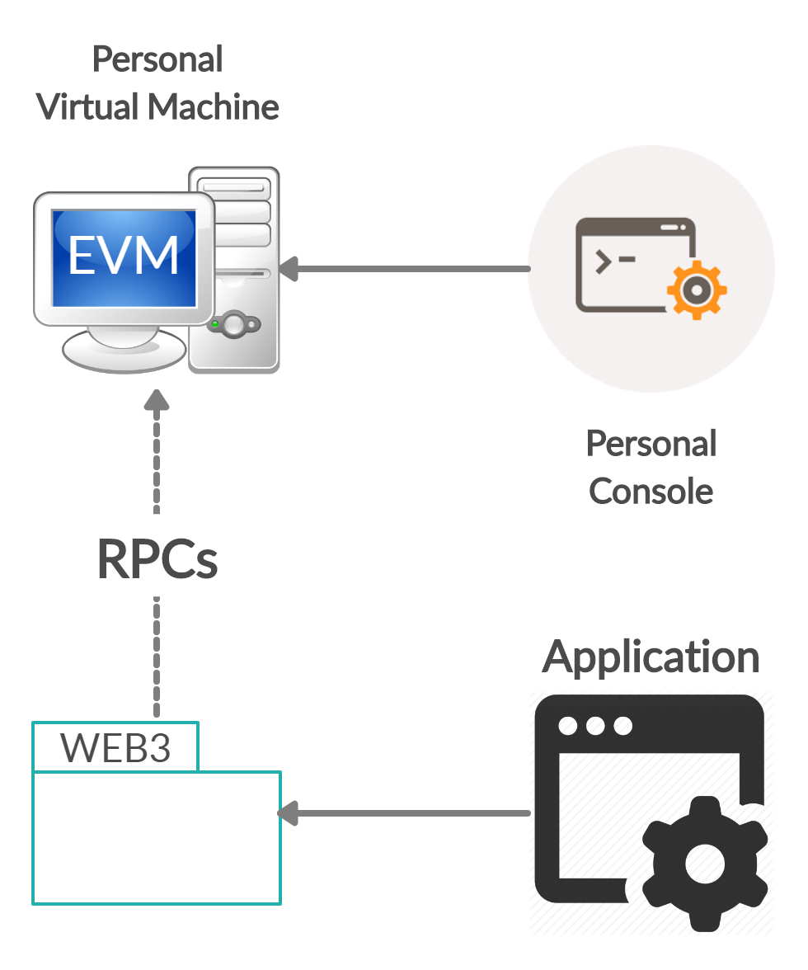

Figure 2.2‑23. Ethereum Node's Interaction

#### Ethereum Networks

Each nodes in Ethereum Network communicate to each other using Ethereum protocol, the 2 most popular EVM implemented are Geth and Parity. Please review part 2.2.4.3 - Ethereum Virtual Machine for more details of the Mist / Parity Browser and Geth / Parity Console.

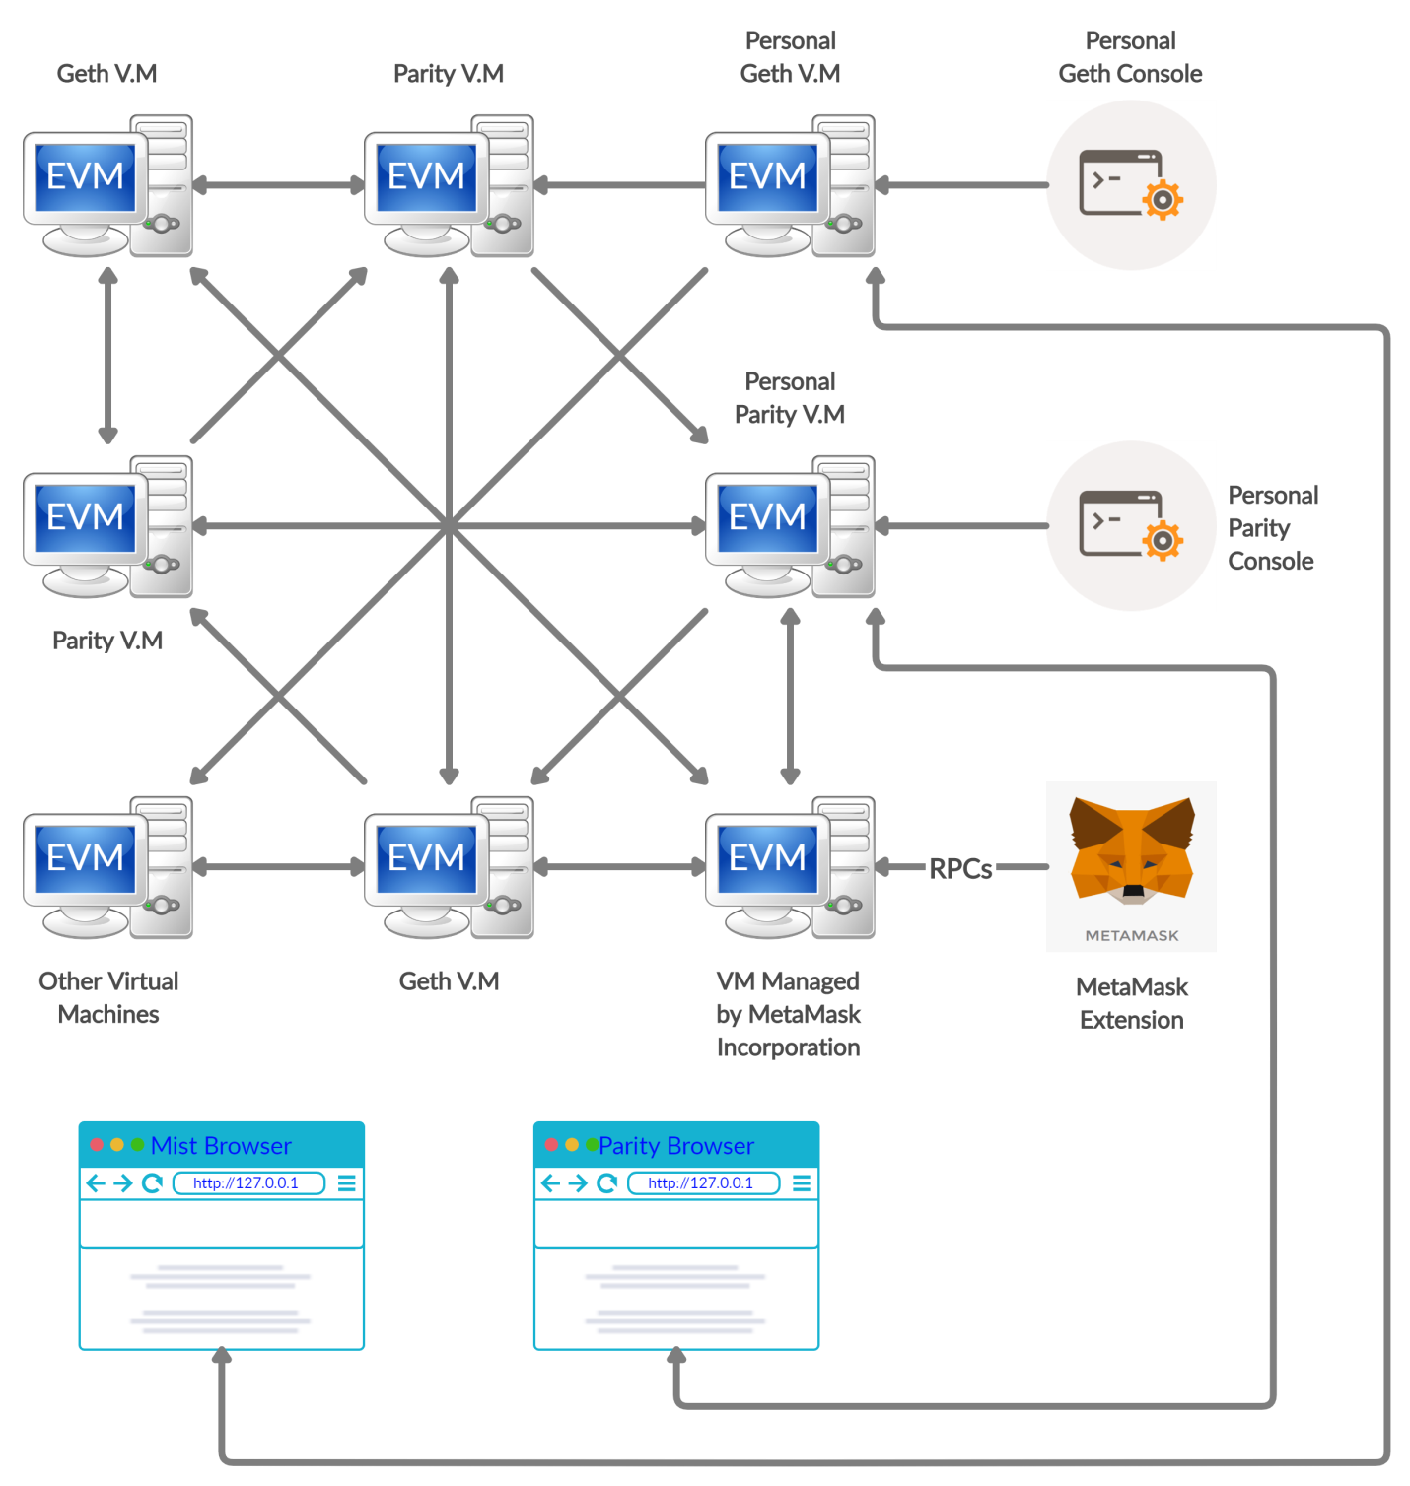

Figure 2.2‑24. Ethereum Blockchain Network

There are many network running based on the Ethereum Platform, included both private and public network. The table below shows all the public network including Ethereum Main-net (Real network) and Ethereum test network.

|  |  |  |
| --- | --- | --- |
| Network | Network ID | Note / Consensus Mechanism |
| Main | 1 |  |
| Morden | 2 | Deprecated |
| Ropsten | 3 | Proof-of-Work |
| Rinkeby | 4 | Proof-of-Authority, supported by Geth only |
| Kovan | 42 | Proof-of-Authority, supported by Parity only |

Table 2.2‑3. Ethereum's Public Networks

#### Ethereum' Currency System

Ether is the standard crypto currency of the Ethereum network which can be used in trading with other supported crypto currencies. In the other hand, it can be seen as the fuel, which is needed to run a transaction on Ethereum Blockchain. Ether is also a reward to miners each time they succeed mining a new block on Ethereum Blockchain. Developers who intend to use Ethereum as a platform to build apps need Ether, as it is used to pay for computation within the EVM. Shortly, users who want to interact with Ethereum Blockchain applications must use Ether.

Ether is to the Ethereum network, what Bitcoin is to the Bitcoin Blockchain network. Hence, users should become Ethereum miners, or trade with other currencies using centralized or trustless services in order to gain some Ethers. The base unit of Ether is called Wei.

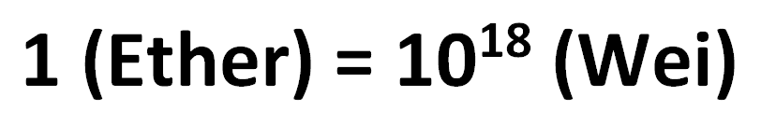

Figure 2.2‑25. Conversion from Ether to Wei Unit

The Figure 2.2‑26 below shows the conversion of Ethereum' units into Wei and Ether

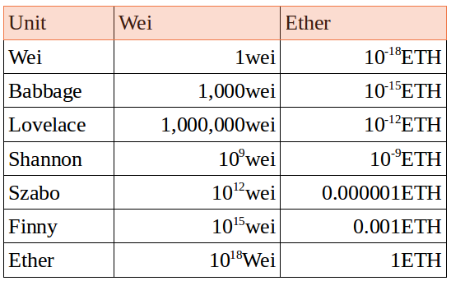

Figure 2.2‑26. Unit Conversion in Ethereum Blockchain

#### Ethereum Accounts

Comparing to Bitcoin, one of the first and biggest Blockchain application which is purely a list of transactions, Ethereum’ basic unit is the accounts. There are two type of accounts:

|  |  |
| --- | --- |
| **Externally Owned Accounts (EOAs)** | **Contract Accounts** |
| * Controlled by an External party or person. * Accessed through private keys. * Contain Ether Balance. * Can send transactions as well as ‘trigger’ contract accounts. | * Have code that executes when being triggered. * Also contain Ether Balance. * Can trigger other contract accounts. * Live on the Ethereum Blockchain. |

Table 2.2‑4. Externally Owned Accounts & Contract Accounts

If a user wants to participate in the Ethereum ecosystem, they should have a user account and the keys to operate that account. These types of accounts are called Externally Owned Accounts (EOAs) in Ethereum. Once an Externally Owned Account (EOA) is created, transactions can be made from that account to the others as well as to other types of account – Contract Accounts, which is on the Ethereum Network.

A Contract Account contains code to execute some designed functions, and this code is put on the Ethereum Blockchain. When a smart contract is triggered – by an EOA or by another contract account – the code inside is executed by the EVM on each participating node.

#### MetaMask Extension

MetaMask [8] is a browser extensions that lets you run DApps without being part of the Ethereum network as a Ethereum Node. By default, it lets you connect to an Ethereum Node managed by Metamask Incorporation through RPCs and run smart contracts on that Node. Or else, developers could set Infura Node or their Personal Node as Http Provider [9] instead of MetaMask Node. Please review part 2.2.4.4 - Ethereum Nodes and 2.2.4.5 - Ethereum Networks for more details of the connections provided by MetaMask.

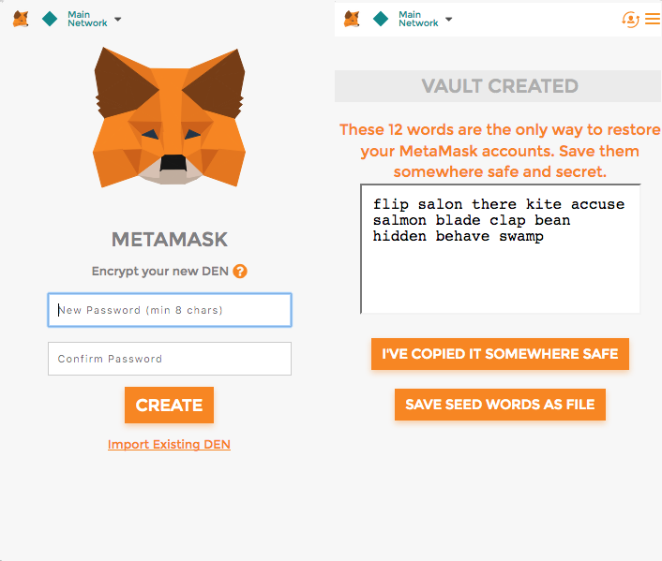

Figure 2.2‑27. Creating MetaMask Wallet

Users can create a new Ethereum account to send and receive Ether with DApps. After creating an account, you get a list of 12 words that can be used to retrieve your account when you forget your password. Make sure to save this somewhere safe where no one can see.

MetaMask manages your Ethereum wallet, which contains your Ethers (or money), and allows you to send and receive Ethers through a DApp of interest. It is a pretty neat tool.

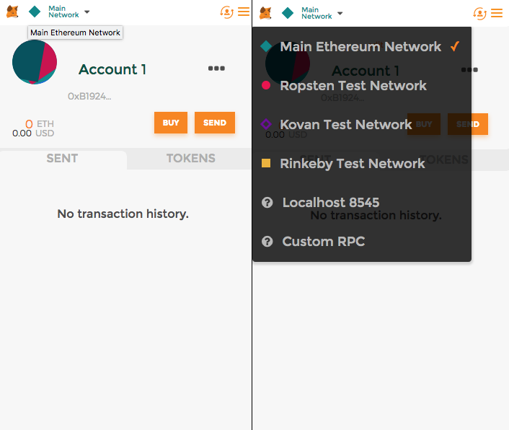

Figure 2.2‑28. MetaMask Accounts & Networks

MetaMask injects web3 object and convenience Web3.js library into the JavaScript context. It helps user to handle authorization using their private key. Any time users make a transaction that requires private key to sign the transaction, MetaMask will automatically prompt the user for permission, and then forward the signed request to the blockchain.

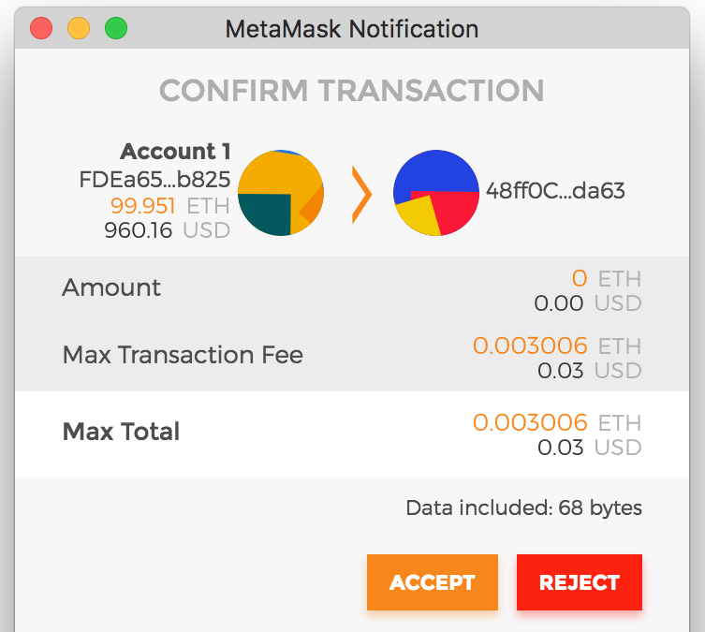

Figure 2.2‑29. MetaMask Signing Transaction

#### Introduction to Solidity Smart Contracts

The born of Smart Contracts is one of the recent developments which are very popular nowadays. The term “smart contract” was first used by Nick Szabo in 1997 since he wanted to use a distributed ledger to store contracts.

Nowadays, smart contracts are much similar to contracts in the real world. The only difference is that they are completely digitalized. Two parties can agree on a set of rules, create and code a contract. As soon as the criterion/rules are met, it automatically authorizes the validation between two parties. Smart contracts not only store conditions but also data. However, people should admit the limitations of the smart contract because some systems need human support and computers cannot handle everything. In the real world, implementing smart contracts is not easy. Moreover, smart contracts once published can neither be altered nor changed, silly mistakes can be costly.

* There are several steps to create a smart contract in Ethereum:

1. A smart contract is coded in Ethereum programming language (such as Solidity) following some conditions (e.g. “If A is true, then do B”) and then deployed on Ethereum Blockchain by an EOA (using some Wei as fees).
2. Once deployed, the smart contract gets a public key address, which can be used to reach the contract and trigger its code execution. This address is the contract account of that smart contract.
3. A deployed smart contract can neither be changed nor tampered, even by the EOA that created it.
4. The EOA which deployed a smart contract becomes the owner of that Contract Account.

The fact is that Smart Contracts are actually codes, which is deployed on the Ethereum Blockchain, and this code runs on every single node connected to the Ethereum network.

* Each smart contract contains:

1. The Smart Contract's address, which is actually a Smart Contract Account.
2. Byte code- This is the code that the EVM executes.
3. ABI — The Application Binary Interface is the standard way to interact with contracts in the Ethereum ecosystem, both from outside the Blockchain and for contract-to-contract interaction.

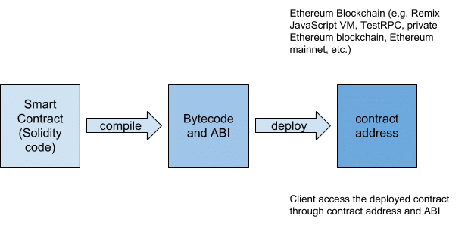

Figure 2.2‑30. Solidity Smart Contract

#### Solidity Programming Language

Solidity is a contract-oriented, high-level programming language for implementing smart contracts. It was influenced by Python, C++ and JavaScript and is designed to run on the Ethereum Virtual Machine (EVM).

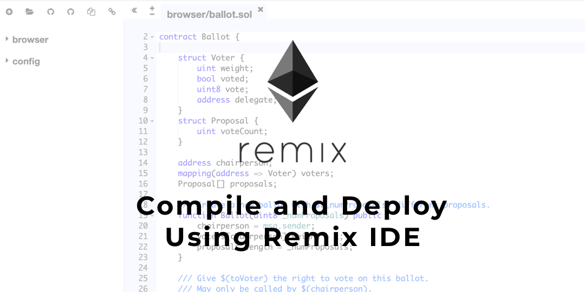

Figure 2.2‑31. Compile & Deploy Solidity Smart Contract with Remix IDE

Solidity is statically typed, supports inheritance, libraries and complex user-defined types among other features.

Remix IDE (Integrated Development Environment) is currently serving as an online IDE, a web based platform at the following url: <http://remix.ethereum.org/>

#### Ethereum' Workflow

Ethereum Blockchain provides Smart Contract for developers and users to achieve consensus without intermediates. For each transaction made by users, the state of EVMs of all Ethereum Node are changed depend on the gas price the user pay. To be more specific, the more gas user pay, the faster the transaction mined. Thus changing the EVM's state and its decentralized data.

##### **Ethereum Contract's Deployment & Interaction**

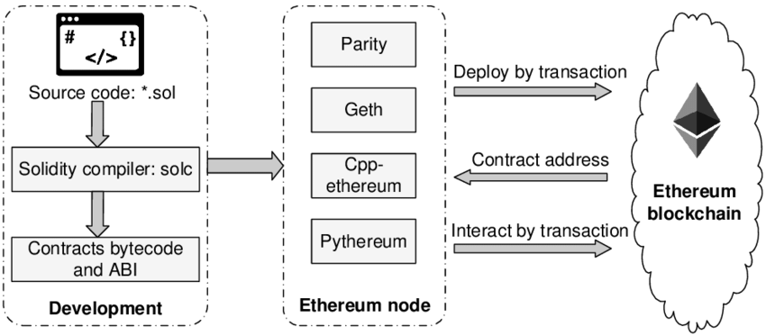

Figure 2.2‑32. Ethereum Smart Contract Interaction

##### **Ethereum Transaction**

Ethereum has the same Hashing data and Proof-of-work mechanism as a Blockchain, but its hashing function is keccak256, sometimes (erroneously) called SHA3. On Ethereum, a user could trigger a transaction from his or her EOA.

* A transaction is a validated packet that contain:
* **The address** of the recipient.
* **A signature** that proves the possession of the sender’s account.
* **Value field** – The amount of ether to transfer from the sender to the recipient. It can be empty, in some cases.
* **An optional data field**, which could be an arbitrary message or function call to a contract. As an example, accidental insurance smart contract would require to input the proportion of damage in order to release the respective compensation.
* **Gas** is required to run transactions on Ethereum Blockchain. It is Ethereum’ metering scheme and it accounts for bandwidth used, cost of data storage and cost of computation on the Ethereum Blockchain. Every computational operation in the EVM consumes gas and different computations consumes different amount of gas. Those additional attributes must be generated before triggering new transactions:
* **startgas**: the quantity of “gas” that a transaction is willing to consume to cover its user of the EVM’s computation and any storage bandwidth used. It is really difficult to define exactly how much is the startgas. Therefore, there are certain APIs pretending the transaction was actually being included in the transaction, and then returning the estimated amount that would have been charged if that pretend operation was real.
* **gasprice**: mentioned by the transaction sender. This is the amount of ether that a sender is willing to pay per unit gas.
* **gas_rem**: If a transaction execution is done and consuming less gas then its specified limit, the transaction sender receives a refund of *gas_rem*gasprice*.

Once a transaction is sent, the destination can be either another EOA or a Contract Account. The transaction to an EOA is simply an Ether transfer, which means ether balances from both sender and receiver will be adjusted. On the other hand, destination of the transaction is a Contract Account, the smart contract’s code will be executed automatically. In some cases, a Contract Account needs to run a function from another Smart Contract (or Contract Account), it will send a message to that Contract Account which contains:

* The address of the contract sending the message.
* The address of recipient contract.
* The amount of ether to transfer alongside the message.
* An optional data field.
* A startgas value.

The message results in the recipient contract running its code.

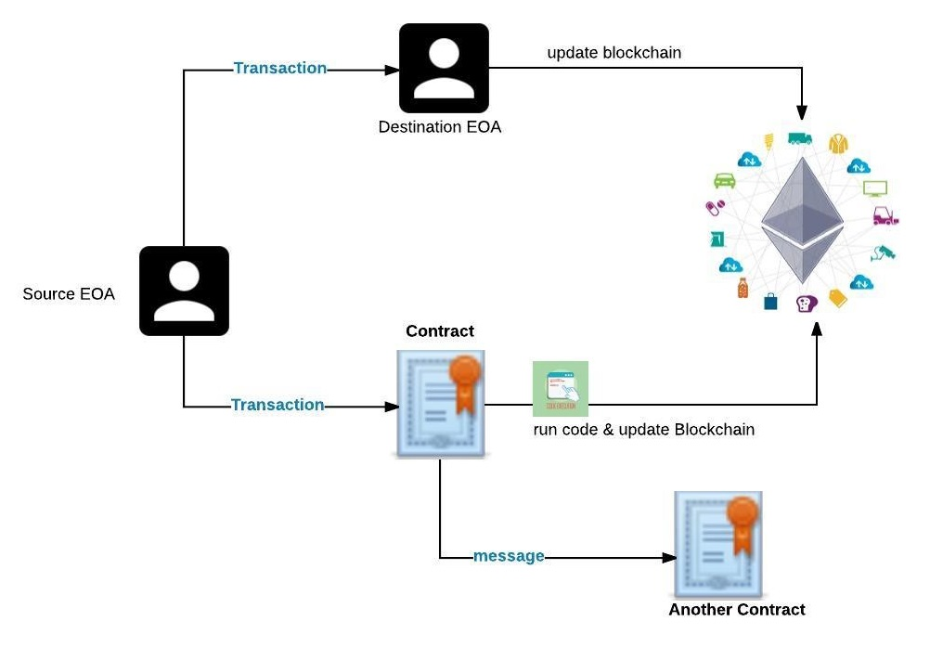

Figure 2.2‑33. Interaction Between Accounts and Blockchain network

After a transaction is done, the “state” of an account is updated to the Ethereum Blockchain. At the first time an account (either EOA or Contract Account) is created, it is at the genesis state. When a transactions, which was successfully added to any block on the Ethereum Blockchain, is successfully mined by a miner (a Blockchain worker who groups transactions – which included many updates to the ”state” of accounts- into block and compete with one another for his or her block to be the next one to be added to Ethereum Blockchain), the current state of the recipient accounts is then updated to the Ethereum Blockchain by the whole listened nodes on the network.

Miners are rewarded the amount of Ethers, which is equal to *startgas*gasprice* of a transaction. At the start of a transaction execution, this amount of ethers is removed from the transaction sender’s account to ensure the miner receives the fee even if the sender account is bankrupted midway during execution. If there is gas refund *gas_rem* to the sender, miner of that transaction receives a refund of *(startgas – gas_rem)* gasprice.*

#### Ethereum Decentralized Application (DApp)

At their core, DApps are software programs that use the power of Blockchain technology and smart contracts to achieve decentralized application. This means that to control over any DApp cannot be exercised by any single entity since the Blockchain itself is immutable. Smart contracts are self-executing contracts that are designed to enforce an agreement created between two parties. Smart contracts can be used to create whole ecosystems of properties exchange within a DApp, making the use case of DApps even more extensive.

The problem DApps are trying to address is that being control over one’s data. When users use the centralized application such as Google services, their actions are likely being recorded on that platform. Hence, the centralized service providers can store that data and sell it to advertisers so that marketers could tailor ads to suit users’ preferences. For many people, it is an uncomfortable feeling to have their data treated in this manner. Ideally, data should remain oneself. DApps give users back control over their data, by ensuring that no single entity is in charge of any user’s data.

For an application to be truly decentralized it usually must meet the following requirements:

* **Open Source**: The application’s code base must be widely available so as to allow for public scrutiny.
* **Decentralized**: The application’s data must be cryptographically stored on a public and decentralized Blockchain network.
* **Incentive**: The application must utilize tokens/digital assets to reward its network supporters.
* **Protocol**: The application must generate tokens using a cryptographic consensus algorithm to demonstrate proof-of-value (e.g. proof-of-work or proof-of-stake).

The Ethereum Blockchain is one the most well-developed network for facilitating the creation of DApps. Using its very own programming language, Solidity, developers can build DApps on just about anything. The DApps that have been produced so far speaks volumes to where this part of the ecosystem can take us to.

##### **Components of Ethereum DApps**

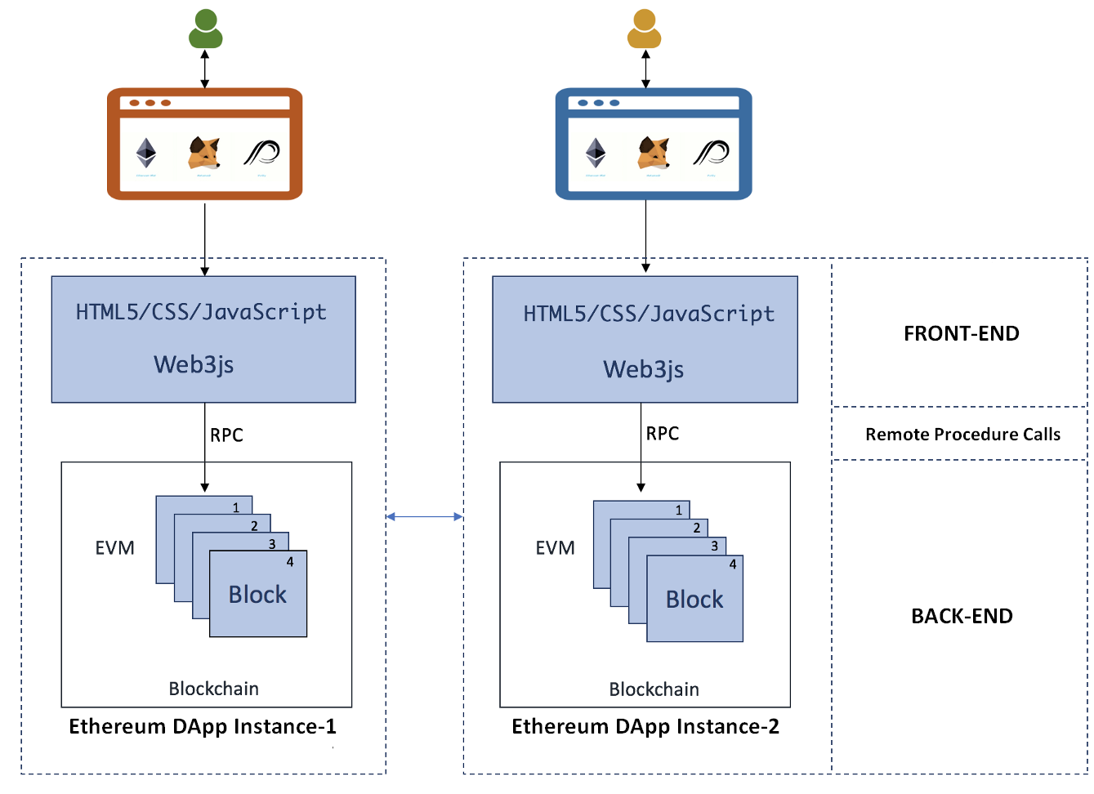

Figure 2.2‑34. Core Components of Ethereum Decentralized Applications

##### **FRONT-END / CLIENT SIDE**

Front end of the Decentralized applications are typically created as web pages or desktop applications using JavaScript/HTML/CSS. It is used to handle with users inputs and display responses from the Back-end (or Ethereum Blockchain). Since there are several JavaScript frameworks, developers feel free to use any of JavaScript frameworks they want.

Web3.js is a JavaScript API that allows clients to interact with the Blockchain, including making transactions and calls to smart contracts. This API abstracts the communication with Ethereum Clients, allowing developers to focus on the content of their application. Developers must have a Web3 instance imbedded in their browser to do so.

##### **RPC**

In distributed computing, a remote procedure call (RPC) is when a computer program causes a procedure (subroutine) to execute in a different address space (commonly on another computer on a shared network), which is coded as if it were a normal (local) procedure call, without the programmer explicitly coding the details for the remote interaction. That is, the programmer writes essentially the same code whether the subroutine is local to the executing program, or remote. This is a form of client–server interaction (caller is client, executor is server), typically implemented via a request–response message-passing system.

Remote procedure calls (or RPC) in Ethereum platform is a connection between a local computer and Ethereum Blockchain. This connection can be archived easily by becoming a full-node of the network or just a light one. For most users, a light client along with its protocol is the best choice. The purpose of the light client protocol is to allow users in low-capacity environments (embedded smart property environments, smart phones, browser extensions, some desktops, etc) to maintain a high-security assurance about the current state of some particular part of the Ethereum state or verify the execution of a transaction. Although full security is only possible for the full nodes, the light client protocol allows light nodes processing about 1KB of data per 2 minutes to receive data from the network about the parts of the state that are of concern to them, and be sure that the data is correct provided that the majority of miners are correctly following the protocol, and perhaps even only provided that at least one honest verifying full node exists. This means that it doesn’t store all of the Blockchain data, and depends on asking the network for the data it needs every time.

##### **BACK-END / ETHEREUM BLOCKCHAIN**

Ethereum Blockchain and Smart Contracts act as the back-end logic and storage. A contract is written in Solidity, a smart contract language, and is a collection of code and data that resides at a specific address on the Ethereum Blockchain. It’s very similar to a class in Object Oriented Programming, where it includes functions and state variables. Smart Contracts, along with the Blockchain, are the basis of all Decentralized Applications. They are, like Blockchain, immutable and distributed, which means modifying them will be a stiffness if they have already deployed on the Ethereum Network. Fortunately, there are some ways to do that.

The Ethereum Virtual Machine (EVM) handles the internal state and computation of the entire Ethereum Network. Think of the EVM as a massive decentralized computer that contains “addresses” that are capable of executing code, changing data, and interacting with each other. Thus, hard forking the whole system will eventually resulted in our desirable outcome. Unfortunately, controlling a large proportion of nodes and convincing them hard-forked along with their satisfaction is a bit difficult.

The Figure 2.2‑35 below illustrates an Ethereum fully decentralized application.

* The Compiled Contract's ABI formatted as JSON are stored on Swarm Decentralized Network. Clients use this ABI and the contract's address to interact with contracts in EVMs.
* The UIs, or Client Sides are served with IPFS (Inter Planetary File System).
* The HTTP Provider serving as an Ethereum Node or EVMs to execute transactions.

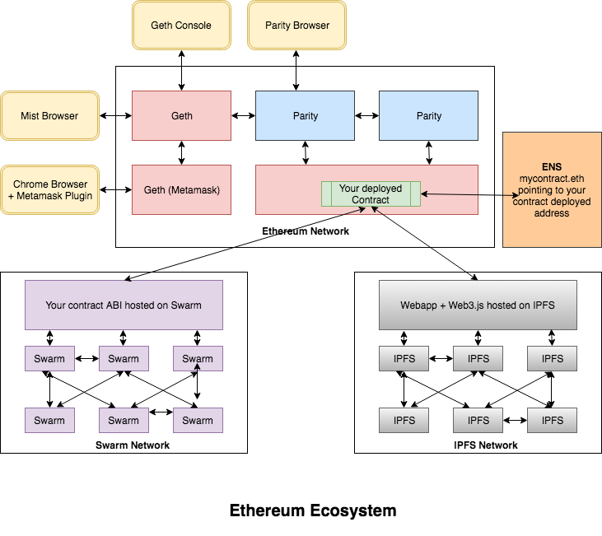

Figure 2.2‑35. Ethereum Fully Decentralized Applications

# SYSTEM REQUIREMENT

## System Description

* Since the database is a special one, Ethereum Blockchain, the main requirement of the system must reach these criterions:
* The system must be connected to the Ethereum Blockchain test network, in this thesis paper, Ropsten..
* The system must be implemented to work along with Wallet Provider for better user's experiences, in this thesis paper, MetaMask - a Chrome Extension.
* The system must be injected with dependencies to interact with Ethereum Blockchain network, in this thesis paper, Web3JS.
* User Interfaces must be clear, simple, intuitive and responsive to help users finish the task with less effort and time, thus Single Page Application (SPA) is applied for Client Side in this thesis paper.
* The performance of Client Side must be adaptive to the drawback of SPA, thus in this thesis paper, Server-Side Rendering for Client is applied.
* APIs must be simple to store compiled Ethereum contracts as JSON format, thus ExpressJS is applied for Server Side in this thesis paper.
* User will no longer afraid of tampered data, scammers or fake commitments since the Ethereum Blockchain will tracking their properties ownership autonomously.

## System Use Cases

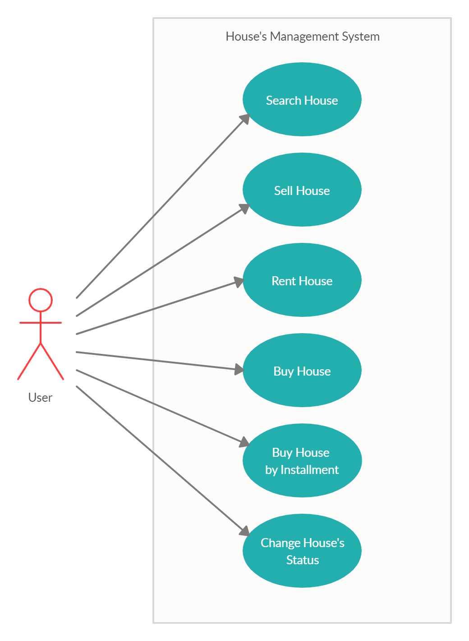

Figure 3.2‑1. System Use Cases

## System Functionality

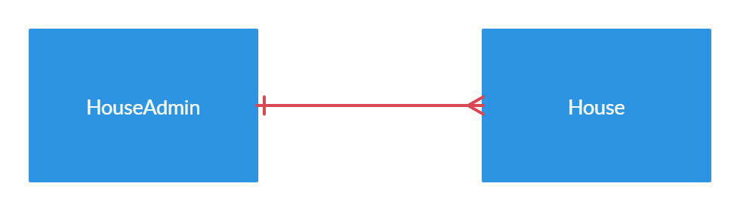

Figure 3.3‑1. System's Entity Relationship

The functionality of the system is described as Table 3.3‑1 below

|  |  |  |
| --- | --- | --- |
|  | Function | Description |
| Front-End / Client Side | Searching house with different categories | Allow user to filter the houses matched requirements |
| Selling house with custom input | Allow user to sell house with custom house's information |
| Renting house by pre-defined time | User could rent a house for a time of 3 / 6 / 9 months |
| Buying house immediately | User could buy the house immediately by fully payment |
| Buying house by instalment | User could buy the house partially overtime of 3 / 6 / 9 months by instalment |
| Changing house's status | User could change the house's information and status, which stop house from being into new transaction |
| Back-End / Server Side | Compiling all Solidity Contracts | Compiling all Ethereum Contracts and exporting output as JSON format |
| Deploying Admin Contract to Ethereum test net | Deploying the Administrator Contract that tracking address of all House Contract |
| Response JSON Contracts to Client Side | Response compiled House, HouseAdmin contract and its address as HTTP response. |
| Ethereum Blockchain | Managing all Houses contract | Buying house or Selling house property is forwarded to HouseAdmin contract |
| Tracking for the existence of all houses |
| Verify House's Ownership | Always check for house's ownership when performing any transactions. |
| Executing Client Side RPC request | Internally executing Client Side Requirement as Client sends transaction to Blockchain Network using its injected RPC, or Web3JS |

Table 3.3‑1. System's Functional Description

## System Workflow

The Figure 3.4‑1 below illustrates the main workflow of the system.

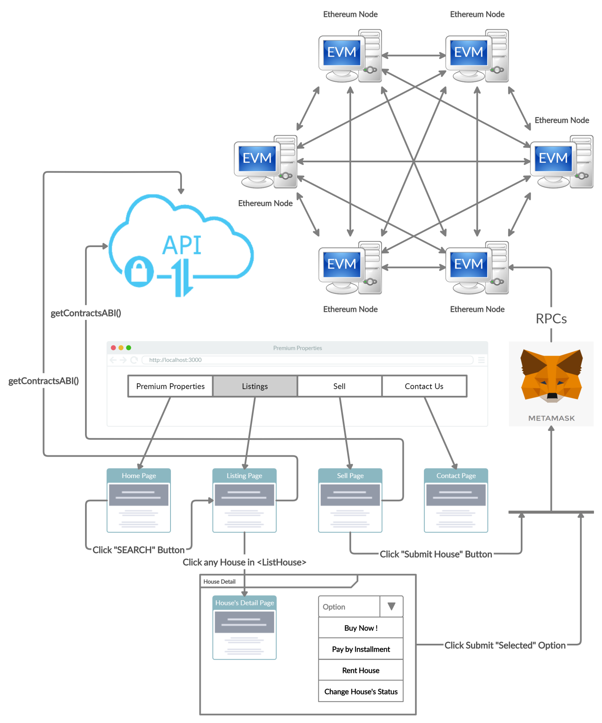

Figure 3.4‑1. System's Workflow

The next 6 figures below illustrate sequence diagram for each of the use case, or else, each of the different buttons the Workflow above, which are [Search, Submit House, Buy Now, Pay by Installment, Rent House, Change House's Status].

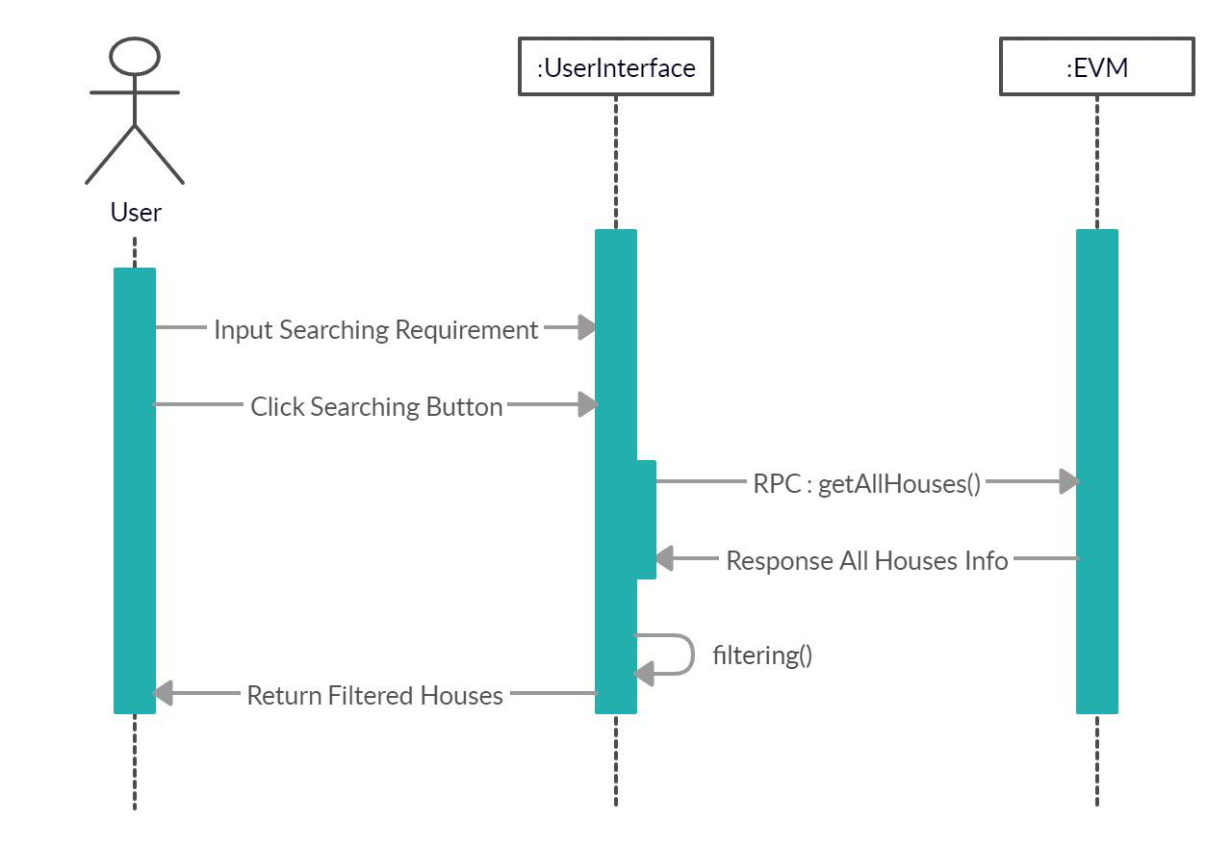

Figure 3.4‑2. Searching Houses - Sequence Diagram

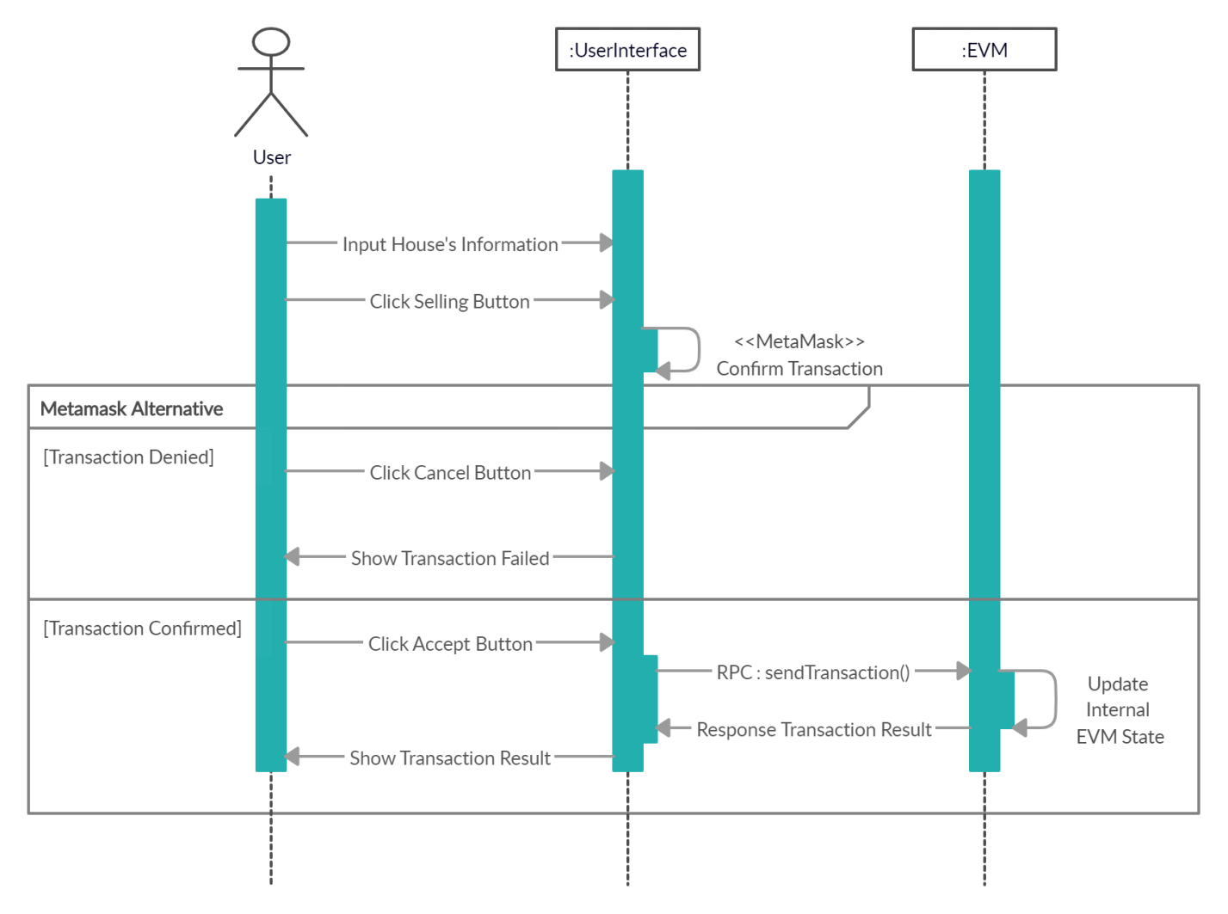

Figure 3.4‑3. Selling Houses - Sequence Diagram

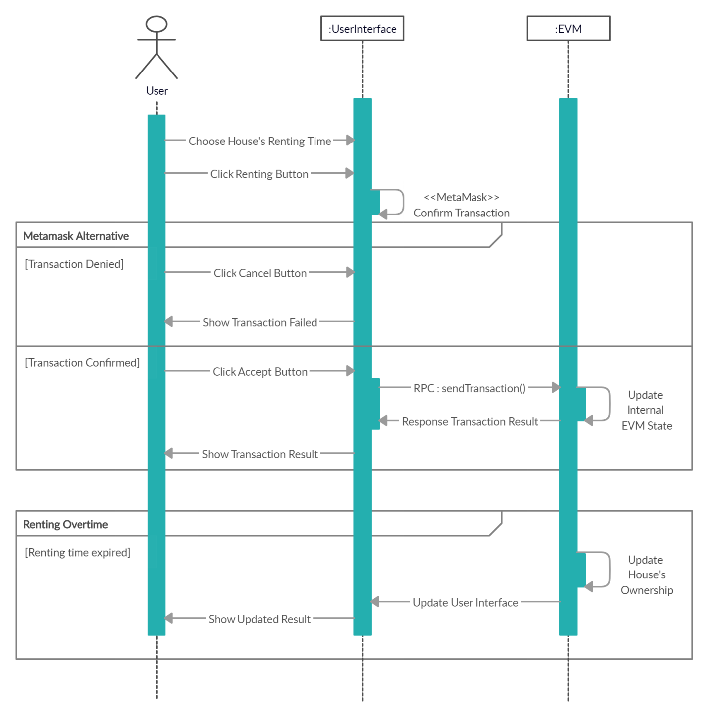

Figure 3.4‑4. Renting Houses - Sequence Diagram

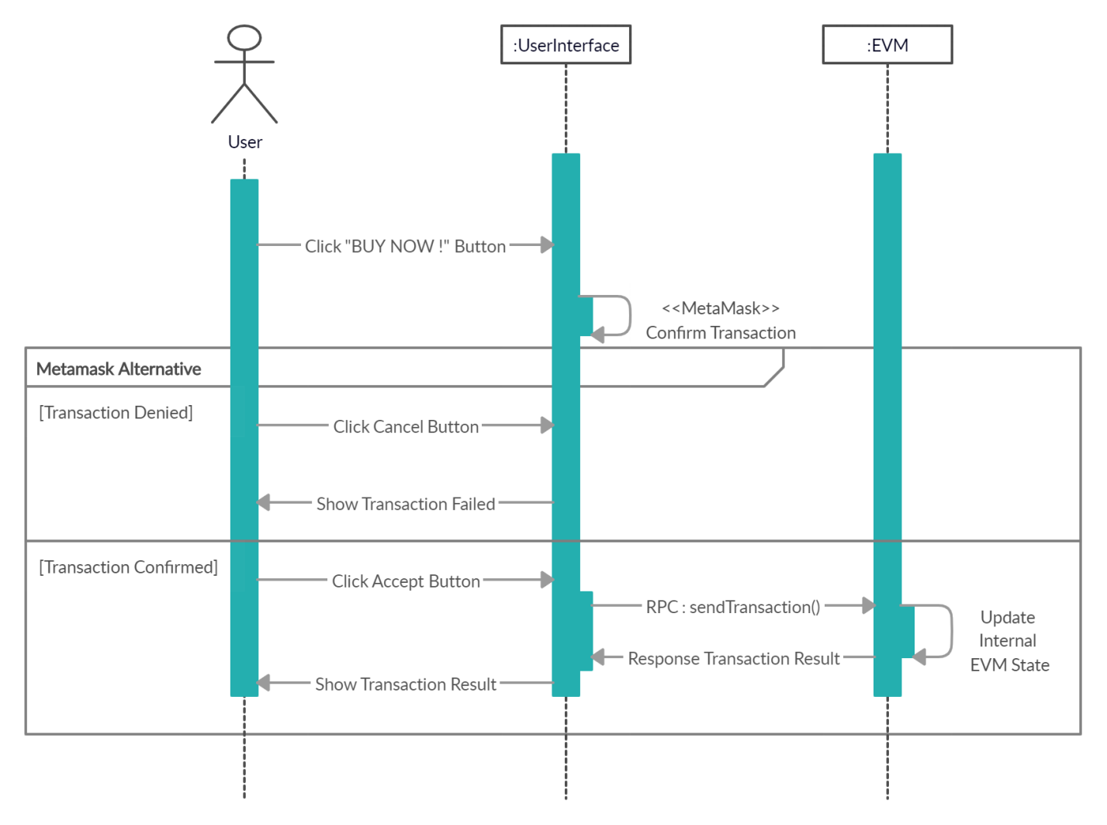

Figure 3.4‑5. Buying Houses - Sequence Diagram

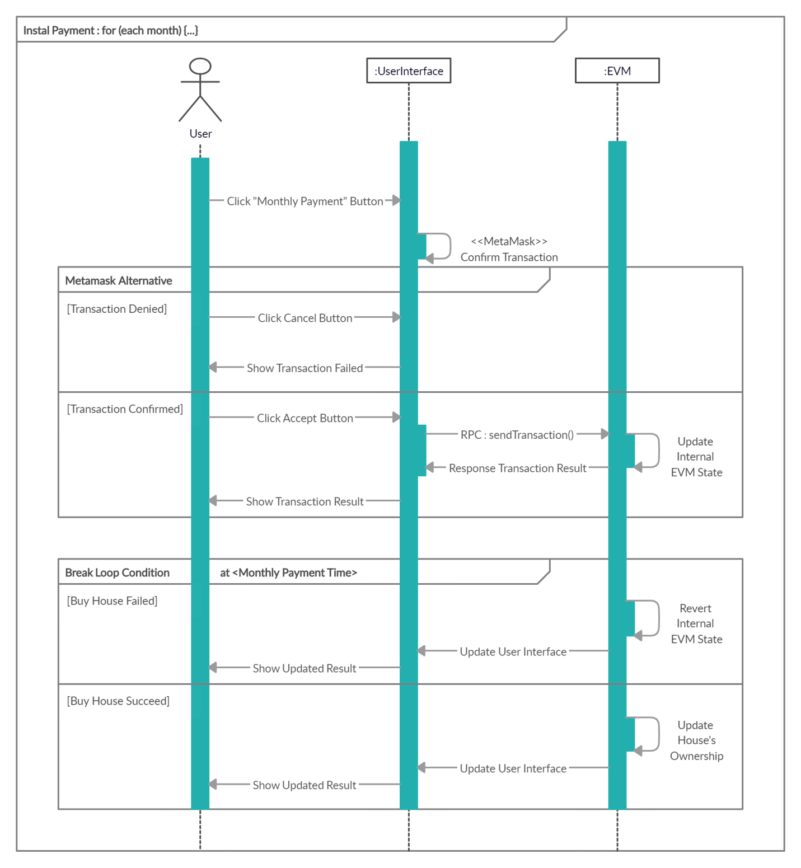

Figure 3.4‑6. Buying Houses by Installment - Sequence Diagram

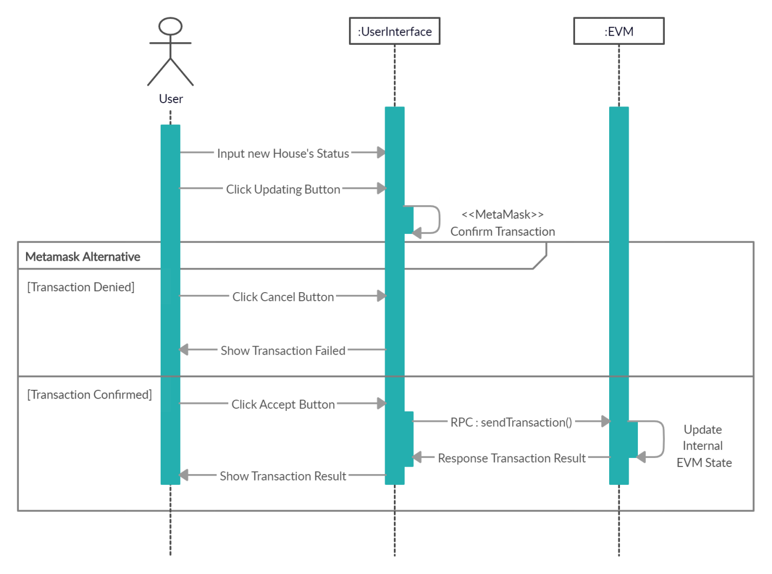

Figure 3.4‑7. Updating House's Status - Sequence Diagram

# SYSTEM ARCHITECTURE

## Overall Architecture

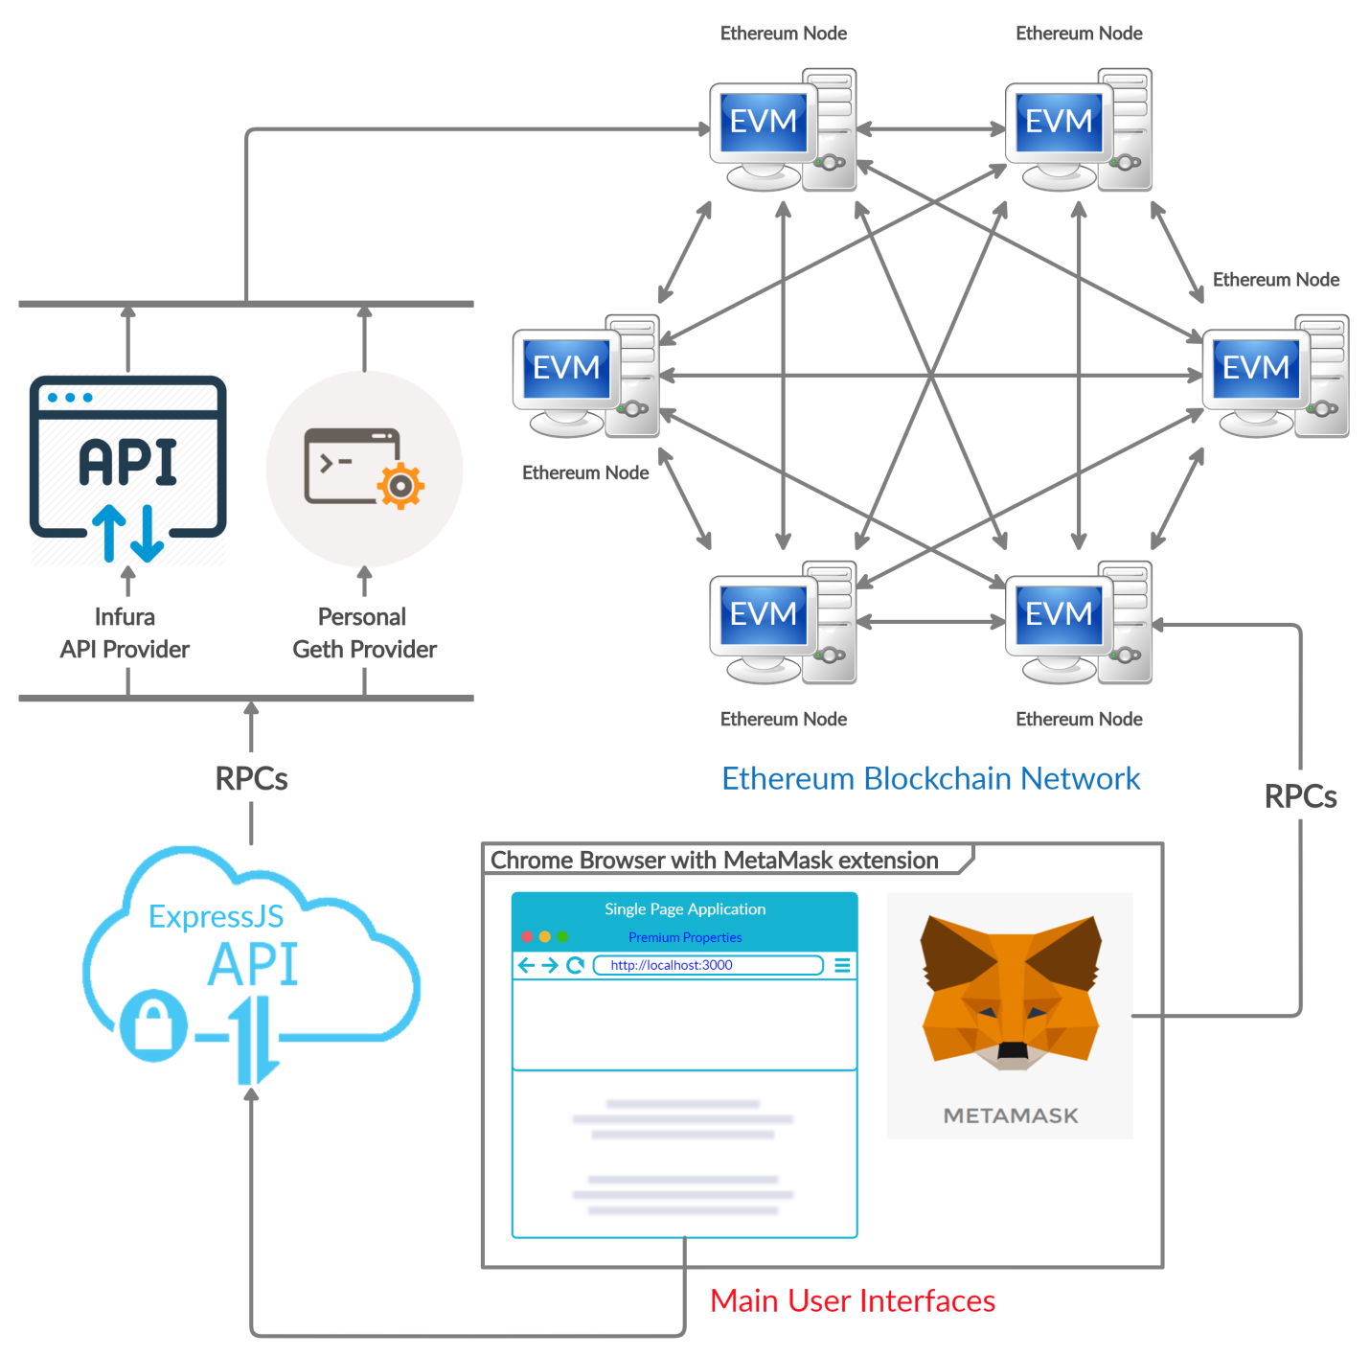

Figure 4.1‑1. System Overall Architecture

## Front-End / Client Side Architecture

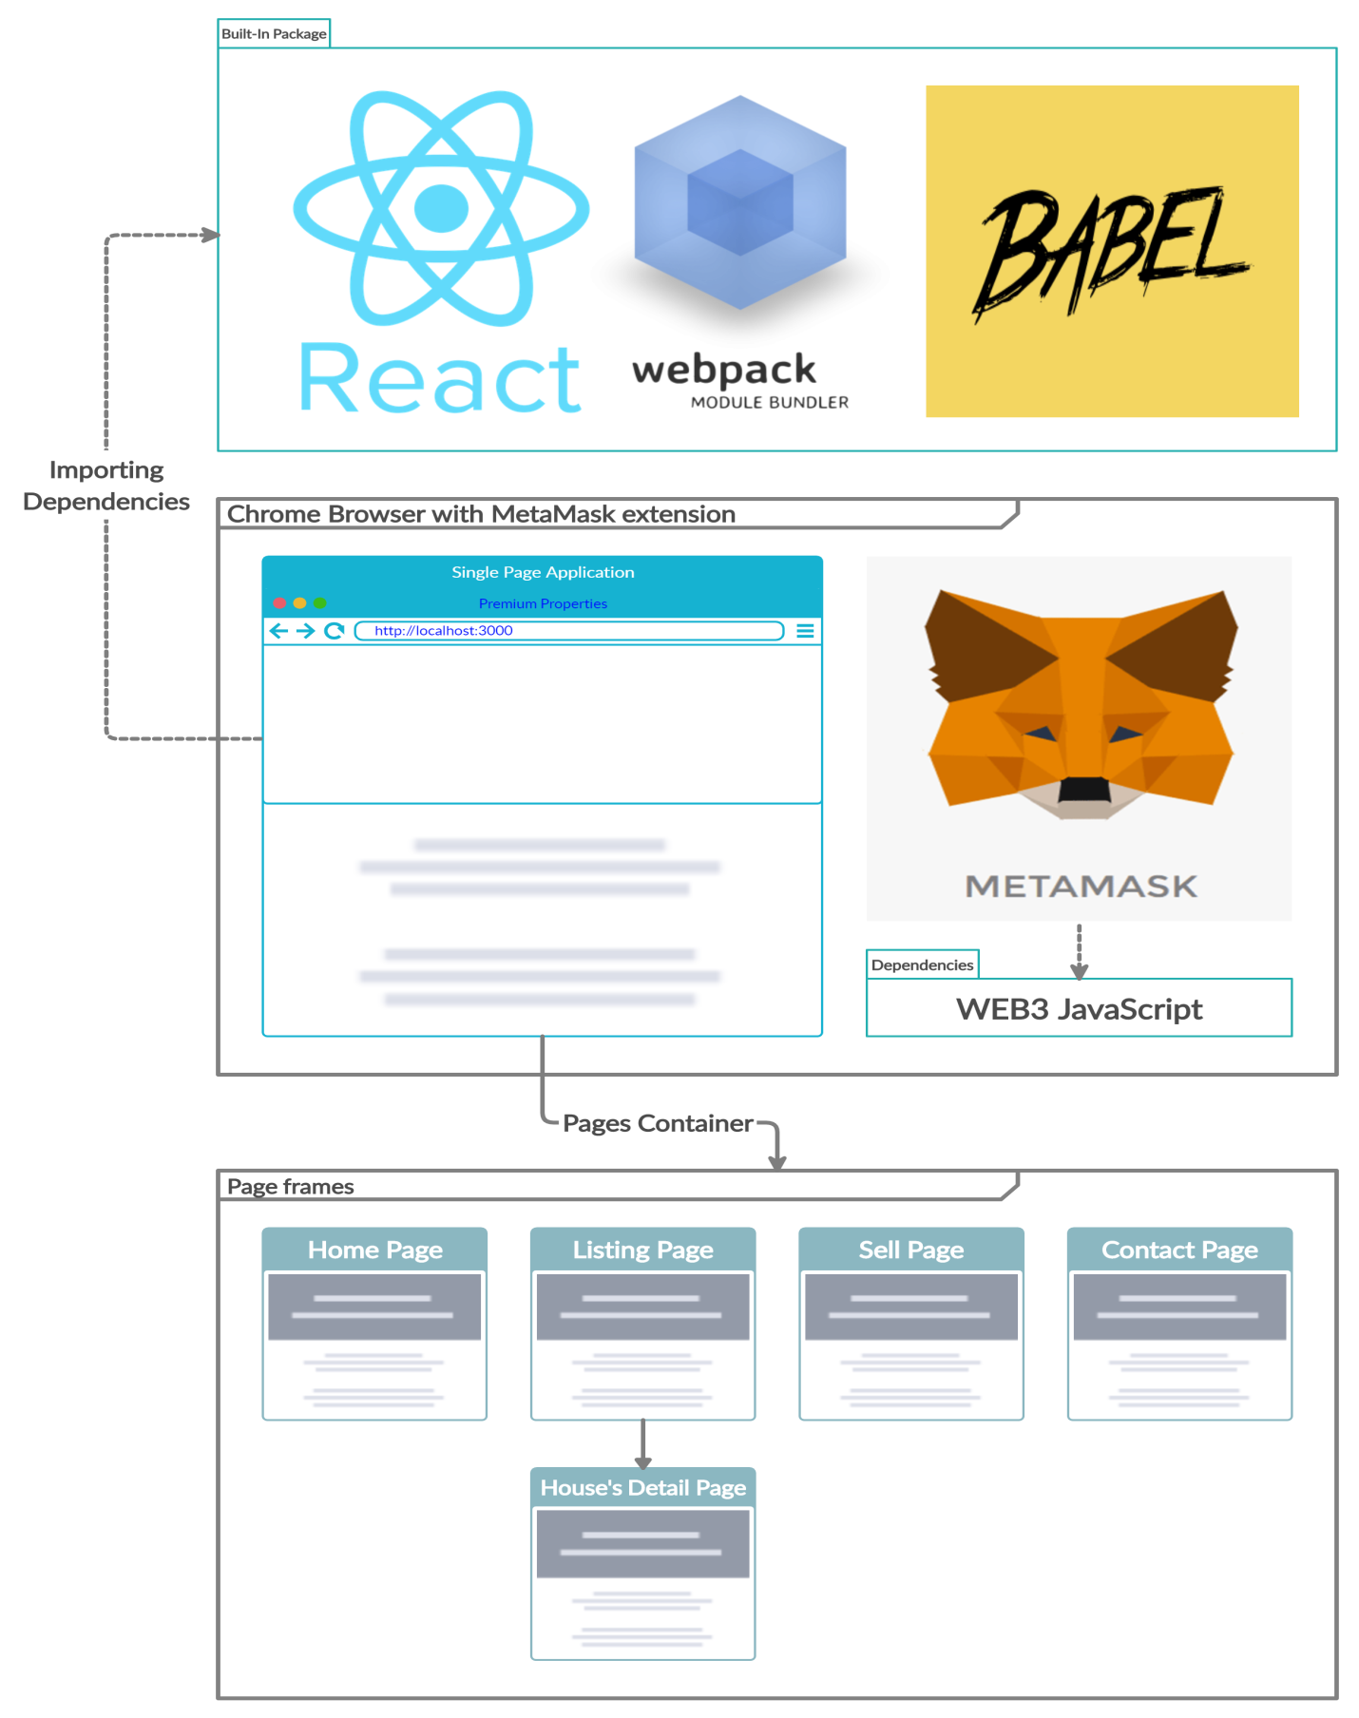

Figure 4.2‑1. Front-End / Client Side Architecture

## Back-End / Server Side Architecture

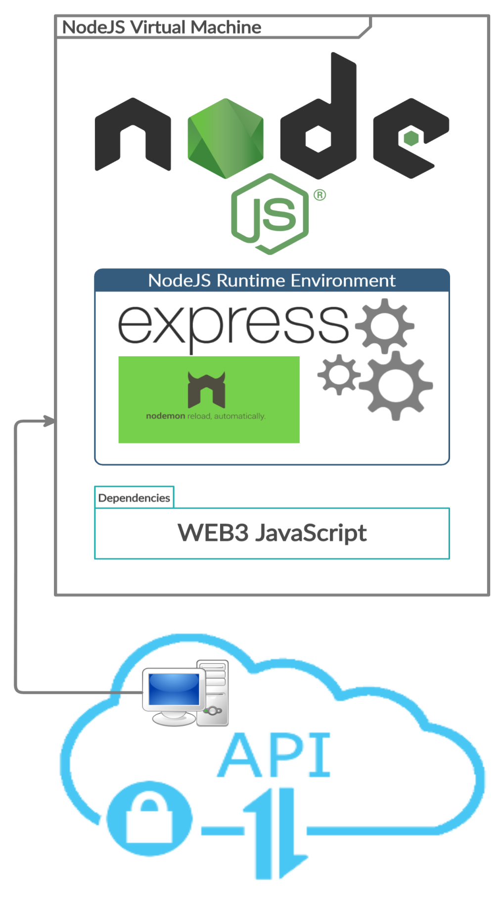

Figure 4.3‑1. Back-End / Server Side Architecture

## Blockchain / Database Architecture

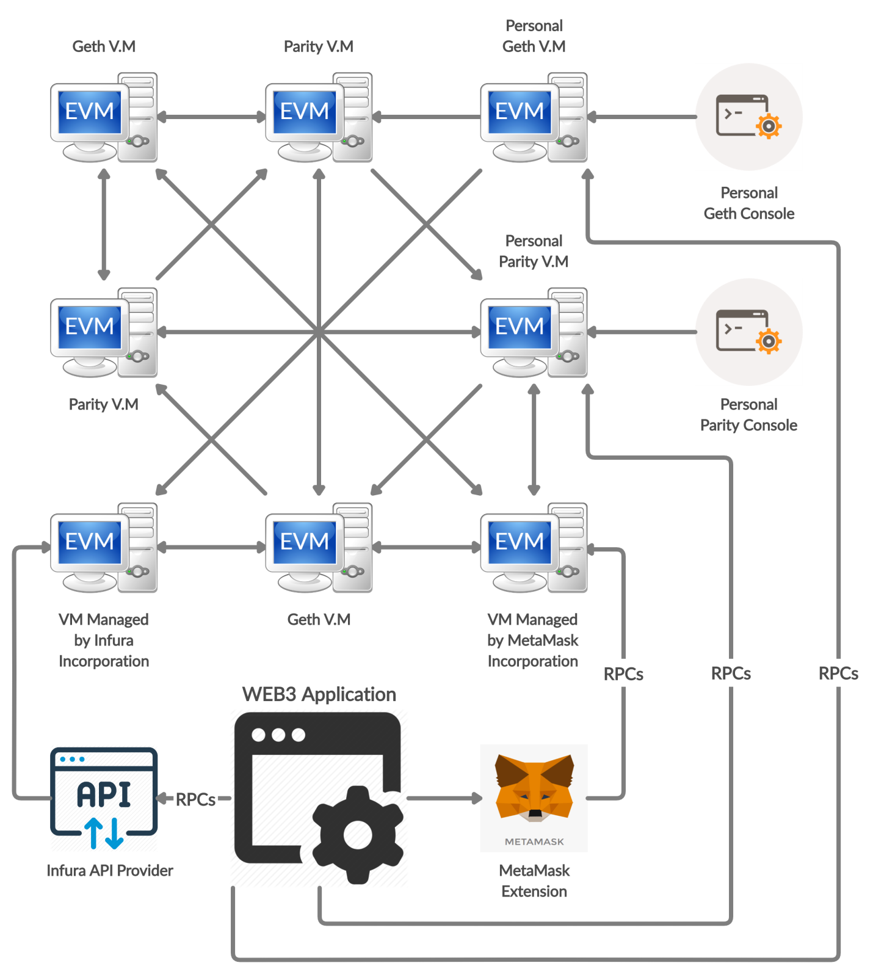

Figure 4.4‑1. Blockchain / Database Architecture

# SYSTEM DESIGN

## Front-End / Client Side

### User Interface (UI)

The User Interfaces included 5 main pages, which is illustrates as 5 figures below.

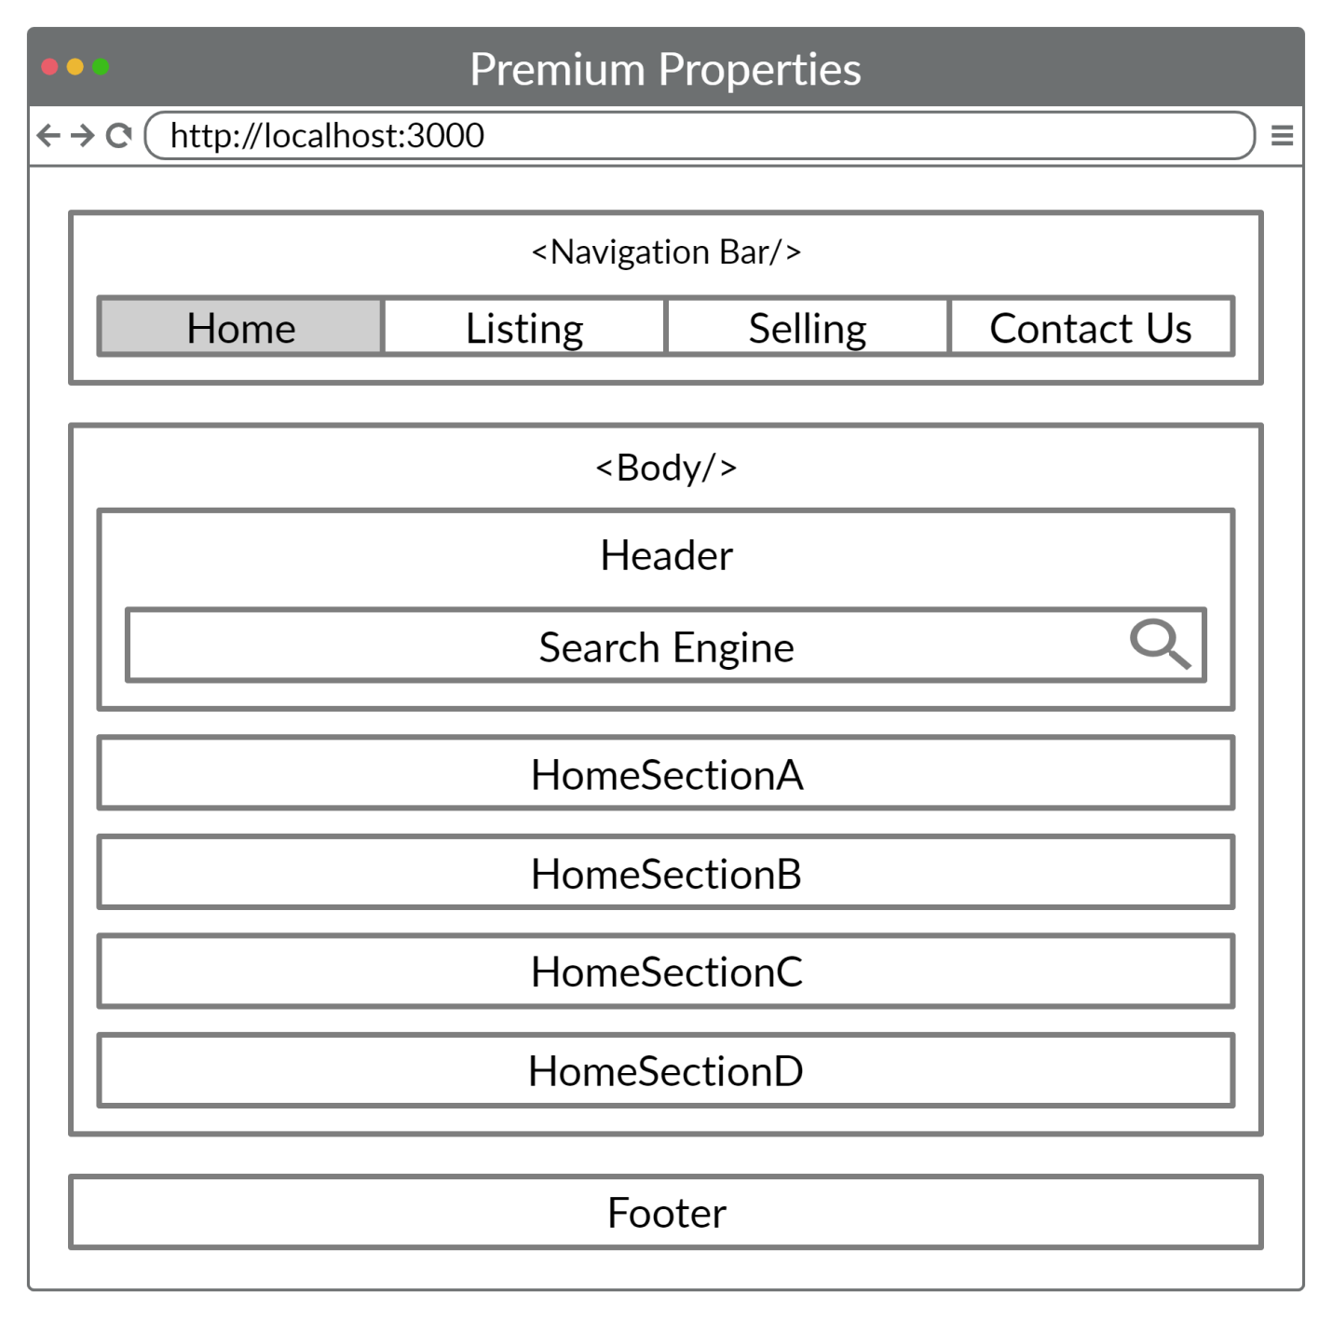

Figure 5.1‑1. Home Page

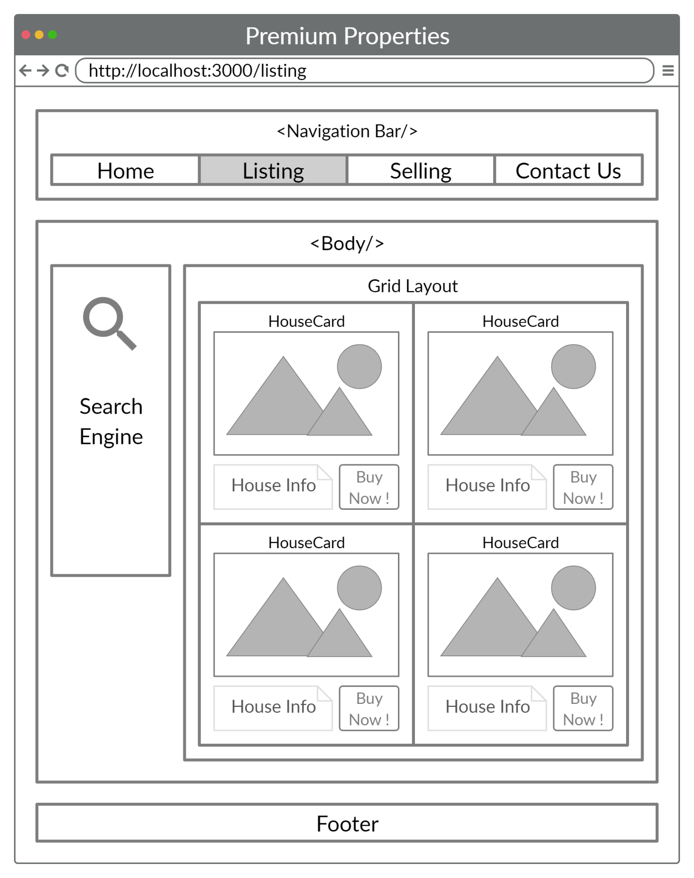

Figure 5.1‑2. Listing Page

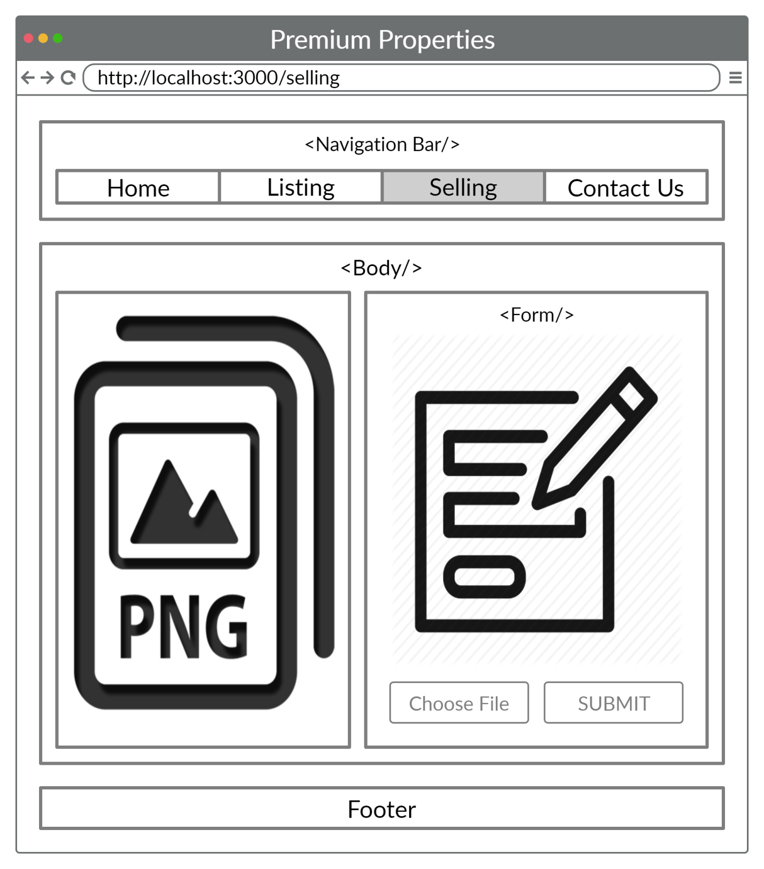

Figure 5.1‑3. Selling Page

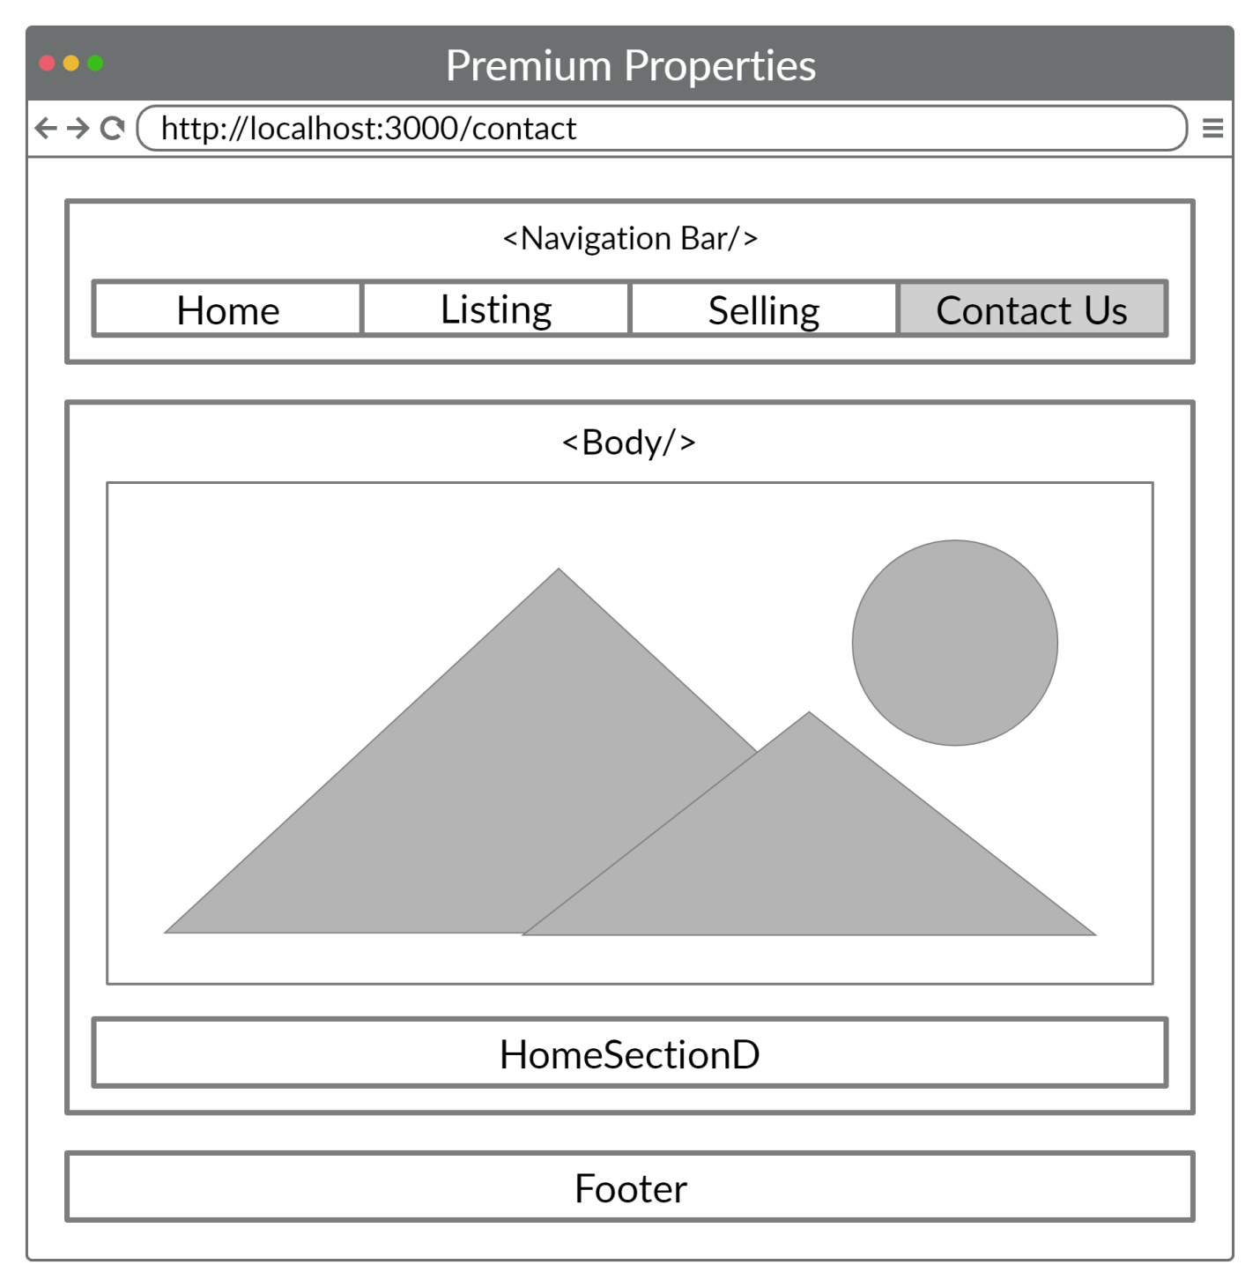

Figure 5.1‑4. Contact Page

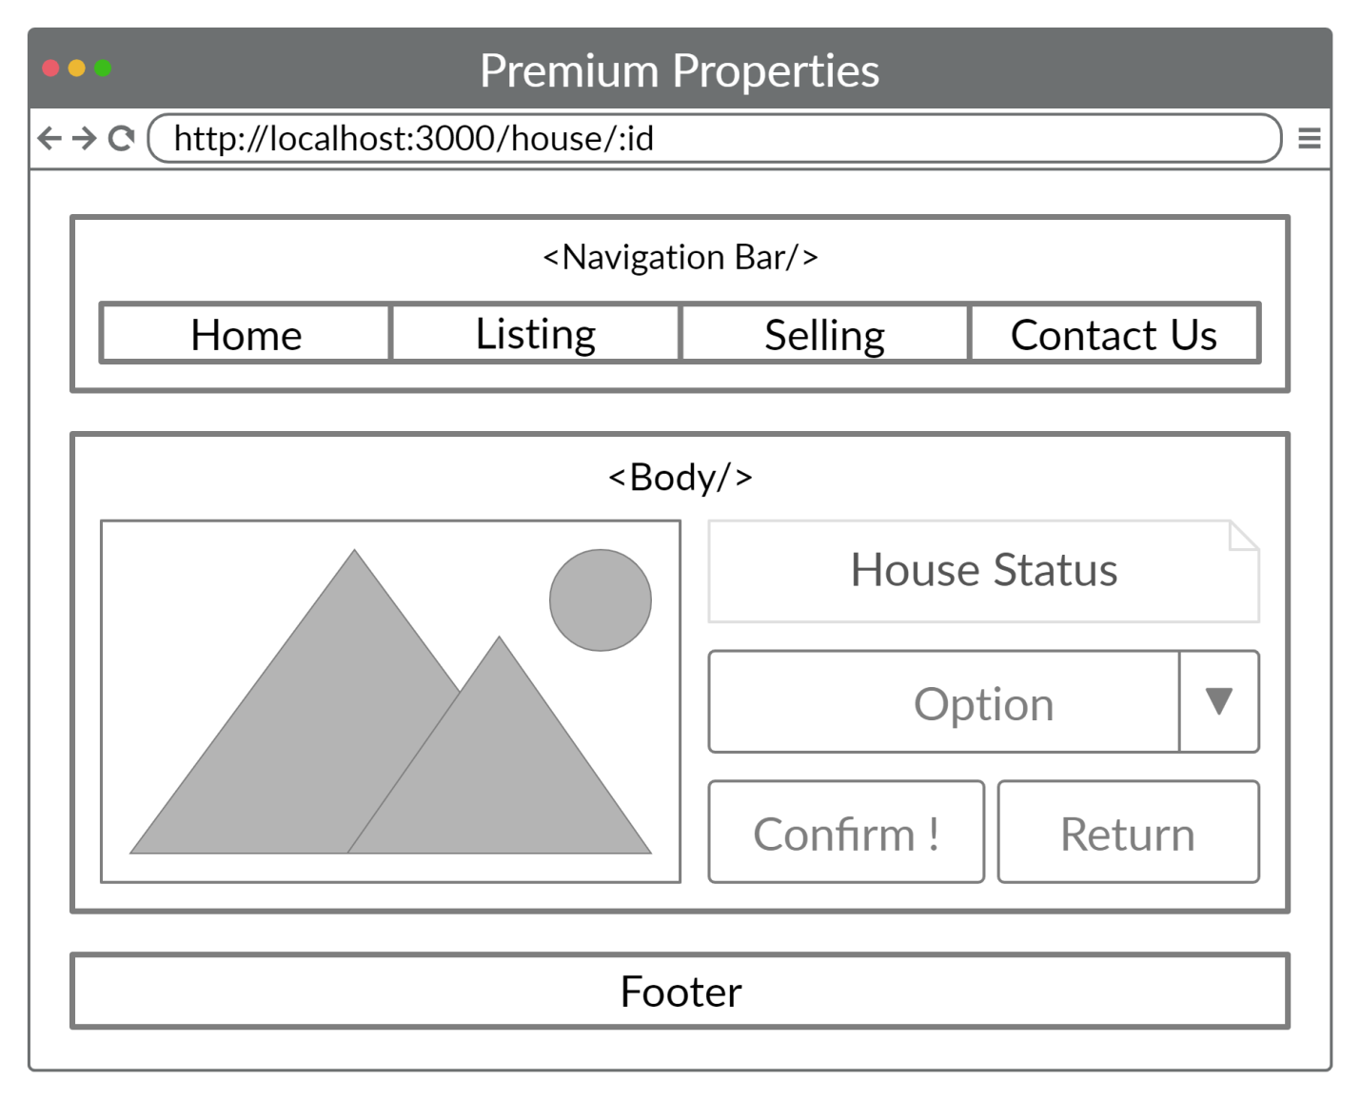

Figure 5.1‑5. House's Detail Page

### Ethereum Interaction

By installing MetaMask, the browser is automatically injected with Web3.js library and be ready to serve as a Web3 Application, hence users could easily interacting with Ethereum Blockchain Network through MetaMask.

Metamask will use Web3 object, which was injected to running environment as the browser started, to interact with the Ethereum Blockchain Network.

Please review part 2.2.4.11 - Ethereum' Workflow to understand the main flow of Ethereum Interaction between Developers / Users and Solidity Smart Contract.

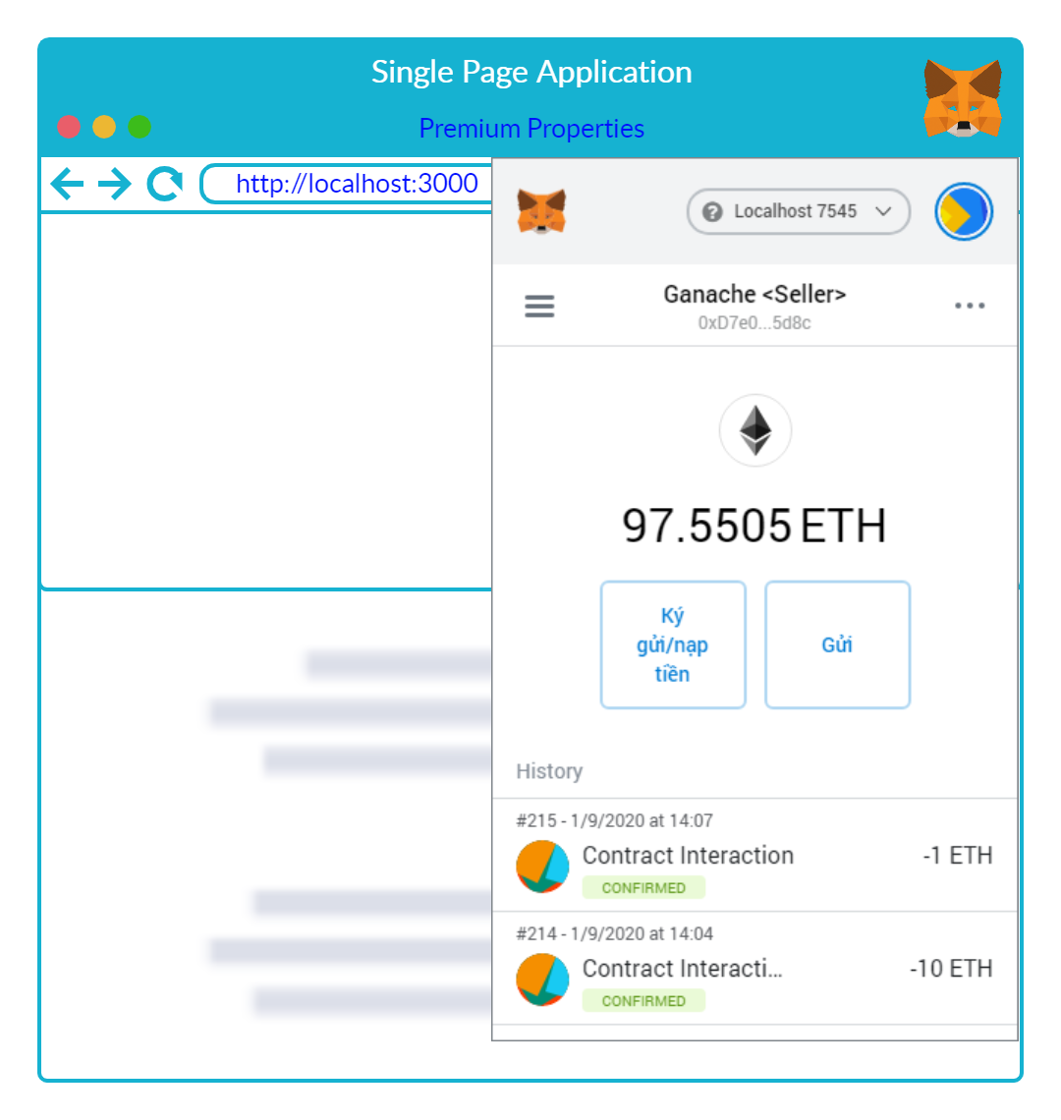

Figure 5.1‑6. Browser with MetaMask

Client-Side will wrap the Contract's ABI (JSON Formatted) and Contract Address (String) into new Web3.Contract object. Hence, the Clients can now interact with deployed contract using RPCs to the remote EVMs, or else, an Ethereum Node. See Figure 5.1‑7 below for a fully illustration.

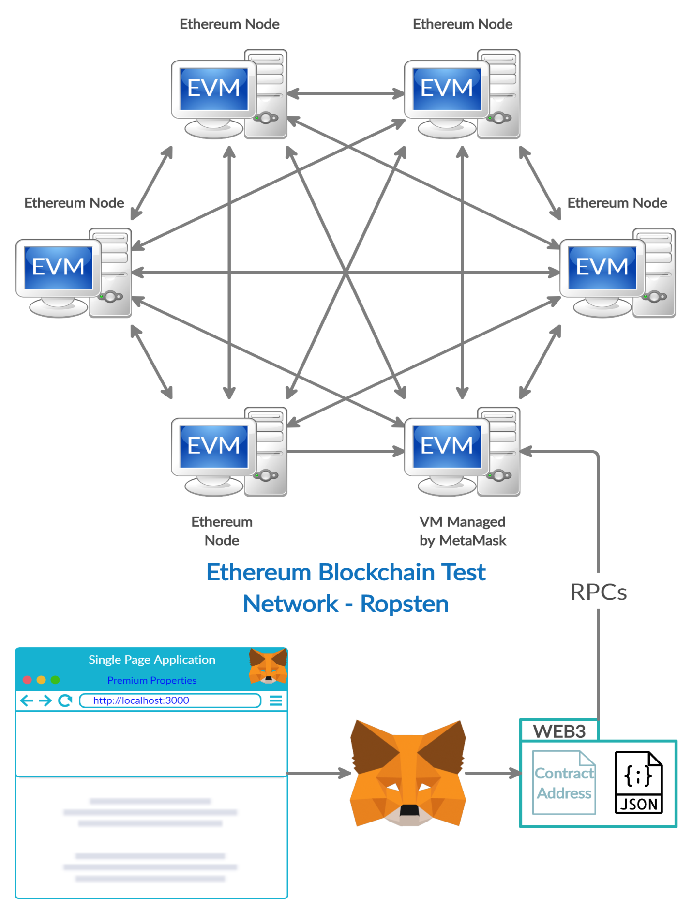

Figure 5.1‑7. Client-Side Interaction with Blockchain Network

## Back-End / Server Side

The Figure 5.2‑1 below shows the total functionality of the designed Express API. The API mainly store, compile and deploy Solidity Contracts to serve the Client Side, or else, to serve users at the end point.

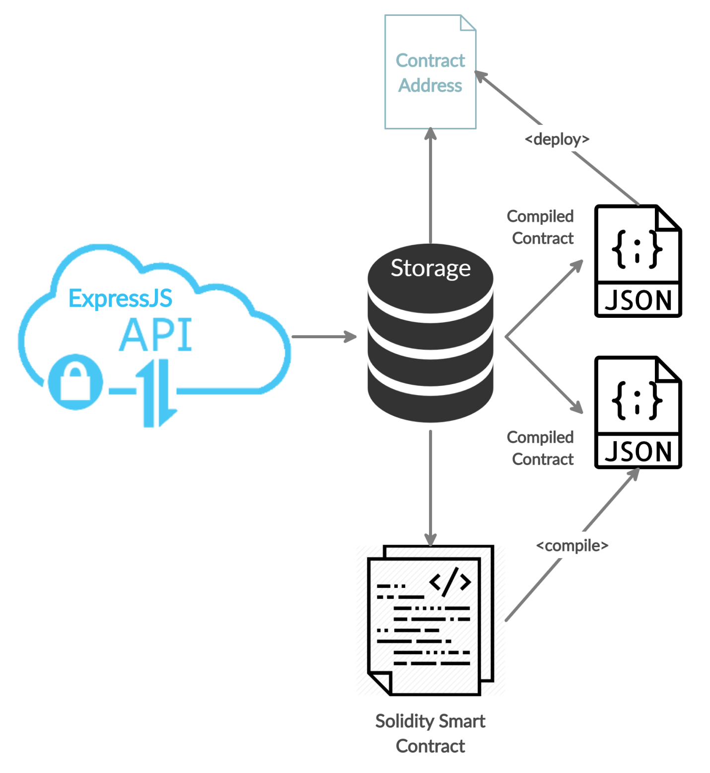

Figure 5.2‑1. Node-Server's Main Flow

### Application Programming Interface (API)

* The API must fulfil the System Requirement, which are:
* Compiling all Solidity Contracts
* Deploying Admin Contract to Ethereum test net
* Response JSON Contracts to Client Side

##### **NodeJS Server as Contract Compiler**

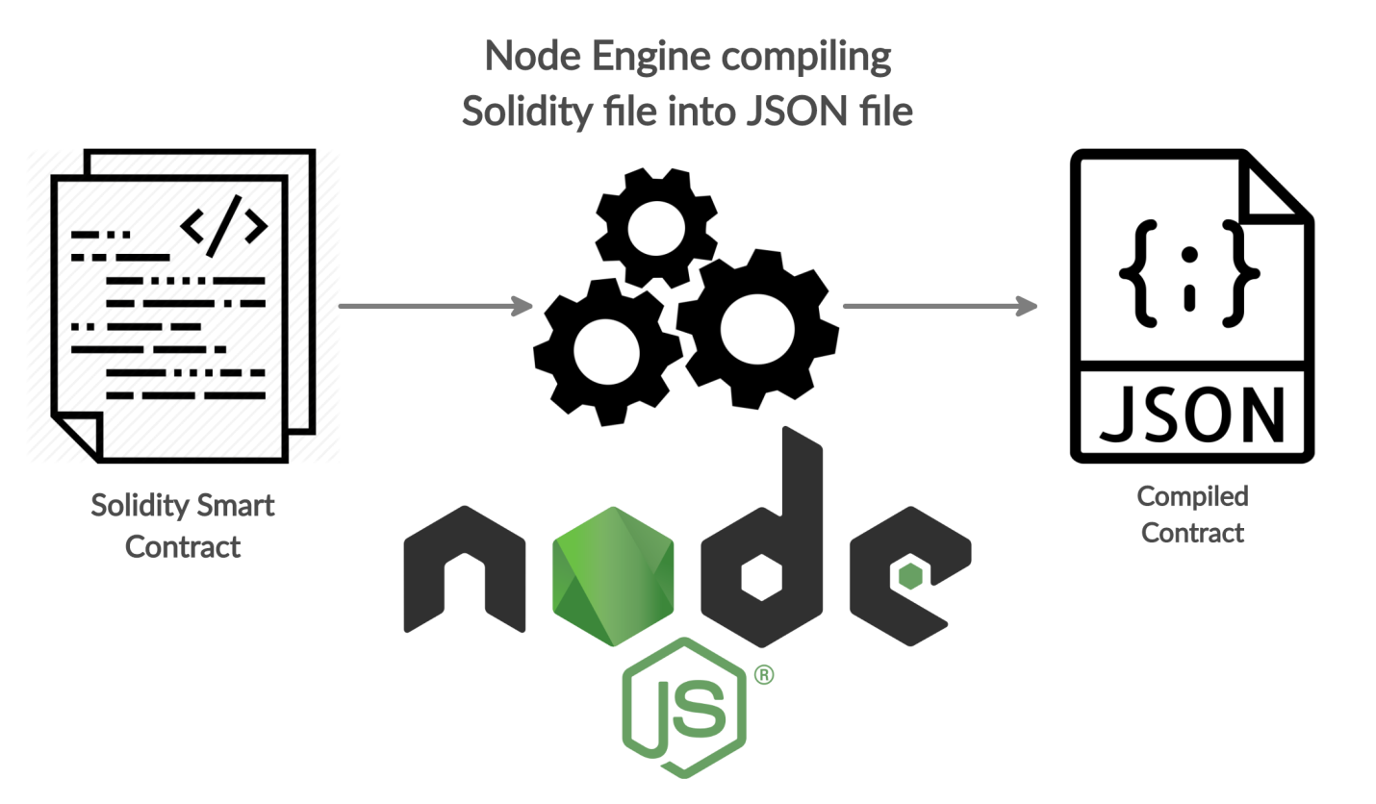

Figure 5.2‑2. Node-Server as Compiler

##### **NodeJS Server as Contract Deployer**

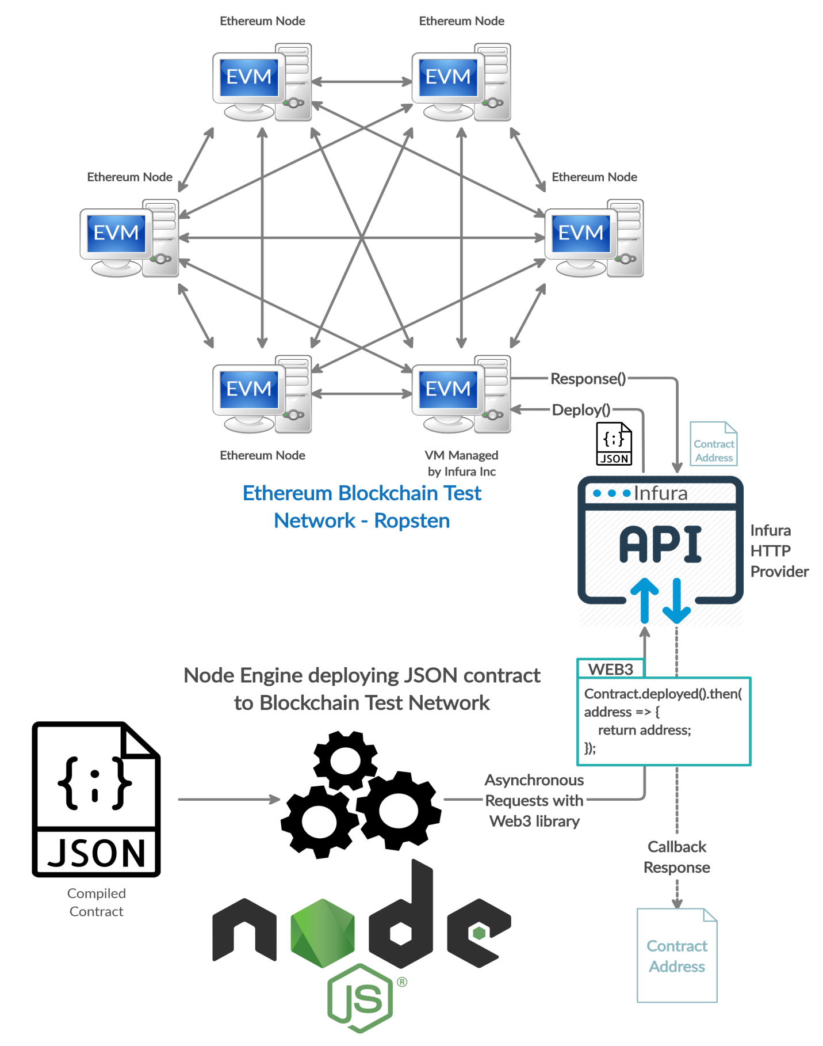

Figure 5.2‑3. Node-Server as Deployer

##### **NodeJS Server as JSON Contract Responder**

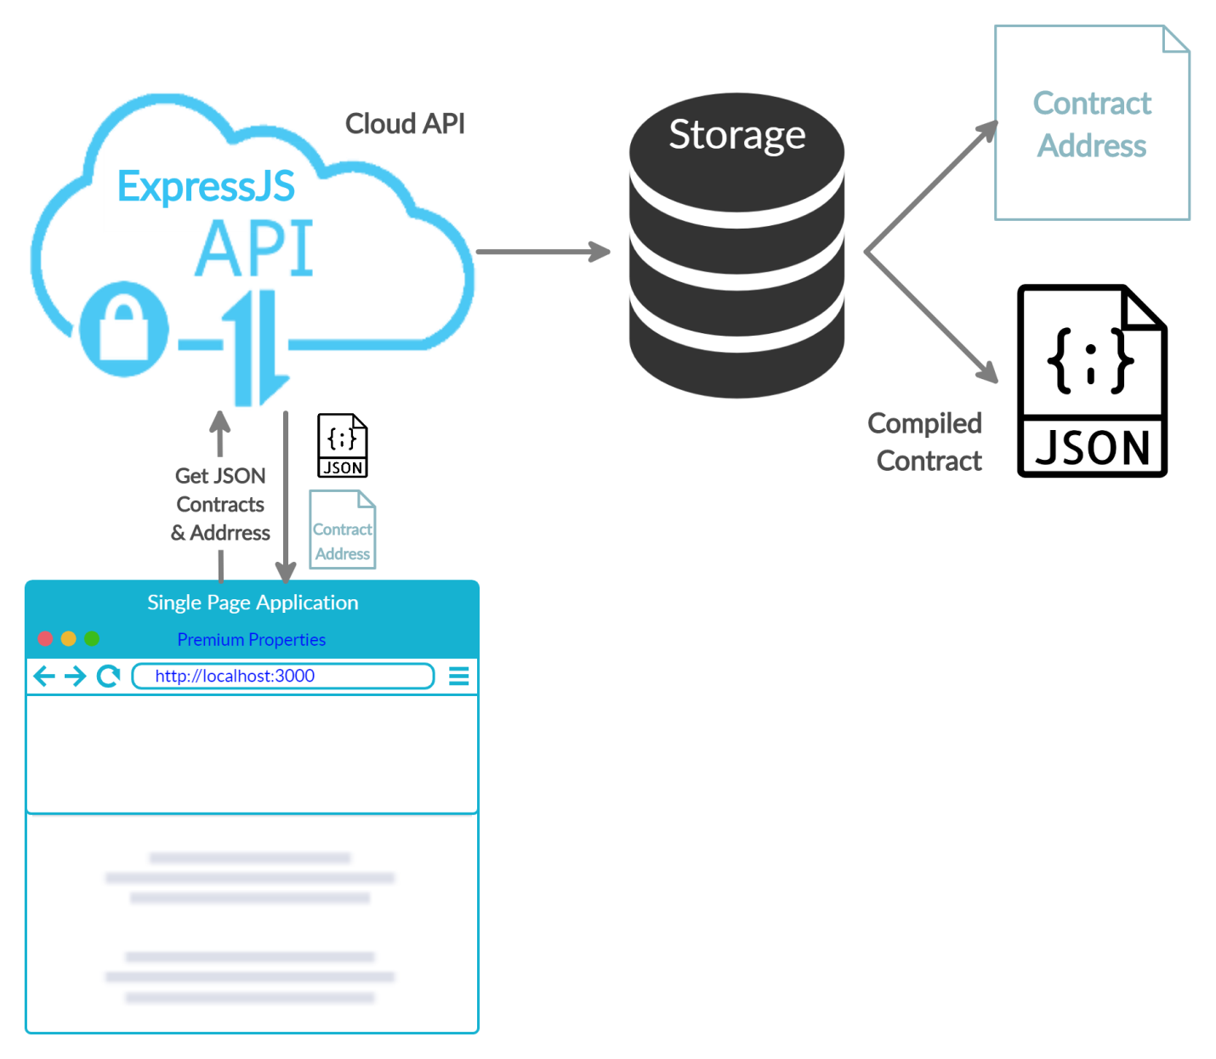

Figure 5.2‑4. Node-Server as Storage for Client Request

### Ethereum Interaction

The server mainly interacts with Ethereum Blockchain through Infura API Provider. Infura provides an EVM, or else, an Ethereum Node for developers to connect to the Blockchain Network.

See Figure 4.1‑1. System Overall Architecture, Figure 4.4‑1. Blockchain / Database Architecture and Figure 5.2‑3. Node-Server as Deployer to understand the main flow of Server Side with Infura HTTP Provider.

## Ethereum Configuration

### Ethereum Network

The network used is described in CHAPTER 3. System Requirement, which is Ropsten Test Net, which is using Proof-of-Work as the main Consensus Mechanism for the whole Network.

##### **Network Setting for Client Side**

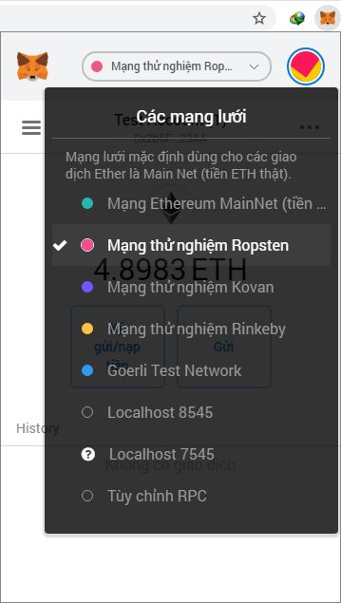

Figure 5.3‑1. MetaMask customs Ropsten Network

To deploy via Infura you'll need a wallet provider (like truffle-hdwallet-provider) to sign your transactions before they're sent to a remote public node. Infura accounts are available for free at: <https://infura.io/register>

##### **Network Setting for Server Side**

|  |  |  |
| --- | --- | --- |
| Ropsten Test Network | Value | Description |
| HTTP Provider | new HDWalletProvider(  String mnemonic,  String infura_key) | - mnemonic: the twelve word phrase the wallet uses to generate public/private key pairs.  - infura_key: HTTP Provider supported by Infura API to connect to an Ethereum Node managed by Infura. |
| Network ID | 3 | Ropsten's Id. |
| Gas | 5500000 | Ropsten has a lower block limit than main network. |
| Block of Confirmation | 2 | Number of confirmations to wait between deployments. (default: 0) |

Table 5.3‑1. Server Side customs Ropsten Network

### Ethereum Accounts

The accounts are freely generated using Hierarchical Deterministic Wallet technology [10].

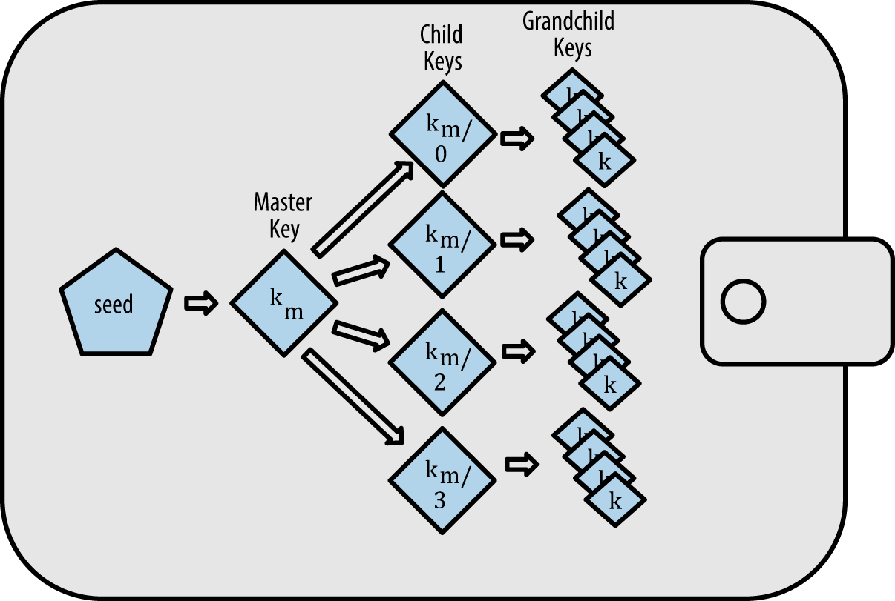

Figure 5.3‑2. HD Wallet Keys

The accounts used in this thesis paper are generated from the 12 random words. For example "eight one nine two eleven four three five six twelve seven ten". The amount of private keys, or accounts, can be created are up to 2 billion from just a small word phrase of 12 words.

### Smart Contracts' Structure

Since Smart Contracts are written in Solidity, a high-level Programming Language. It's possible to illustrate the relationship between classes with UML notation.

Each Smart Contract could be self-executed under Ethereum Virtual Machine when a signed transaction has been forward to any Ethereum Node. Thus update the EVM's internal data in a valid way and broadcast the transactions along with changed data under consensus mechanism.

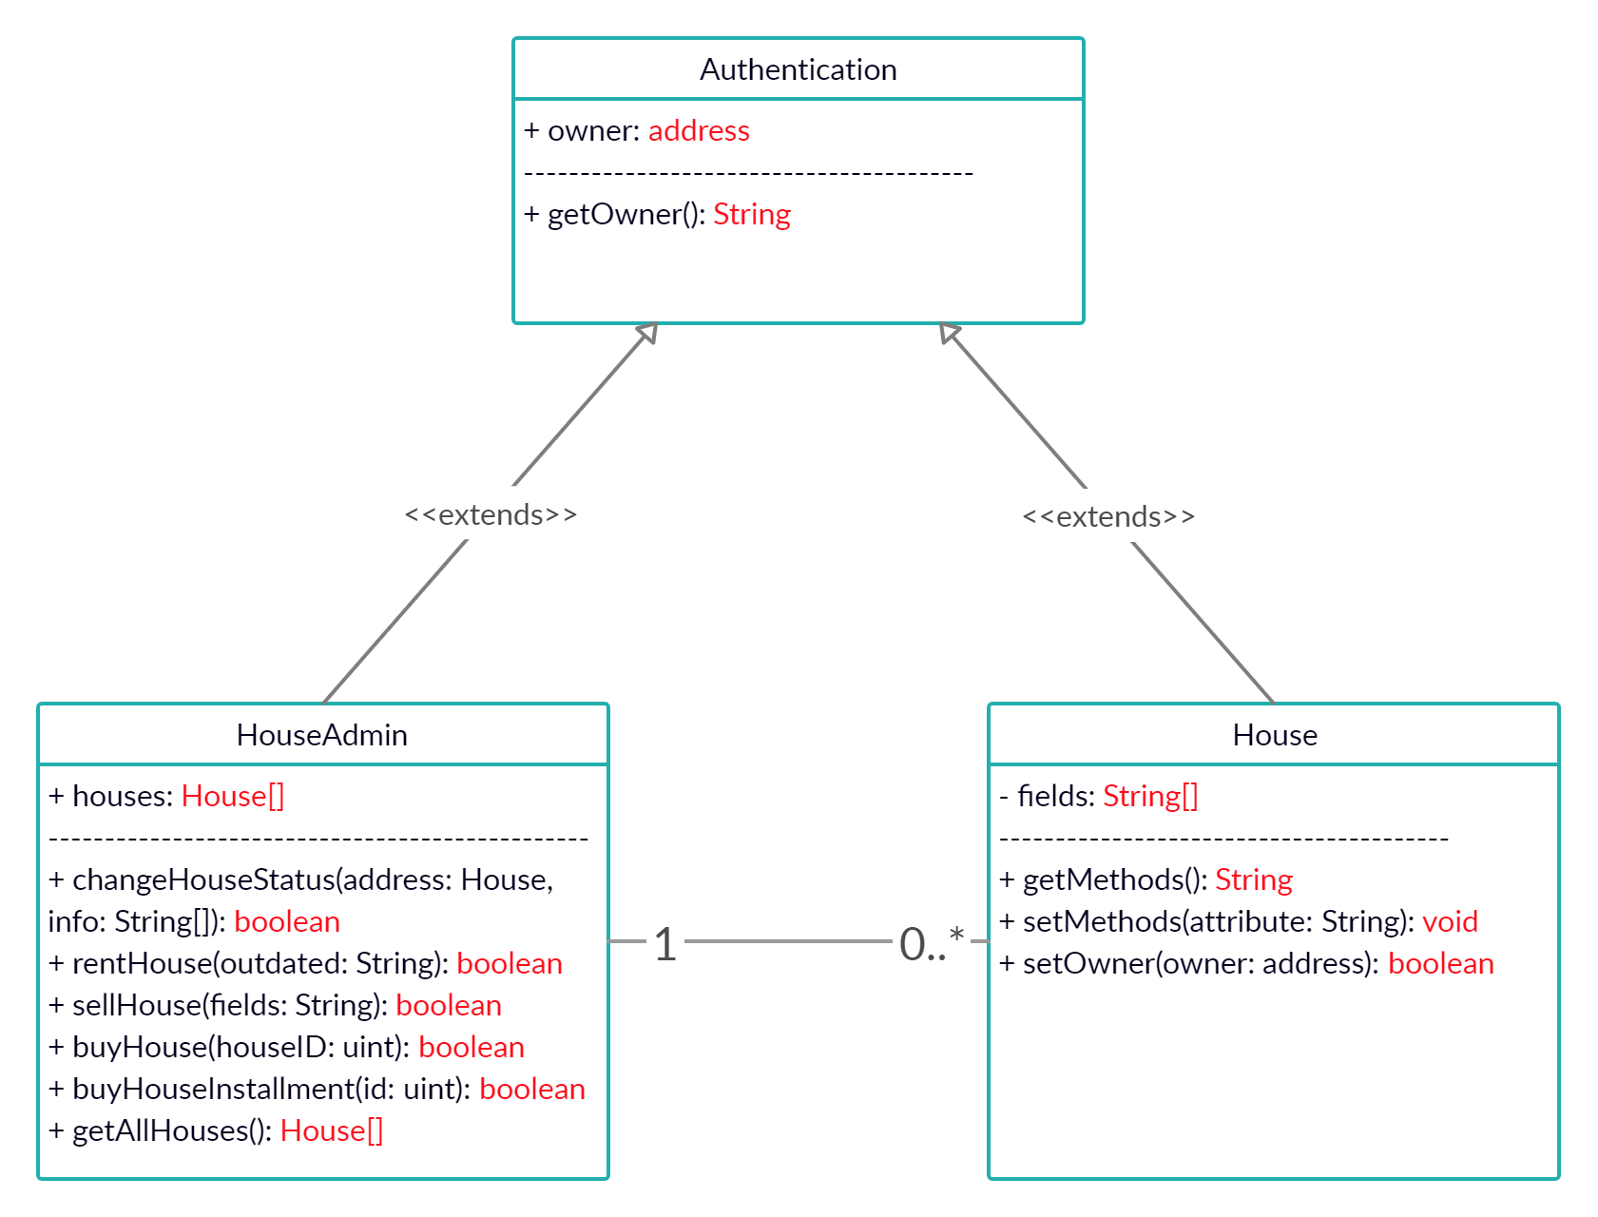

Figure 5.3‑3. Smart Contracts' Relationship

# IMPLEMENTATION

## Setup Environments

### Operating System

This implementation is based on Windows 7 Professional 64 bits.

##### **Windows Command Line Terminal**

Windows OS provides a command line interface (CLI), where you type commands to tell the computer what to do. Although using CLI will make your command executed faster rather than through any middle services, it requires a basic understanding in command prompt knowledge.

To open this CLI, click on Windows button, then type "cmd" inside searching box. When the program named "cmd.exe" appears, clicking on to open it normally or Run as administrator, which is your option.

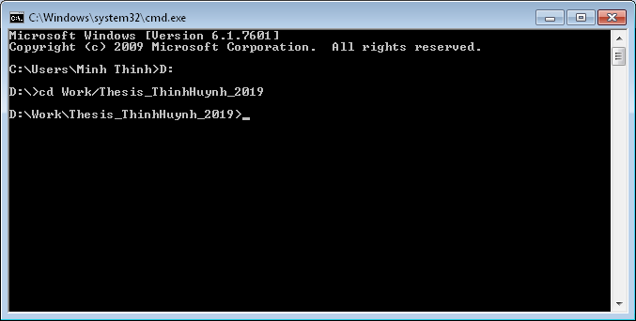

Figure 6.1‑1. Windows Command Prompt

After open the command prompt, change directory to your project using "cd" command. Firstly, type <D:> to move to disk D. Then cd to <Your_Project_Folder> as in Figure 6.1‑1 above.

* <D:>
* <cd Work/Thesis_ThinhHuynh_2019>

### Required Tools

The Figure 6.1‑2 below shows all contained folders inside <My_Project_Folder>, or else, <Thesis_ThinhHuynh_2019>.

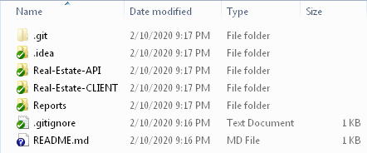

Figure 6.1‑2. Thesis Folder

#### NodeJS and NPM

Node.js is a software platform which helps to build asynchronous and event-driven network applications. It contains built-in HTTP server libraries which allow developers to create their own web server and build highly scalable web applications on top of it. Node.js is the first program to be downloaded since its provides the platform on which a Decentralized Application is built. It can be downloaded from the website:

<https://nodejs.org/en/download/>

After the download and installation, both node.js and npm are now running on your computer. Their version can be checked by issuing commands from the terminal as illustrated in the Figure 6.1‑3 below. Though there are 2 ways to specify the flag <-v> or <--version>.

* <node -v> || <node --version>
* <npm -v> || <node --version>

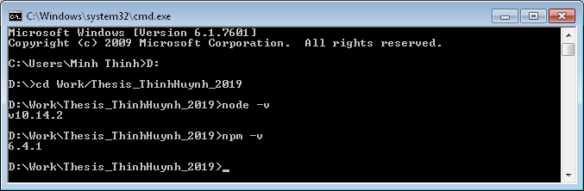

Figure 6.1‑3. Node & NPM Version

#### ReactJS with Babel and Webpack

Let first <cd> to <Real-Estate-CLIENT> and run <npm init -y>.

* <cd Real-Estate-CLIENT>
* <npm init -y>

The flag <-y> allows you to create an empty package.json file without input from the prompt.

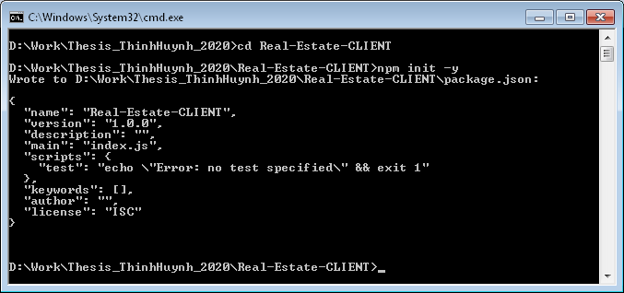

Figure 6.1‑4. NPM Initialization for CLIENT

Then, a file named package.json are create inside Real-Estate-CLIENT folder and the configuration is illustrated as Figure 6.1‑5 below.

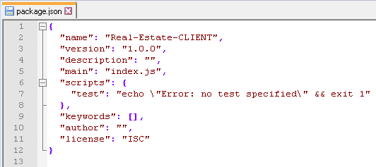

Figure 6.1‑5. CLIENT Package JSON (1)

After successfully created the json file, type the following command to the prompt. Wait until the installation done after each command.

* <npm install @babel/core@7.2.0 --save-dev>

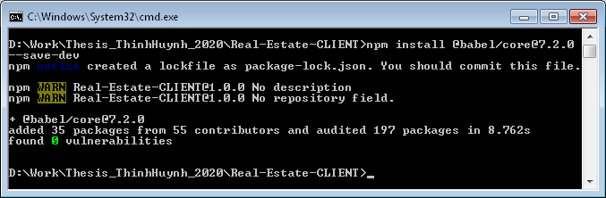

Figure 6.1‑6. NPM Install --save-dev for CLIENT

Continue to run the following command in prompt.

* <npm install react@16.6.3 webpack@4.27.1 web3@0.20.0 --save>

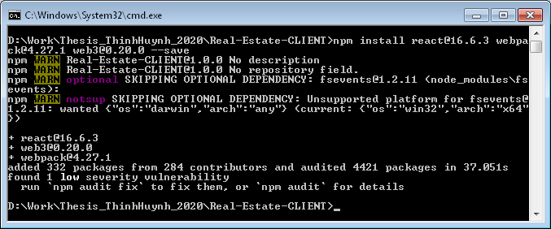

Figure 6.1‑7. NPM Install --save for CLIENT

The flag <--save> will let NPM knows to save the dependency's version into package.json file. And the flag <--save-dev> is to save the dependency into dev-dependency.

Now your package.json would look like the Figure 6.1‑8 below.

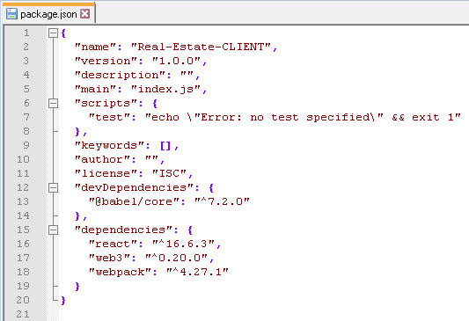

Figure 6.1‑8. CLIENT Package JSON (2)

Now let's specify some other dependencies in package.json as the Figure 6.1‑9 below.

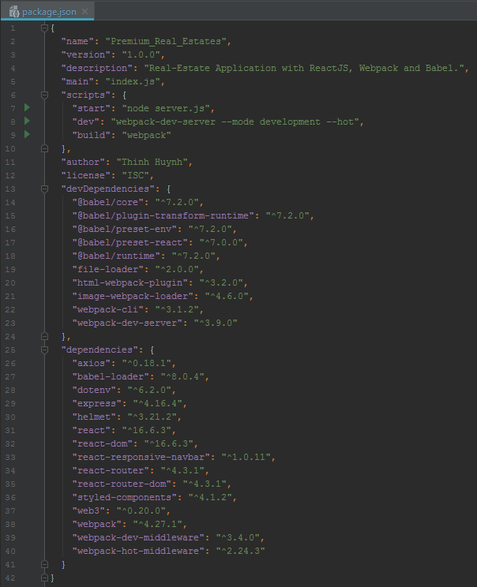

Figure 6.1‑9. CLIENT Package JSON (3)

Let's command the prompt again after updating other dependencies in package.json file.

* <npm install>

Then let's wait until all dependencies specified in package.json file are successfully downloaded into <YOUR_PROJECT_FOLDER>/Real-Estate-CLIENT/node_modules folder.

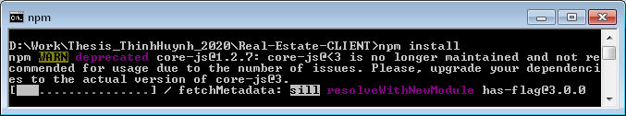

Figure 6.1‑10. NPM Install for CLIENT

#### ExpessJS with Nodemon

Let first <cd> to <Real-Estate-API> and run <npm init -y>.

* <cd Real-Estate-API>
* <npm init -y>

The flag <-y> allows you to create an empty package.json file without input from the prompt.

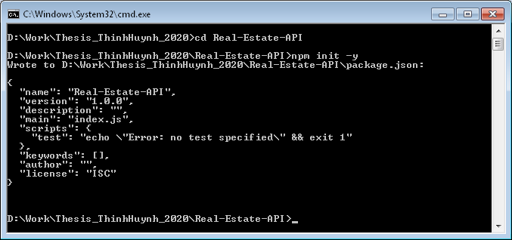

Figure 6.1‑11. NPM Initialization for API

Then, a file named package.json are create inside Real-Estate-API folder and the configuration is illustrated as the Figure 6.1‑12 below.

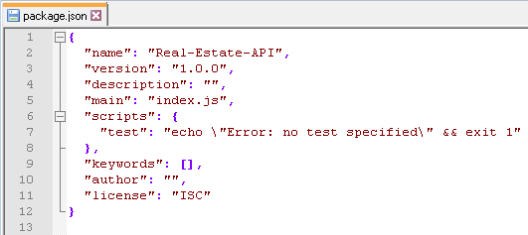

Figure 6.1‑12. API Package JSON (1)

After successfully created the json file, type the following command to the prompt. Wait until the installation done after each command.

* <npm install nodemon@2.0.2 --save-dev>

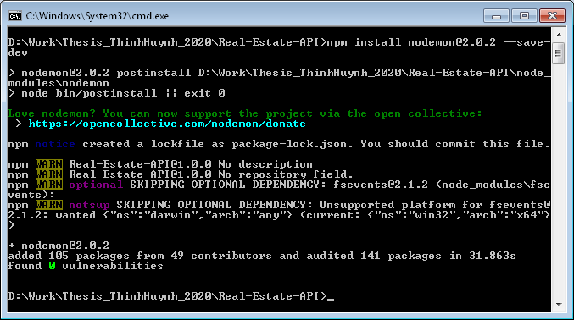

Figure 6.1‑13. NPM Install --save-dev for API

Continue to run the following command in prompt.

* <npm install express@4.16.4 --save>

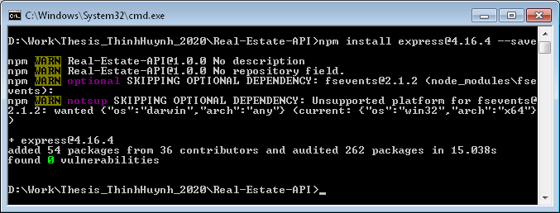

Figure 6.1‑14. NPM Install --save for API

The flag <--save> will let NPM knows to save the dependency's version into package.json file. And the flag <--save-dev> is to save the dependency into dev-dependency.

Now your package.json would look like the Figure 6.1‑15 below.

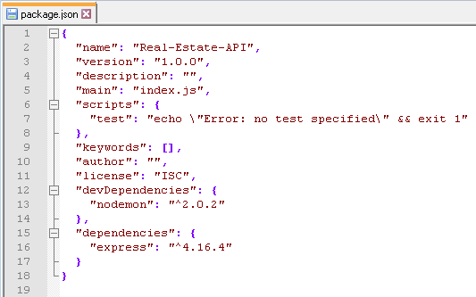

Figure 6.1‑15. API Package JSON (2)

Now let's specify some other dependencies in package.json as the Figure 6.1‑16 below.

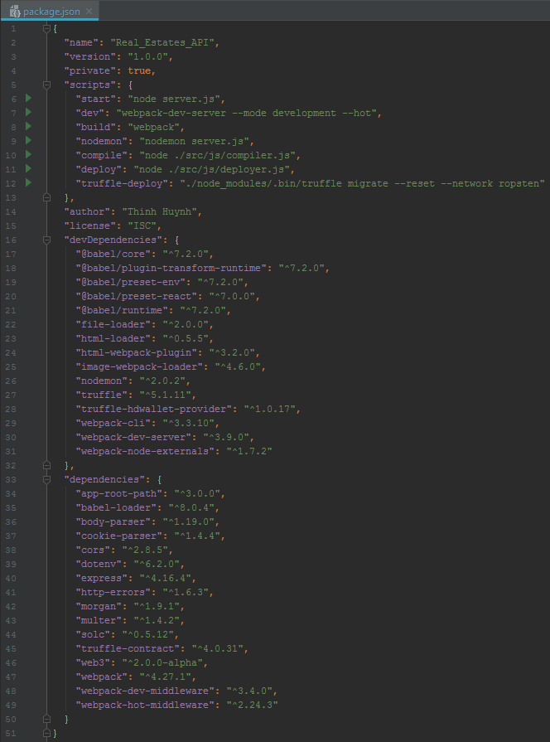

Figure 6.1‑16. API Package JSON (3)

Let's command the prompt again after updating other dependencies in package.json file.

* <npm install>

Then let's wait until all dependencies specified in package.json file are successfully downloaded into <YOUR_PROJECT_FOLDER>/Real-Estate-API/node_modules folder.

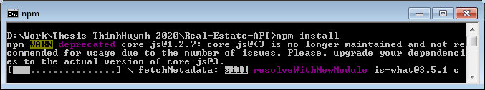

Figure 6.1‑17. NPM Install for API

#### Metamask

Metamask is the standard Ethereum web3 API. It is an add-on of our web browsers such as Firefox or Chrome. There for, installing Metamask is quite simple. With Metamask, every user can interact with Ethereum Blockchain (Main net, test net or even private Blockchain) without becoming a full node. A light node user is not required to install Geth or Ganache to use Ethereum DApps. To playing with Ethereum DApps, users now only need to install Metamask add-on on their web browsers, custom the RPC URL of it and register account.

* Step 1: Install Add-on

Go to <https://metamask.io/>

Get chrome extension > add to chrome > add extension > done.

You will see Metamask' icon in your browser as the Figure 6.1‑18 below.

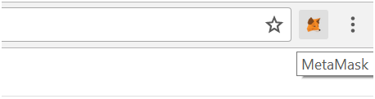

Figure 6.1‑18. Installed Metamask Extension Icon

* Step 2: After Metamask is installed into Chrome Extension, it is able to use by clicking the “fox head” icon on the chrome toolbar. Click it!

Users are now asked to enter a password, which protects their key by encrypting it. This means users are more secure. Choose a strong, easy to remember password. Do not share this password with anyone. Keep it in mind !

Users are now shown 12 words. This is a fancy private key which creates an infinite amount of private keys underneath it. Users need this to access their Ether. No one can recover it if they lose it, their computer dies, re-install Chrome, uninstall the Metamask extension, or reinstall OS. A better way is to store a second copy of these 12-word in a different physical location.

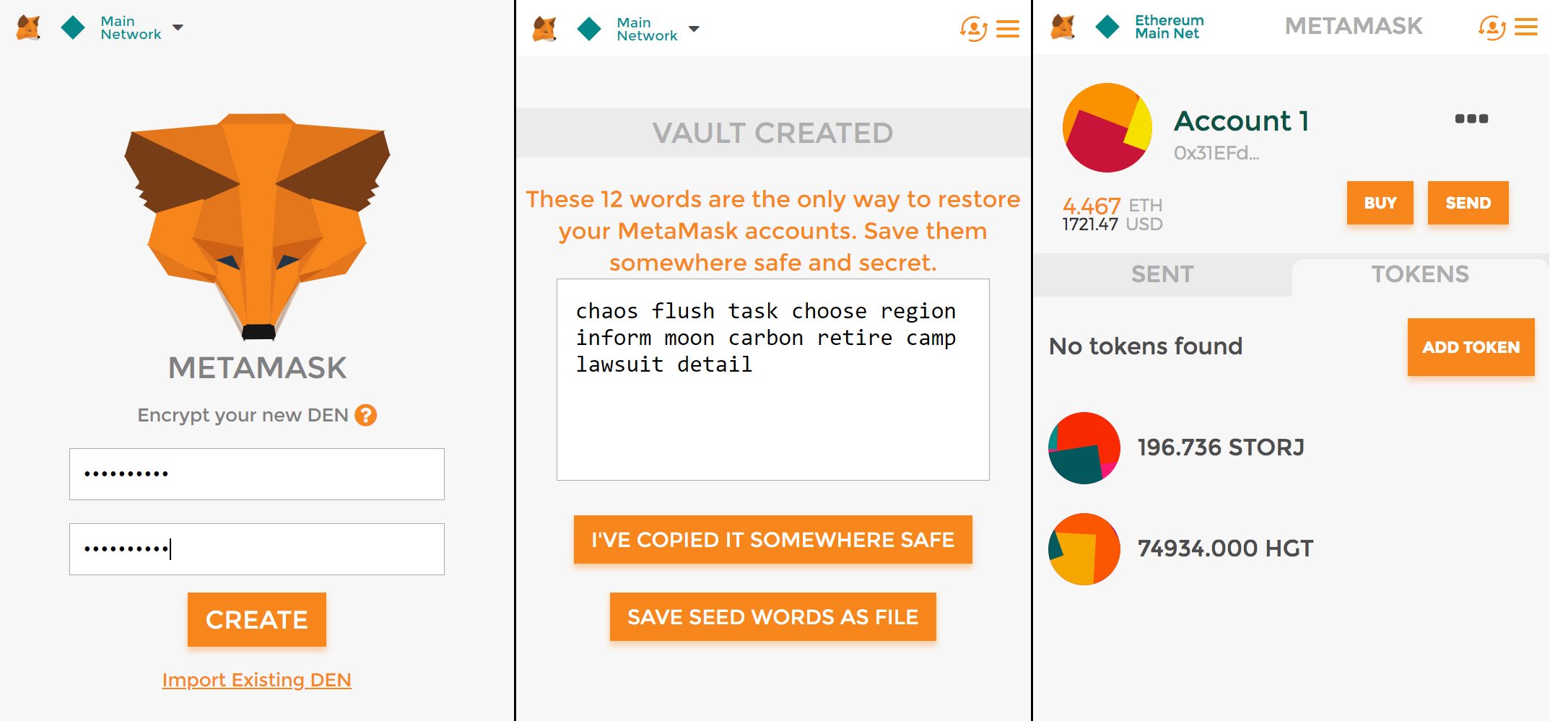

Figure 6.1‑19. Metamask Creating Accounts and Back-Up Code

* Step 3: Customizing HTTP Provider by changing RPCs to different Ethereum Node to connect to the target Blockchain.

Chrome Extension API provides a home page for each extension. Please paste this to your browser's url panel to go to MetaMask home page.

[chrome-extension://<Your-Chrome-Extension-ID>/home.html](chrome-extension://nkbihfbeogaeaoehlefnkodbefgpgknn/home.html)

Please paste this url <chrome://extensions/> into your browser's url panel to see your MetaMask Extension's ID.

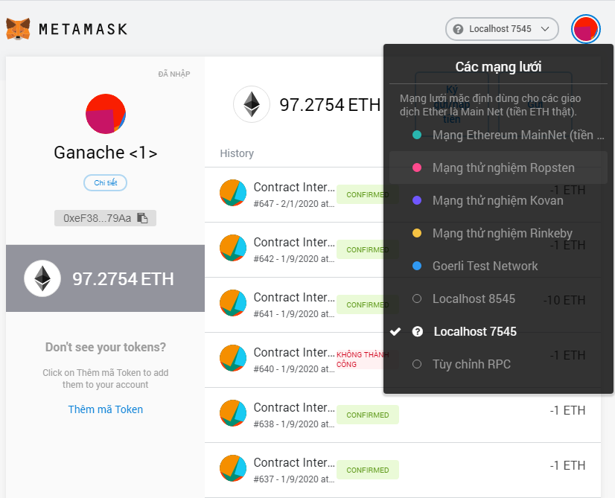

Figure 6.1‑20. Installed Metamask Extension Home Page

Now change the network to Ropsten Testnet to perform transactions in this thesis paper.

#### Truffle (Solidity Smart-Contract's Compiler and Deployer)

Truffle is a development environment, testing framework and asset pipeline for Ethereum, aiming to make life as an Ethereum developer easier. With Truffle, you get:

* Built-in smart contract compilation, linking, deployment and binary management.
* Automated contract testing with Mocha and Chai.
* Configurable build pipeline with support for custom build processes.
* Scriptable deployment & migrations framework.
* Network management for deploying to many public & private networks.
* Interactive console for direct contract communication.
* Instant rebuilding of assets during development.
* External script runner that executes scripts within a Truffle environment.

Since you've done part 6.1.2.3 - ExpressJS with Nodemon above, truffle dependency has been added to <YOUR_PROJECT_FOLDER>/Real-Estate-API/node_modules folder.

The files inside <YOUR_PROJECT_FOLDER>/Real-Estate-API/ are now looked like the Figure 6.1‑21 below.

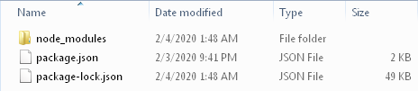

Figure 6.1‑21. Real-Estate-API Folder (1)

Now it's time to use truffle ! Run the following command in prompt, and remember to change directory to this path folder <YOUR_PROJECT_FOLDER>/Real-Estate-API/.

* <npx truffle init --force>

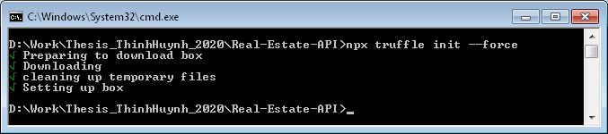

Figure 6.1‑22. Truffle Initialization for API

NPX is a replacement for NPM command and it comes bundled with NPM version 5.2+ [11]. The only difference is that NPX takes local dependency inside node_modules instead of using global dependency. Please refer to part 2.1.1.2 - NPM to review about local packages and global packages.

The flag --force will empty all duplicated folder inside the current workspace, or the workspace that execute the NPX command, without prompting the warning.

The files inside <YOUR_PROJECT_FOLDER>/Real-Estate-API/ are changed and now they looked like the Figure 6.1‑23 below.

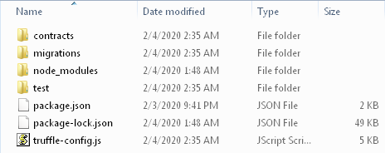

Figure 6.1‑23. Real-Estate-API Folder (2)

#### Remix IDE with Remix Daemon

Let's first open a remix IDE, which is located at <http://remix.ethereum.org/>. Its provides a friendly interface for Ethereum Smart Contract developers.

Currently (at January 2020) there are 2 version of Remix IDE:

Version 0.7.7 is served at: <http://remix.ethereum.org/#appVersion=0.7.7>

Version 0.8.0 is served at: <http://remix.ethereum.org/#appVersion=0.8.0>

* In this thesis paper, I used Remix IDE Version 0.8.0 due to its good-looking UI, rather than the Version 0.7.7.

Following the steps specified in the Figure 6.1‑24 below.

* Step 1: Changing the Remix's Theme, I used Cerulean (light) since this theme has good-looking interface to me.
* Step 2: Opening the Remix's Compiling Environment, by clicking Solidity and Vyper button in step 2.1. The UI will appear 2 environmental configurations for the 2 programming languages, which specified as buttons in step 2.2.
* Step 3: Connecting Remix IDE file system with your local file system. To be more specific, as you write your Solidity code in Remix, they are automatically saved in your local file system, the same where your local IDE is pointing to.

But hold on ! We need Remix Daemon service running locally to finish step 3.

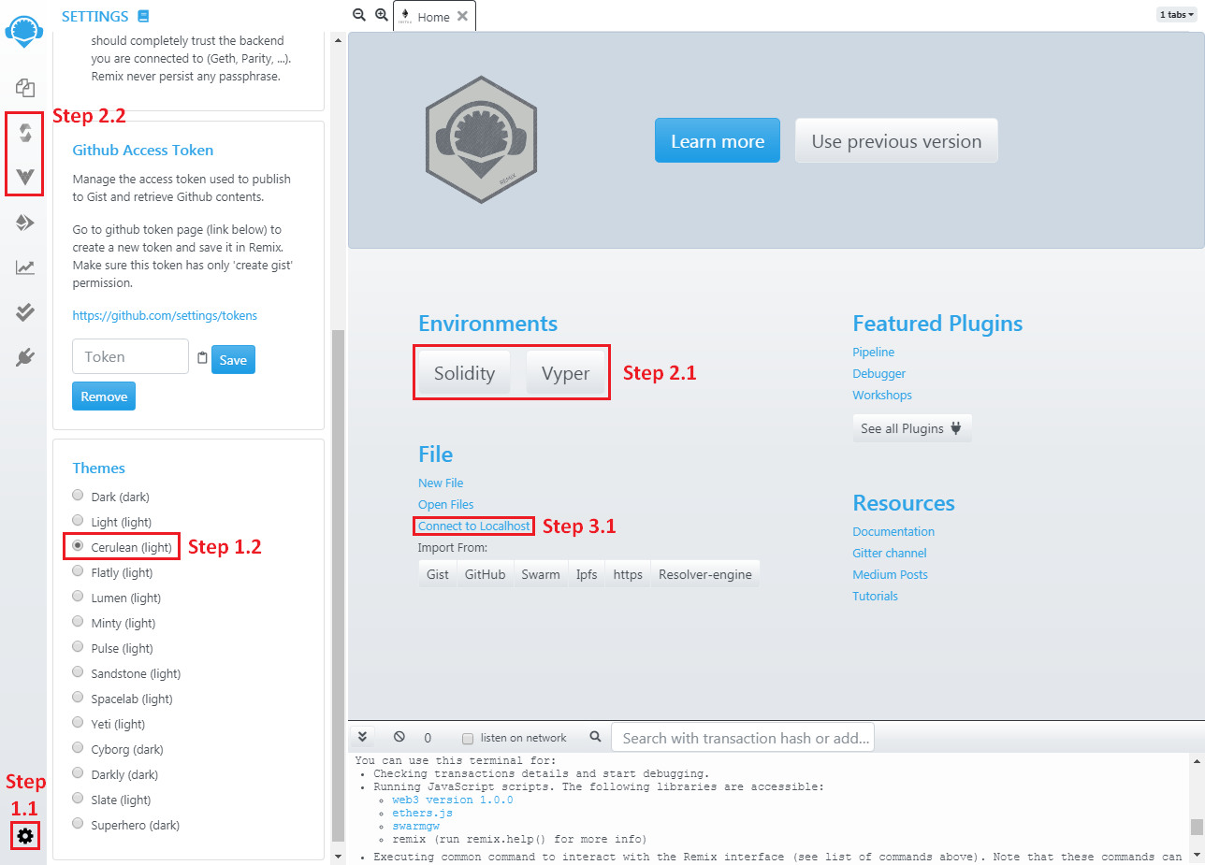

Figure 6.1‑24. Remix Online IDE

Now let's install remixd, which is a NPM module, as a global package on your computer. Its purpose is to give the remix web application access to a folder from your local computer. To be more specific, it synchronizes the local files in your computer to the remix web browser through a websocket port.

* <npm install remixd -g>

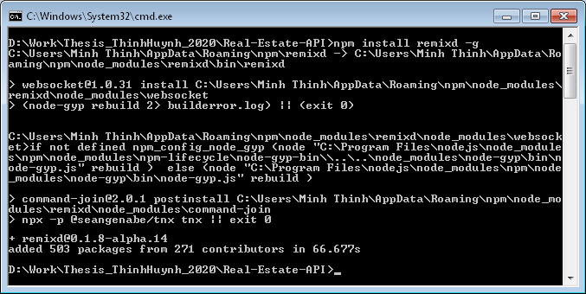

Figure 6.1‑25. NPM Install Remidx --global

Please do not worry about the logged errors in Command Prompt. Now let's check all global dependencies installed in your computer.

* <npm list -g --depth 0>

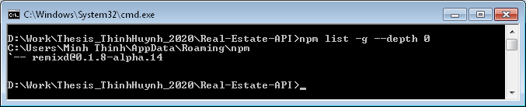

Figure 6.1‑26. Installed Global Dependencies

Let's change the directory into <YOUR_PROJECT_FOLDER>/Real-Estate-API/contracts by running the following command in prompt, and remember to change directory to this path folder <YOUR_PROJECT_FOLDER>/Real-Estate-API/.

* <cd contracts>

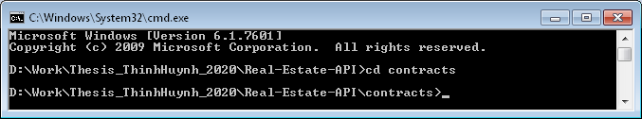

Figure 6.1‑27. Change Directory to Contract Folder

Finally, it's time to link your remix IDE in the browser to this local folder that stored Solidity Contracts, thanks to the help of remixd middleware. Continue to run the following command in the command prompt interface.

* <remixd -s ./ --remix-ide http://remix.ethereum.org>

Please make sure Remix IDE is running at http://remix.ethereum.org. If Remix IDE is running with Secure HTTP Protocol https://remix.ethereum.org, please change to HTTPS Protocol in the URL. Then run the following command in prompt with HTTPS URL.

* <remixd -s ./ --remix-ide https://remix.ethereum.org>

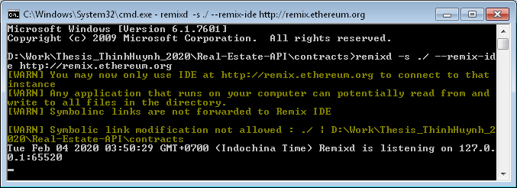

Figure 6.1‑28. Remix Daemon with Web Socket

The flag <-s> or < --shared-folder > is the shared folder through API of websocket, and the argument is <./> that is the current workspace, or <YOUR_PROJECT_FOLDER>/Real-Estate-API/contracts.

And the flag <--remix-ide> takes 1 argument after, which is the URL of remix instance allowed to connect to this web socket connection, please double check whether the protocol is HTTP or HTTPS (Secured HTTP).

We have run a web socket server at ws://127.0.0.1:65520, and now let's connect Remix IDE with the local web socket by following step 3.1 in Figure 6.1‑24. Clicking "Connect to Localhost" button makes Remix prompts the below alert.

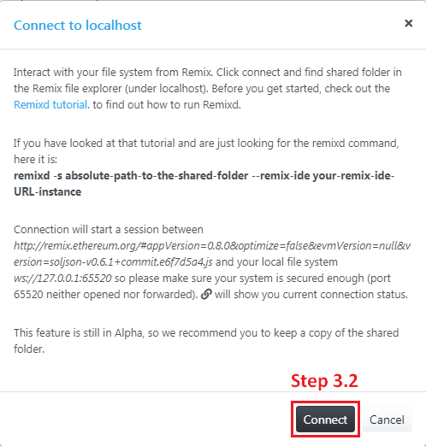

Figure 6.1‑29. Remix Connect to Local Web Socket

Click connect button in step 3.2 to link Remix IDE with Local Files served by Web Socket in Local Remix Daemon.

Remix IDE now does appear the localhost file in FILE EXPLORERS panel as in the Figure 6.1‑30 below.

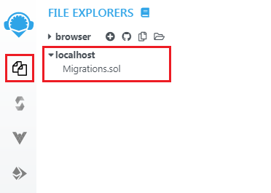

Figure 6.1‑30. Localhost Solidity Files in Remix IDE

Migration.sol is the Solidity file that has been generated during Truffle initialization in part 6.1.2.5 - Truffle (Solidity Smart-Contract's Compiler and Deployer). In detail, this file is generated in Figure 6.1‑22. Truffle Initialization for API.

Truffle uses Migration.sol to manage the deployed contracts in the network, so please don't change anything specified in this file !

Now feel free to develop your smart contracts in Remix IDE, since any change in localhost file explorer in Remix IDE will synchronize with your local files.

#### Ganache (Private Testing Blockchain for Developers)

Ganache is a testing Ethereum Blockchain that is run locally on your computer, and it is used for fast deployment and testing Ethereum Smart Contracts.

There are 2 ways to install Ganache, you can use ganache-cli (Command Line Interface Ganache) or Ganache (Desktop Application)

The table below shows the comparison between 2 types of Ganache.

|  |  |
| --- | --- |
| ganache-cli | Ganache Desktop Application |
| * Fast start. * Manually save the used workspace after terminating the process. * Manually tracking the mined and pending transaction * Manually tracking the state of contracts by run the command in terminal line. | * Slow start. * Automatically save the workspace for later reused after terminating the process. * Automatically tracking and storing the mined and pending transactions. * Automatically tracking and storing the state of contracts |

Table 6.1‑1. Ganache CLI and Ganache Desktop UI

##### **Install and Run Ganache-cli**

Now let's install Ganache Command Line Interface, which is a NPM module, as a global package on your computer. Its purpose is to imitate the Ethereum Blockchain Network that runs locally. To be more specific, it fakes the Blockchain Network for developers to deploy and test smart contracts without waiting the transactions to be mined. Run the following command.

* <npm install -g ganache-cli>

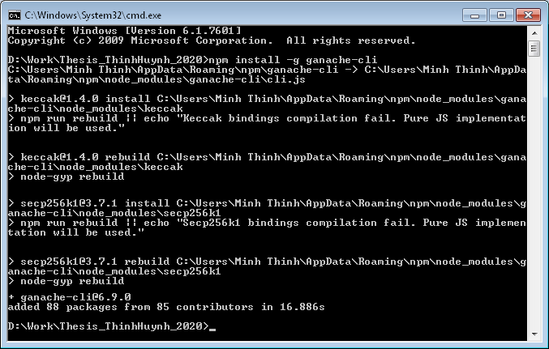

Figure 6.1‑31. NPM Install Ganache-CLI --global

Now let's run ganache-cli with your Command Prompt by run the following command.

* <ganache-cli -p 7545>

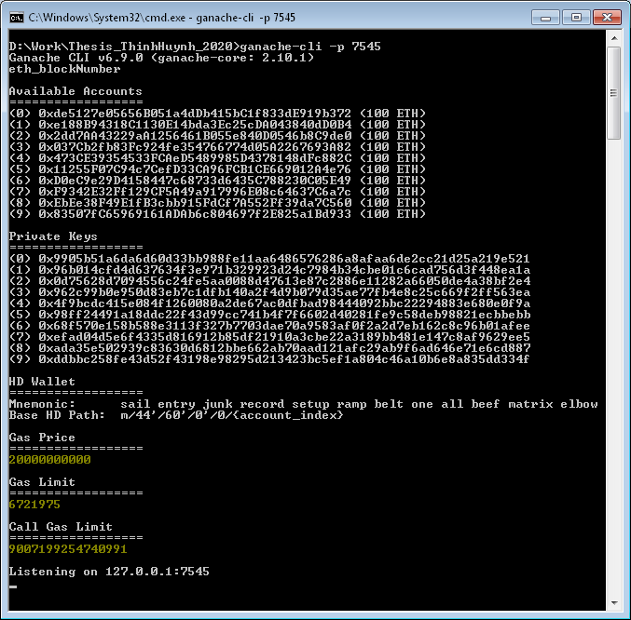

Figure 6.1‑32. Run Ganache-CLI at Localhost --Port 7545

BAMP ! We now have a fake Ethereum Blockchain that runs locally on your computer and a fake Ethereum Node that been served at localhost:7545 (Localhost with Port 7545).

Please reading Ganache CLI documents [12] to have more understanding about different arguments and flags that could be input through ganache-cli application.

But remember every time you run Ganache like this, it's going to create a totally fake new Ethereum Blockchain, means you could not save the current workspace. To save the workspace please run the following command in prompt.

* <ganache-cli -p 7545 --db <PATH-TO-YOUR-WORKSPACE>>

Since I used Windows 7, Ganache-CLI is installed globally in disk C, thus the path to your workspace must belongs to disk C. If the path belongs to disk C, Ganache-CLI will throw the error in the prompt after initiation failed ! So run ganache-cli with saving workspace options with the following command in prompt.

* <ganache-cli -p 7545 --db C://<CHOOSE-YOUR-PATH-FOLDER>>

##### **Install and Run Ganache Desktop UI**

Please download installation for Ganache Desktop at <https://www.trufflesuite.com/ganache>.

After installation, open Ganache and the UI appears as the Figure 6.1‑33 below.

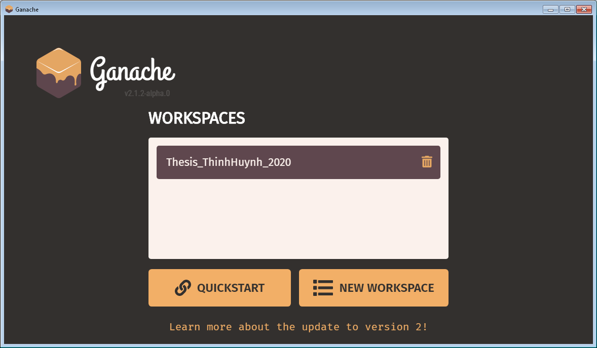

Figure 6.1‑33. Ganache Home Page UI

You can choose either Quick Start or creating New Workspace.

###### **QUICK START**

Ganache Desktop Application will direct to the UI at the Figure 6.1‑34 below.

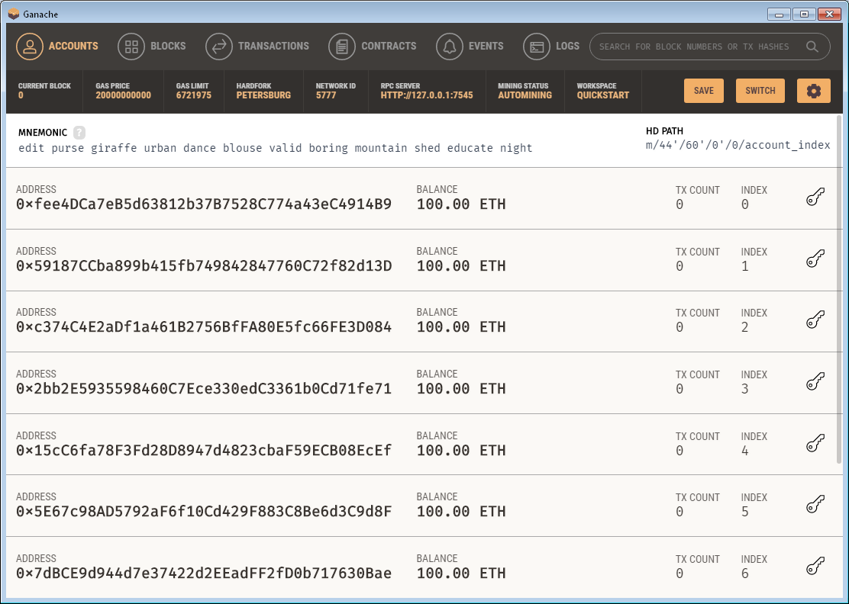

Figure 6.1‑34. Ganache Quick Started

The UI contains many options and show adaptive information for developers.

* Choose Button # CONFIG to custom the configuration of the fake Blockchain.
* Choose Button # SWITCH to switch to other Workspaces, see Figure 6.1‑33.
* Choose Button # SAVE to switch to saving Workspace, see Figure 6.1‑35.
* Top First Panel shows the buttons for tracking interfaces (show detail information of the fake Ethereum Blockchain) of the current Workspace and Search Engine.
* Second Panel shows the detailed custom the configuration of the fake Ethereum Blockchain and included 3 buttons.
* Third Panel shows 12 randomly mnemonic words to generate keys in Address Panel (Fourth Panel) using Hierarchical Deterministic Wallet technology (HD Wallet).

###### **NEW WORKSPACE**

Ganache Desktop Application will direct to the UI at the Figure 6.1‑35 below.

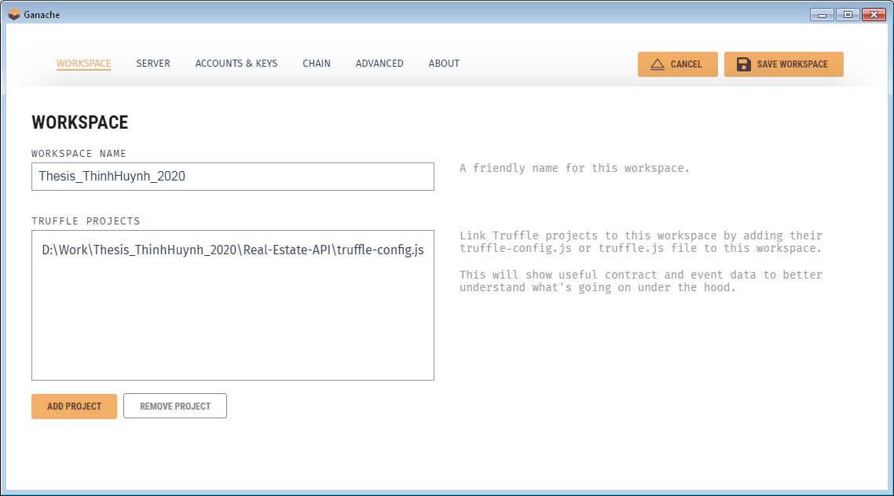

Figure 6.1‑35. Ganache Creates New Workspace

* Choose Button # SAVE WORKSPACE to save the fake Ethereum Blockchain workspace.
* Choose Button # ADD PROJECT to add truffle-config.js file for Ganache to track the contracts and events automatically.
* First Panel shows the buttons for adding custom options to the current Workspace.
* Second Panel shows the workspace name and truffle configuration path.

In this thesis paper, I'll use port 7545 for Ganache, which means now I have a fake Ethereum Node that serves as a HTTP Provider for Web3 Application at <http://localhost:7545/>.

## Implementation

In this part, I will neither show you the detail, nor else, fully explain the source code. But rather gives readers an abstract view of code structure and the functionality of each module or component specified in this thesis paper. Please visit my Github to access the fully documented paper and the source code at: <https://github.com/minhthinhls/Thesis_ThinhHuynh_2019/>.

### Front-End / Client Side

The file structure inside <YOUR_PROJECT_FOLDER>/Real-Estate-CLIENT/ are illustrated as the below.

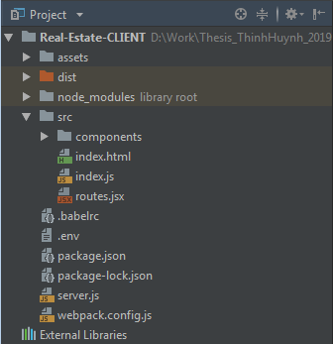

Figure 6.2‑1. Project Structure - CLIENT

#### NPM Scripts in Client's Configuration.

Let first begin with NPM scripts specified in package.json in Real-Estate-CLIENT folder.

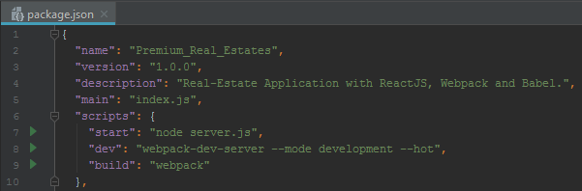

Figure 6.2‑2. NPM Scripts - CLIENT

Suppose you type the below command in prompt at Real-Estate-CLIENT path folder.

* <npm run start>

Then the NPM module will automatically replace the command into the below command.

* <node server.js>

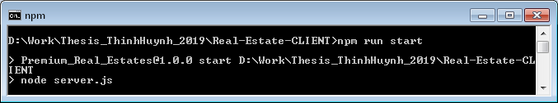

Figure 6.2‑3. NPM Run Start - CLIENT

This will eliminate the difficulties in remembering the exact command to run since the command <npm run start> is unified in all NodeJS Application. Sometime, your running command is too long. You can replace the long and forgettable command

* <webpack-dev-server --mode development --hot>

with the very short and memorable below.

* <npm run dev>

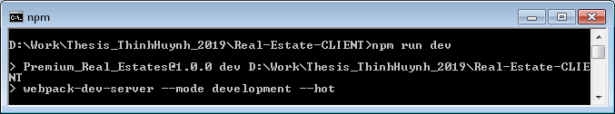

Figure 6.2‑4. NPM Run Dev - CLIENT

The flags should be customized inside NPM scripts since the customized flag as <--mode> or <--hot> are sometime confused with the other developers.

#### Module Workflow in Client Side Architecture.

Client Side Service in this thesis paper is based on Server-Side Rendering, thus the Client requires a NodeJS platform to render HTML, CSS, JS before response rendered data to Client.

The below illustrates the workflow of bundling files using webpack and its supported modules by running the following command in prompt.

##### **<npm run build>**

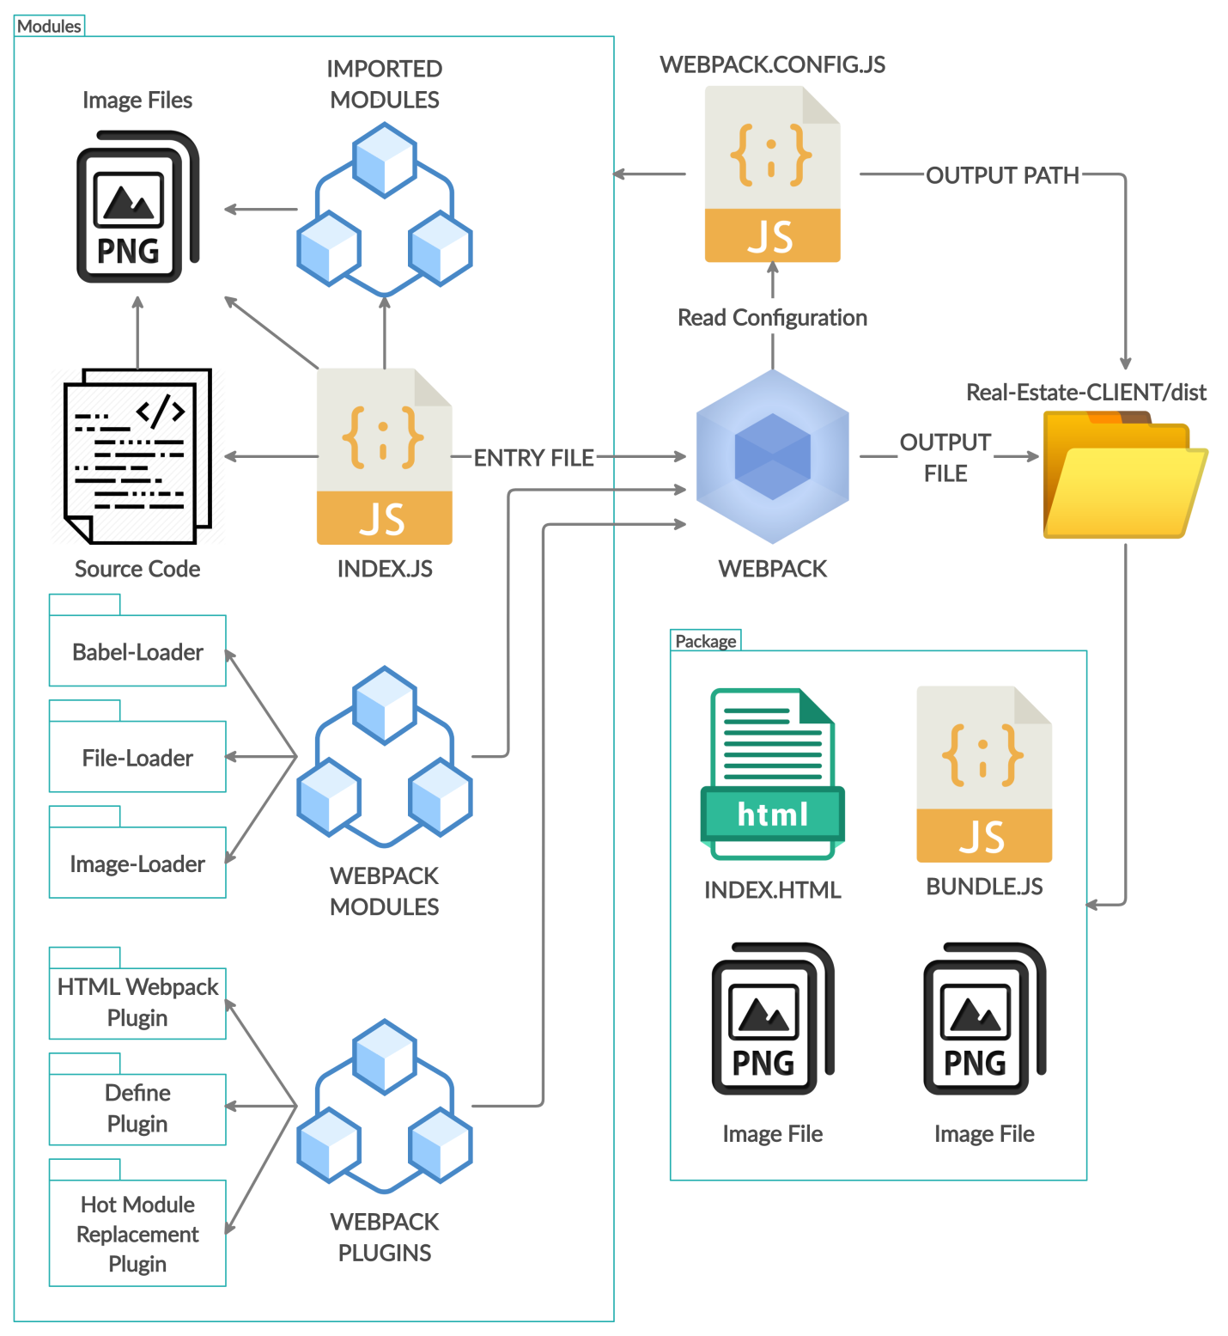

Figure 6.2‑5. Webpack Bundling Files Workflow - <NPM Run Build>

However, since we need Babel to transfer ES6 Script into ES5 Script along with webpack bundler, the following illustrates the flow of Babel-Loader, a webpack module defined in the above.

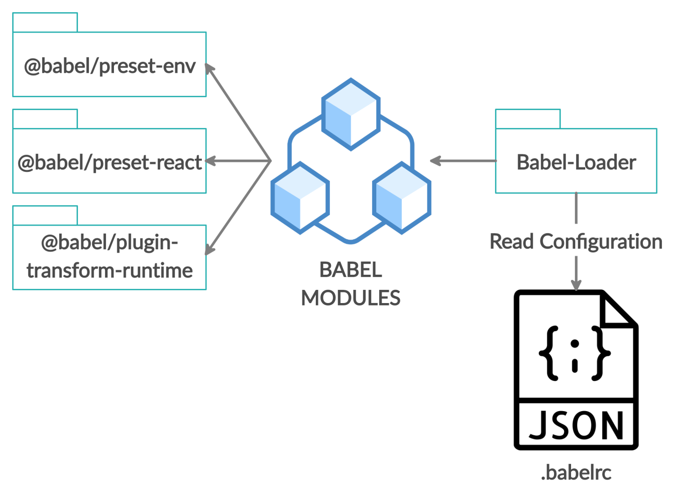

Figure 6.2‑6. Babel as Webpack Module Workflow - <NPM Run Build>

Moreover, Webpack requires a HTML file as an input template for Bundle.js file, thus HTML Webpack Plug-in is used as a dependency. The following illustrates the flow of HTML Webpack Plug-in, a webpack plug-in defined in the .

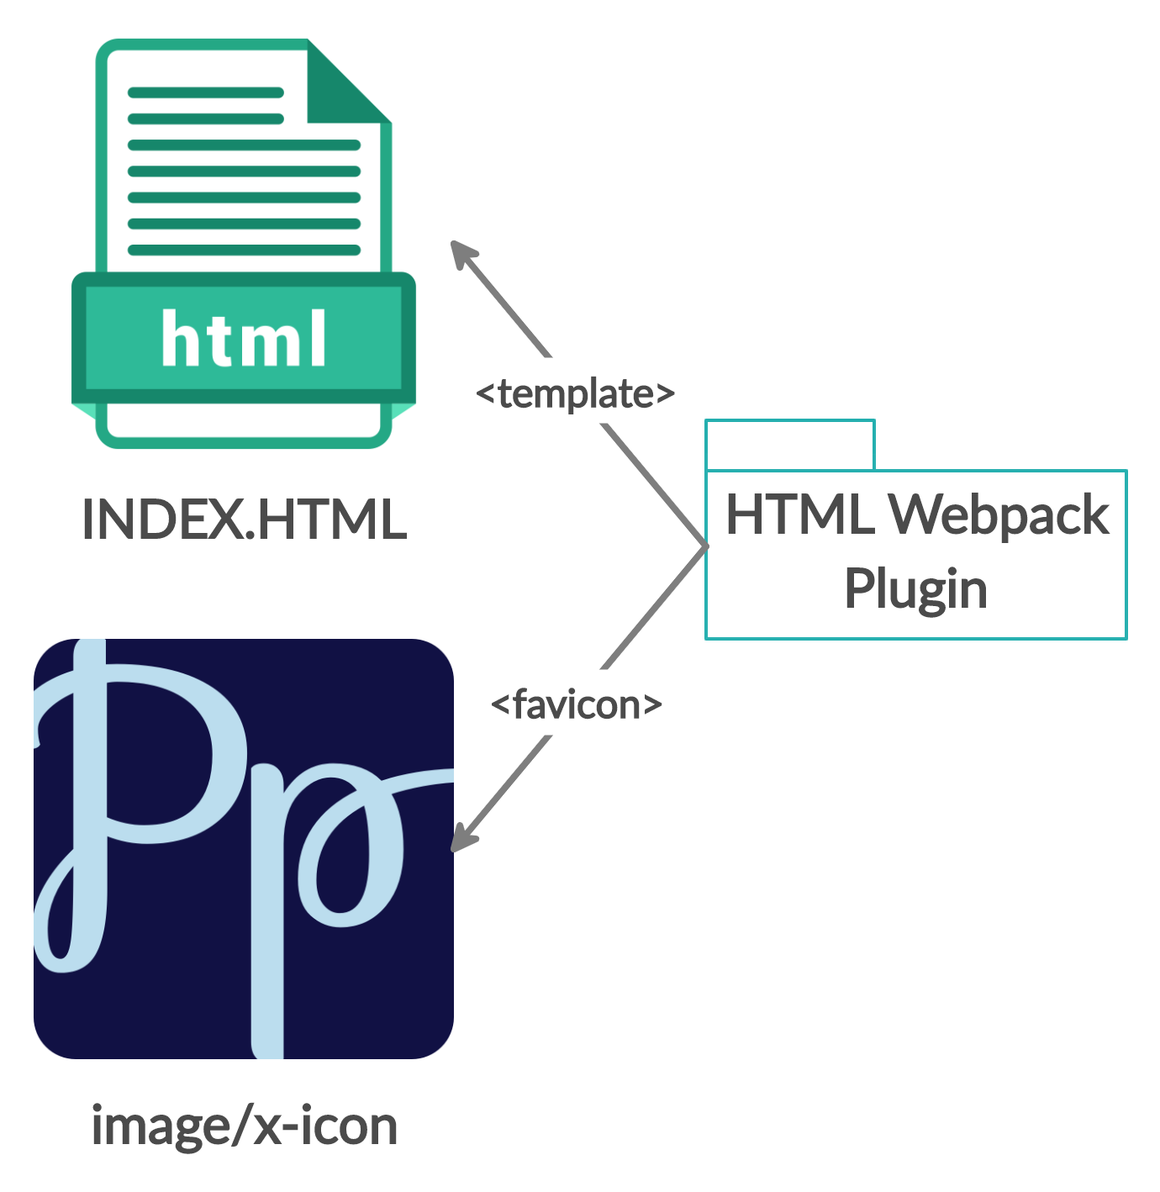

Figure 6.2‑7. HTML Webpack Plug-in Workflow - <NPM Run Build>

The below illustrates the workflow of starting front-end rendering server using NodeJS with webpack and its supported modules by running the following command.

##### **<npm run start>**

Please specify the Node Environment in .env file before deploy project to the server. For DEVELOPMENT, the code will automatically restart if Webpack Hot Module detects changes.

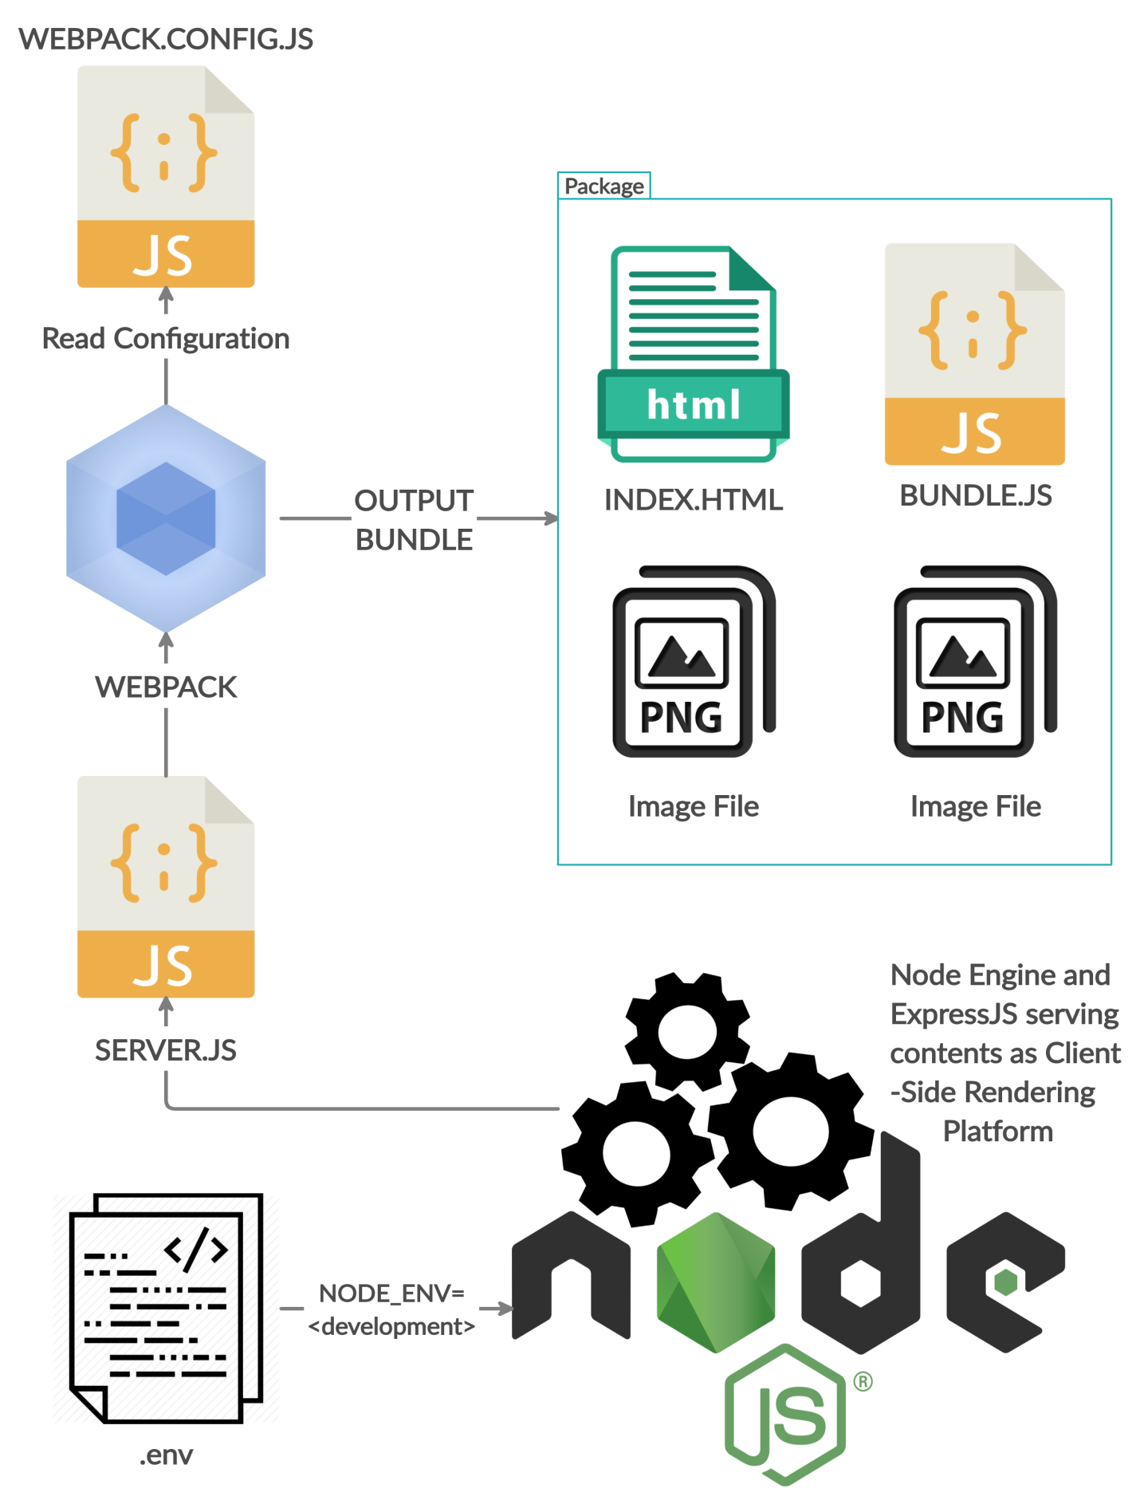

Figure 6.2‑8. NodeJS Rendering Client Side for Development - <NPM Run Start>

For PRODUCTION environment, the code will not automatically restart after deployment, since Webpack Hot Middleware and Webpack Dev Middleware are not used in SERVER.JS file.

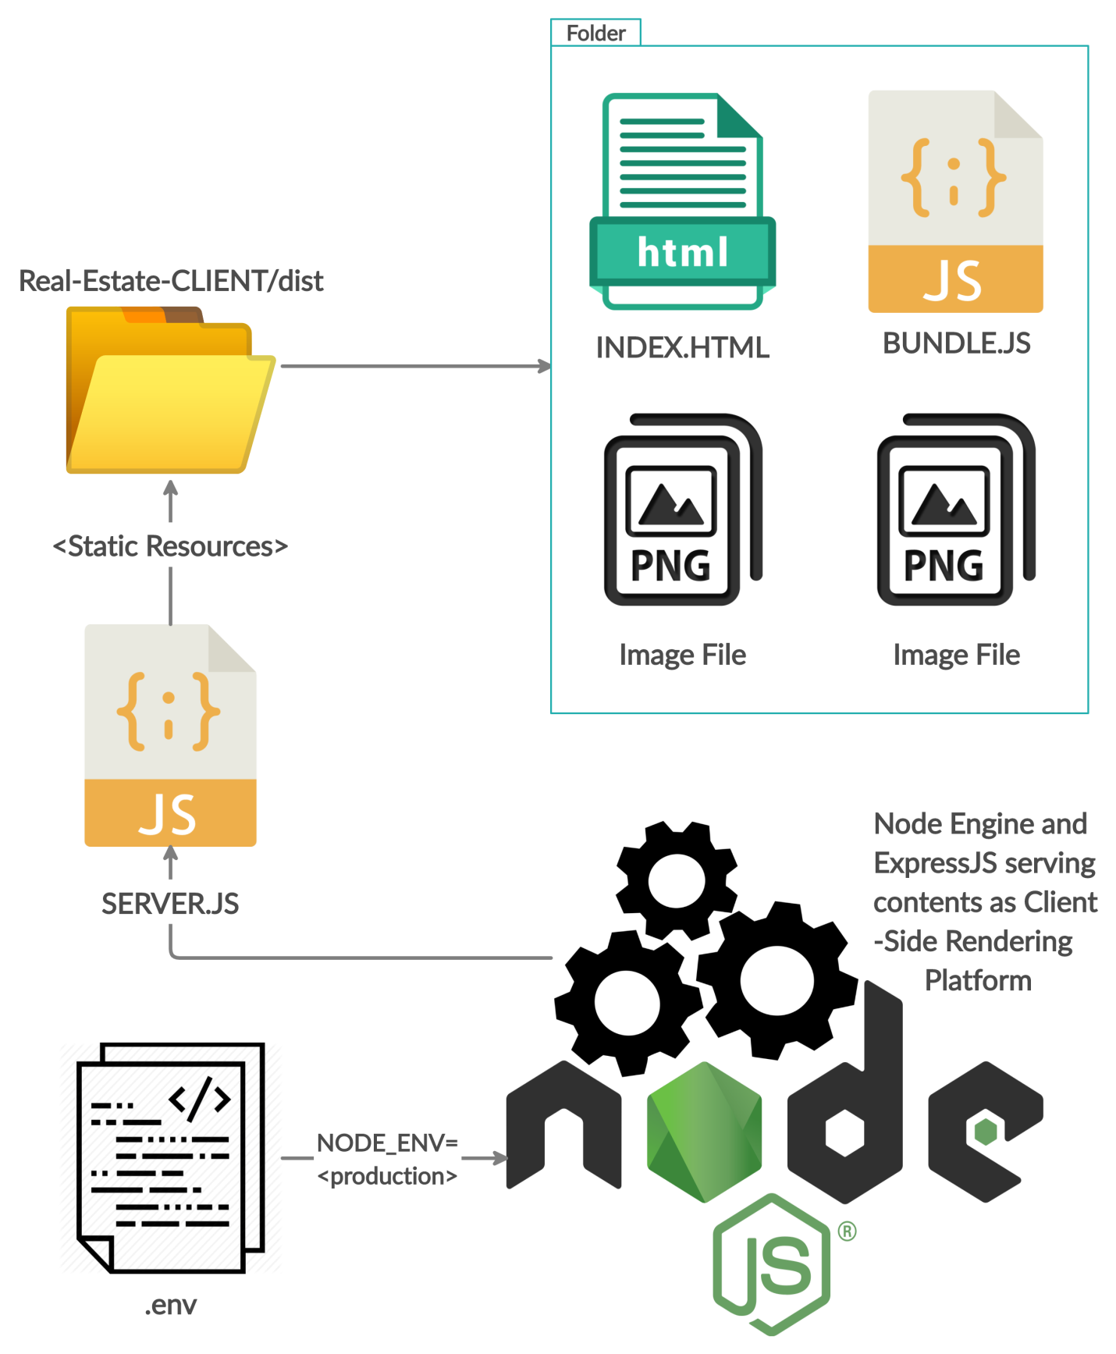

Figure 6.2‑9. NodeJS Rendering Client Side for Production - <NPM Run Start>

##### **<npm run dev>**

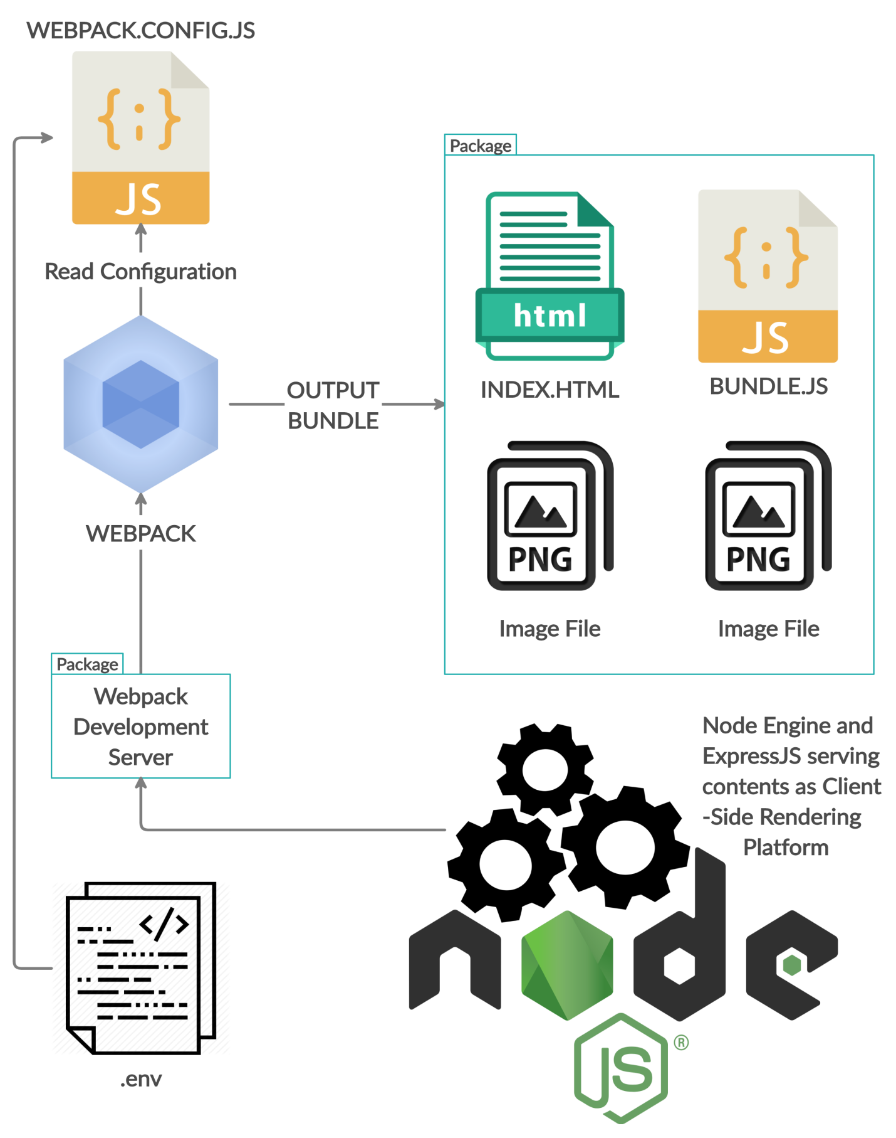

Figure 6.2‑10. NodeJS Rendering Client Side for Development - <NPM Run Dev>

The above illustrates the workflow of starting front-end rendering server using NodeJS with webpack-dev-server by running the command <npm run dev>.

#### ReactJS Code Structure and JSX Page.

The implementation of this thesis paper is web-based platform, thus the browser requires a HTML file to render DOM tree and visualize to rendered data for user.

The code structure first started with HTML file structured as the below.

<!DOCTYPE html>  
<html lang="en">  
 <head>  
 <meta charset="UTF-8">  
 <meta http-equiv="X-UA-Compatible" content="ie=edge">  
 <title>Premium Properties</title>  
 </head>  
 <body>  
 <div id="app"></div>  
 </body>  
</html>

Figure 6.2‑11. HTML Index Page

However, an index JavaScript file is required for mapping the rendered data in JavaScript context to the HTML DOM tree by selecting the ID = "app". See below.

**import** React **from** 'react';  
**import** {render} **from** 'react-dom';  
**import** Routes **from** './routes';   
  
render(<Routes/>, document.getElementById('app'));  
**if** (module.hot) {  
 module.hot.accept();  
}

Figure 6.2‑12. JavaScript Index File

As React is used for Singe Page Application, specifying the direction for pages is much important than ever before. Luckily, React provides Router component for developers to manage direction between pages with the help of sub-components as Route and Switch.

**import** React, {Fragment} **from** 'react';  
**import** {BrowserRouter **as** Router, Route, Switch} **from** 'react-router-dom';  
**import** HomePage **from** './components/home/HomePage';  
**import** GlobalStyle **from** './components/GlobalStyle';  
**import** ListHouse **from** './components/listing/ListHouse';  
**import** HouseDetail **from** './components/listing/HouseDetail';  
**import** SellPage **from** './components/selling/SellPage';   
**import** ContactPage **from** './components/contact/ContactPage';   
  
**const** Routes = () => (  
 <Router>  
 <Fragment>  
 <GlobalStyle/>  
 <Switch>  
 <Route exact path="/" component={HomePage}/>  
 <Route exact path="/listing" component={ListHouse}/>  
 <Route exact path="/selling" component={SellPage}/>  
 <Route exact path="/signing" component={SignUpPage}/>  
 <Route exact path="/contact" component={ContactPage}/>  
 <Route path="/house/:id" component={HouseDetail}/>  
 </Switch>  
 </Fragment>  
 </Router>  
);  
  
**export default** Routes;

Figure 6.2‑13. React Router Component

Every components in Clients Side are written in JSX format, since JSX is built for React. Moreover, components in React are considered as a variable and could be reused. The code written in JSX format looked explicitly and clearly.

With the help of styled-components dependency, developers now could freely write CSS for each individual component without worrying about the conflicts between them.

See below to get an overall view of a JSX file in React Application.

**import** React, {Component} **from** 'react';  
**import** {Link} **from** 'react-router-dom';  
**import** styled **from** 'styled-components';  
**import** Logo **from** '../assets/favicon-1024.png';  
  
**const** Nav = styled.div`  
 img {  
 height: 40px;  
 float: left;  
 }  
`;

**const** ItemCardStyle = styled.div`  
 margin: 10px;  
`;

**const** ItemCard = ({children, image}) => (  
 <ItemCardStyle>  
 <img src={image || 'http://placehold.it/200'} alt="Item"/>  
 <div>  
 {children}  
 </div>  
 </ItemCardStyle>  
);  
  
**class** NavBar **extends** Component {  
 constructor() {  
 **super**();  
 **this**.state = {  
 init: []  
 };  
 }  
   
 render() {  
 **return** (  
 <Nav>  
 <ItemCard image={Logo}>  
 <Link to="/">Home </Link>  
 <Link to="/listing">Listing </Link>  
 <Link to="/selling">Selling </Link>  
 <Link to="/contact">Contact </Link>  
 </ItemCard>  
 </Nav>  
 )  
 }  
}  
  
**export default** NavBar;

Figure 6.2‑14. React Basic Component

However in the above JSX file, . React Basic Component. There are 2 points in which to be concerned, they are:

##### **React {Children} property**

Every React component implicitly have children attribute inside its properties , to access children context, use the following code <this.props.children>

**this**.props.children; // Access children context of any component

Figure 6.2‑15. React Children Property

For component that is functional declaration, such as ItemCard constant, could be explicitly passing 1 argument in JavaScript ES6 - Object Destructuring Pattern. In this passed object, it could be destructed with children property.

Please look back at , inside render() function, there are 4 Link Components declared as children inside ItemCard Component. However, if children variable is not specified in ItemCard constant declaration and put inside <div/> tag as <div> {children} </div>, the 4 Link Components are considered not exists in HTML DOM tree.

##### **Link Component**

This component plays a special role in React Application, it provides an immediate jump to the declared Route in the . React Router Component. Making redirecting for user interface becomes a piece-of-cake.

### Back-End / Server Side

The file structure inside <YOUR_PROJECT_FOLDER>/Real-Estate-API/ are illustrated as the below.

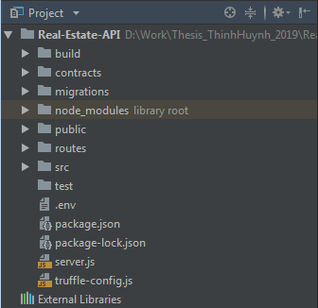

Figure 6.2‑16. Project Structure - API

#### NPM Scripts in Server's Configuration.

Let first begin with NPM scripts specified in package.json in Real-Estate-API folder.

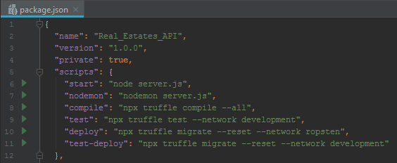

Figure 6.2‑17. NPM Scripts - API

Suppose you type the below command in prompt at Real-Estate-API path folder.

* <npm run nodemon>

Then the NPM module will automatically replace the command into the below command.

* <nodemon server.js>

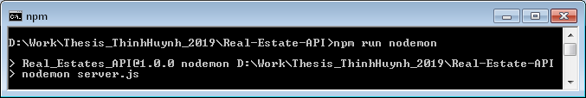

Figure 6.2‑18. NPM Run Nodemon - API

This will eliminate the difficulties in remembering the exact command to run since the command <npm run nodemon> is more memorable to your NodeJS Application. Sometime, your running command is too long. You can replace the long and forgettable command:

* <npx truffle migrate --reset --network ropsten>

with the very short and memorable below.

* <npm run deploy>

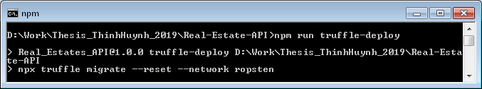

Figure 6.2‑19. NPM Run Truffle Deploy - API

The flags should be customized inside NPM scripts since the customized flag as <--reset> or <--network> are sometime confused with the other developers.

#### Module Workflow in Server Side Architecture.

Server Side Service in this thesis paper is based on Express and its Middlewares, thus the Server requires a NodeJS platform to apply Routing and Middlewares before responding to requests from Client Side.

The Figure 6.2‑21 below illustrates the workflow of ExpressJS Server based on NodeJS platform and its wrapper or supported modules - Nodemon.

To run the ExpressJS Server without using Nodemon, or else stop the server from restarting if anything in the project folder change, change Node Environment in .env folder to Production, NODE_ENV="production" and then run the following command in prompt.

##### **<npm run start>**

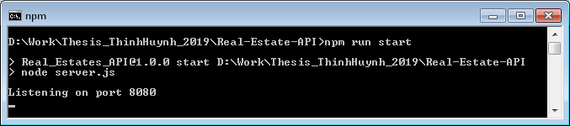

Figure 6.2‑20. NPM Run Start - API

However the ExpressJS Server could be automatically restarted if any things changed by changing Node Environment in .env folder to Nodemon, NODE_ENV="nodemon" and then run the following command in prompt.

##### **<npm run nodemon>**

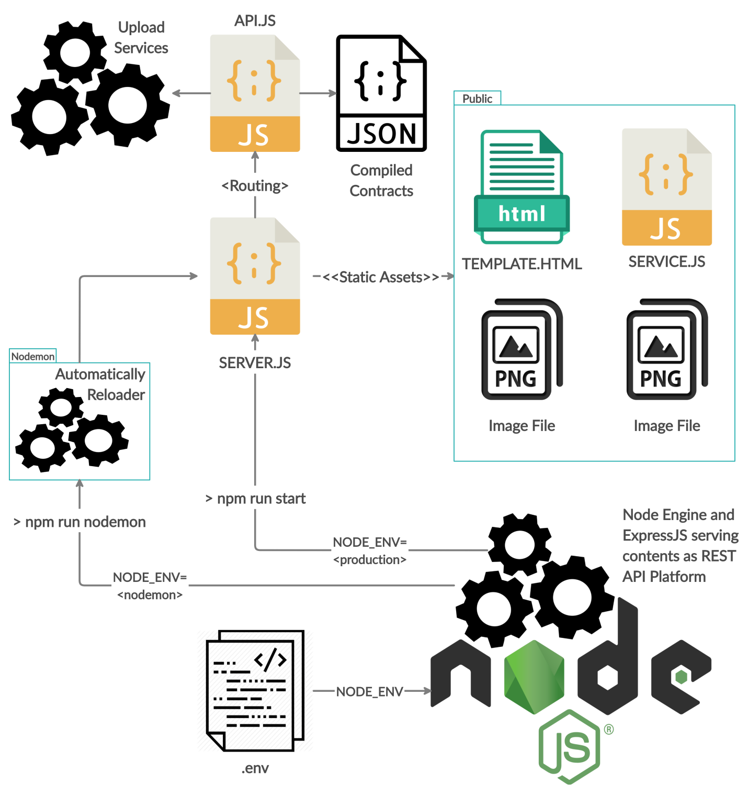

Figure 6.2‑21. ExpressJS API Workflow - <NPM Run Nodemon>

Please keep in mind that in Production Environment, the server will not automatically restart if anything inside the project folder changes.

#### ExpressJS Code Structure and Router.

The implementation of this thesis paper is web-based platform, thus the API requires a file to manage the Express Server, which is server.js inside the Real-Estate-API folder.

The main flow of ExpressJS API follows the code structure that firstly starts with server.js file implemented as the below.

/* SERVER FILE TO RUN NODE ENVIRONMENT */  
require('dotenv').config(); // Read <.env> file into $<process.env> global variable.  
**const** path = require('path');  
**const** express = require('express');  
**const** createError = require('http-errors');  
**const** cookieParser = require('cookie-parser');  
**const** logger = require('morgan');  
**const** cors = require('cors');  
**const** app = express();  
  
/* All engine setup */  
app.use(cors());  
app.use(logger('dev'));  
app.use(cookieParser());  
app.use(express.json());  
app.use(express.urlencoded({extended: **false**}));  
  
/* Public all file within folder ./public and ./dist */  
app.use('/dist', express.static(path.join(__dirname, 'dist')));  
app.use('/public', express.static(path.join(__dirname, 'public')));  
  
/* All router setup */  
app.use('/api', require('./routes/api'));  
  
/* Catch 404 and forward to error handler */  
app.use(**function** (req, res, next) {  
 next(createError(404));  
});  
  
/* Error handlers */  
app.use(**function** (err, req, res) {  
 /* Set locals, only providing error in development */  
 res.locals.message = err.message;  
 res.locals.error = req.app.get('env') === 'development' ? err : {};  
  
 /* Render the error page */  
 res.status(err.status || 500);  
 res.render('error');  
});  
  
/* Finally, let's start our server... */  
**var** server = app.listen(8080, **function** () {  
 console.log('Listening on port ' + server.address().port);  
});  
  
module.exports = app;

Figure 6.2‑22. Server File for ExpressJS API

The ExpressJS Application takes advantages of using middlewares by calling the function named <use> from the instance <app> that is generated by express dependency. Please review part to understand the main flow of an Express Application.

Let's look into the setup of Express Router, the below illustrates the detail of services that is served by the Express API.

**const** express = require('express');  
**const** router = express.Router();  
**const** uploader = require('../src/js/uploader');  
  
/* Application Programming Interfaces */  
router.get('/contract/house', (req, res) => {  
 res.json(require('../build/contracts/House.json'));  
});  
  
router.get('/contract/houseAdmin', (req, res) => {  
 res.json(require('../build/contracts/HouseAdmin.json'));  
});  
  
// Service to receive Image Uploaded from Clients.  
router.post('/upload', (req, res) => {  
 uploader(req, res, (err) => {  
 console.log("Request ---", req.body);  
 console.log("Request file ---", req.file); // Here you get file.  
 /* Now do where ever you want to do */  
 **if** (!err) {  
 **return** res.send(200).end();  
 }  
 })  
});  
  
module.exports = router;

Figure 6.2‑23. ExpressJS Router for API Services

In this thesis paper, the implemented ExpressJS API could handle the uploading of Images from Clients and response to Clients the compiled Ethereum Smart Contracts.

### Ethereum Smart Contracts

In this thesis paper, Truffle is applied to handle the compilation and deployment for Ethereum Smart Contracts. Please review part - Truffle (Solidity Smart-Contract's Compiler and Deployer) to understand the basic concepts of Truffle.

Inside the Real-Estate-API folder, there's a file named truffle-config.js that's been generated under the command <npx truffle init> at Real-Estate-API folder. Here are the alternative path to the configuration file: <YOUR_PROJECT_FOLDER>/Real-Estate-API/truffle-config.js.

The below illustrates the configuration for Truffle in truffle-config.js file.

require('dotenv').config(); // Read <.env> file into $<process.env> global variable.  
**const** HDWalletProvider = require('truffle-hdwallet-provider');  
**const** MNEMONIC = process.env.MNEMONIC;  
**const** INFURA_KEY = process.env.INFURA_KEY;  
  
module.exports = {  
 networks: {  
 development: {  
 host: "127.0.0.1",  
 port: 7545,  
 network_id: "*",  
 },  
 ropsten: {  
 provider: () => **new** HDWalletProvider(MNEMONIC, process.env.ROPSTEN + INFURA_KEY),  
 network_id: 3,  
 gas: 5500000,  
 confirmations: 2,  
 timeoutBlocks: 200,  
 skipDryRun: **true** }  
 },  
 mocha: {  
 timeout: 100000  
 },  
 compilers: {  
 solc: {  
 version: "0.5.1",  
 docker: **true**,  
 settings: {  
 optimizer: {  
 enabled: **false**,  
 runs: 200  
 },  
 evmVersion: "byzantium"  
 }  
 }  
 }  
};

Figure 6.2‑24. Truffle Configuration File

The configuration contains 3 main part, which are: network, mocha and compiler.

* Network: I've already specified the development network at localhost, port 7545 (running Ganache) for development purposes and ropsten test network for demonstration.
* Mocha: The configuration for testing smart contract. To perform unit test please run the following command <npx truffle test --network development> in folder Real-Estate-API.
* Compiler: Compiling configuration provided by Truffle, developers could specify the version and optional customization for settings.

The configuration contains 3 main part, which are: network, mocha and compiler.

#### Compile Contracts

Since you have already done part - Remix IDE with Remix Daemon. You can see all the Solidity contracts inside <YOUR_PROJECT_FOLDER>/Real-Estate-API/contracts.

To compile all Solidity smart contracts please run the following command in prompt at the Real-Estate-API directory. Fully path: <YOUR_PROJECT_FOLDER>/Real-Estate-API/.

* <npm run compile>

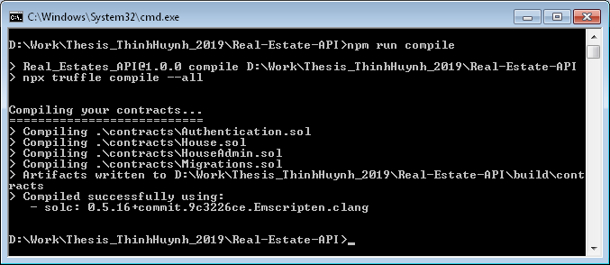

Figure 6.2‑25. Truffle Compiles All Contracts - <NPM Run Compile>

Or you can run the command directly with NPX for Truffle Compilation without using NPM Scripts replacement.

* <npx truffle compile --all>

Now all of your Solidity Contracts are compiled into JSON Contracts at the path folder: <YOUR_PROJECT_FOLDER>/Real-Estate-API/build/contracts.

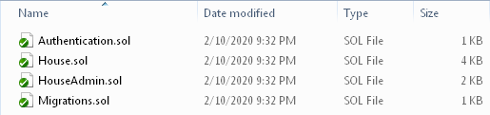

Figure 6.2‑26. Compiled Contracts Folder

#### Deploy Contracts

Please review part - to have an overview of the system workflow to deploy Solidity Contract to Ethereum Network using Infura HTTP Provider.

The Figure 6.2‑27 below illustrates the main flow of deploying the Compiled Solidity Contracts to either Ropsten Test Network or Developing Network (Ganache).

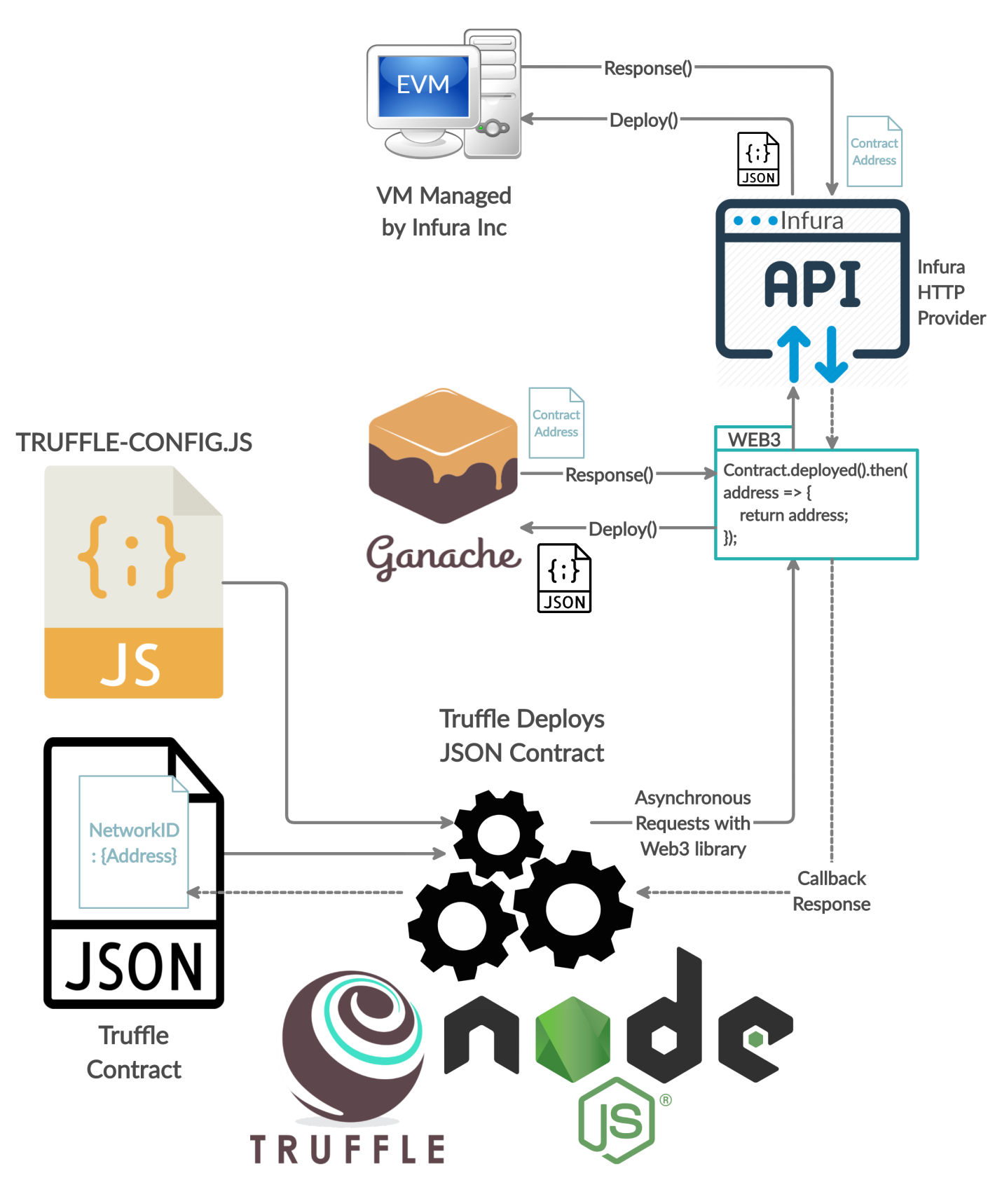

Figure 6.2‑27. Truffle Deploys Contracts Workflow

Deploying Solidity Smart Contracts require following these steps in command prompt at the Real-Estate-API directory. Fully path: <YOUR_PROJECT_FOLDER>/Real-Estate-API/.

* Since HouseAdmin Contract must be deployed to the Ethereum Network, please modifying the JavaScript file named < 2_deploy_contracts.js> inside the alternative path folder: <YOUR_PROJECT_FOLDER>/Real-Estate-API/migrations/ as Figure 6.2‑28 below.

**var** HouseAdmin = artifacts.require("./HouseAdmin.sol");  
  
module.exports = **function**(deployer) {  
 deployer.deploy(HouseAdmin);  
};

Figure 6.2‑28. Truffle Deployer Configuration

* To deploy Smart Contracts specified in < 2_deploy_contracts.js> to your development Blockchain (Ganache at localhost:7545), please run the following command in prompt.
* <npm run test-deploy>

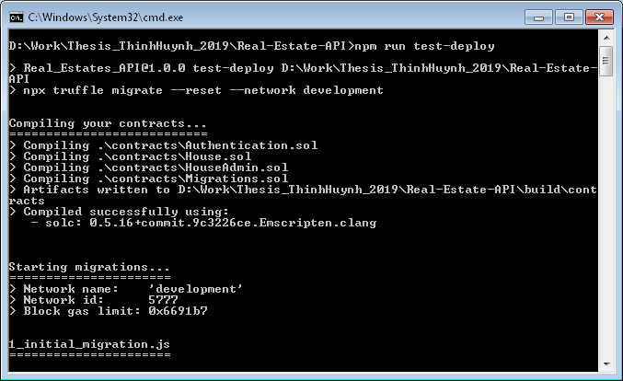

Figure 6.2‑29. Truffle Deploys Contract at Ganache - <NPM Run Test Deploy>

Or you can run the command directly with NPX for Truffle Compilation without using NPM Scripts replacement.

* <npx truffle migrate --reset --network development>

However, deploying the House Admin Contract to Ganache is for development purpose only, as CHAPTER 3 - System Requirements has already specified that for thesis demonstration, the Ethereum Ropsten Test Net must be applied.

* To deploy Solidity Smart Contracts specified inside < 2_deploy_contracts.js> to the Ropsten Test Network Blockchain, please run the following command in prompt.
* <npm run deploy>

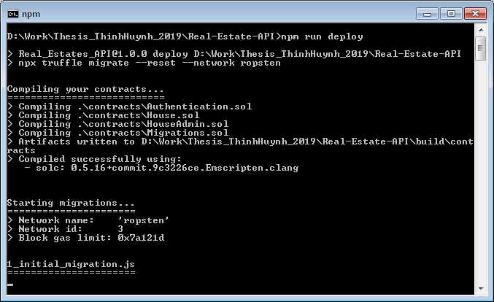

Figure 6.2‑30. Truffle Deploys Contract at Ropsten - <NPM Run Deploy>

Or you can run the command directly with NPX for Truffle Compilation without using NPM Scripts replacement.

* <npx truffle migrate --reset --network ropsten>

Let's just wait for about 2 minutes since deploying to the Ropsten Test Network takes time.

#### Contract's Interaction

Interacting with Ethereum Blockchain Network requires Web3 dependency injected into the browser. Let's modify the source code of index.js in Client Side, see Figure 6.2‑12. Fully path to JavaScript Index File: <YOUR_PROJECT_FOLDER>/Real-Estate-CLIENT/src/index.js

**import** React **from** 'react';  
**import** {render} **from** 'react-dom';  
**import** Routes **from** './routes';  
  
**const** Web3 = require('web3');  
  
**try** {  
 **if** (**typeof** web3 !== 'undefined') {  
 // If a web3 instance is already provided by MetaMask Browser Extension.  
 window.web3 = **new** Web3(web3.currentProvider);  
 } **else** {  
 /* Injecting new Web3 instance with customized HTTP Provider at http://localhost:7545 if no web3 instance provided */  
 window.web3 = **new** Web3(

**new** Web3.providers.HttpProvider('http://localhost:7545')

);  
 }  
 web3.eth.defaultAccount = web3.eth.accounts[0]; // Set first accounts as default one !  
} **catch** (Exception) {  
 console.log(Exception);  
}  
  
**try** {  
 /* Add Event Listeners for MetaMask Browser Extension */  
 window.ethereum.on('accountsChanged', **function** (accounts) {  
 web3.eth.defaultAccount = accounts[0];  
 render(<Routes/>, document.getElementById('app'));  
 });  
 window.ethereum.on('networkChanged', **function** (networkID) {  
 web3.version.network = networkID;  
 render(<Routes/>, document.getElementById('app'));  
 });  
} **catch** (Exception) {  
 console.log(Exception);  
}  
  
render(<Routes/>, document.getElementById('app'));  
  
**if** (module.hot) {  
 module.hot.accept();  
}

Figure 6.2‑31. JavaScript Index File - CLIENT

If the browser detects a web3 instance that is injected during the opening of MetaMask Extension, then we should reuse that web3 instance. On the other hand, a new web3 instance must be created in case the user hasn't installed and opened MetaMask.

MetaMask also support Event Listener API for developers. Since the application must be re-rendered after the users change their accounts or change the network, I have already put 2 event listeners, namely: "accountsChanged" and "networkChanged" using "on" function provided by MetaMask Programming API.

The scope of web3 instance is global, thus every React Component could access this instance to read the data from Ethereum Blockchain or make new transactions, sign transactions and forward transactions to the Blockchain Network.

#### Contract's Implementation

# CONCLUSION & FUTURE DISCUSSION

## Summary

### Work done

The 5 figures below shows the implementation of designed User Interfaces as in part - .

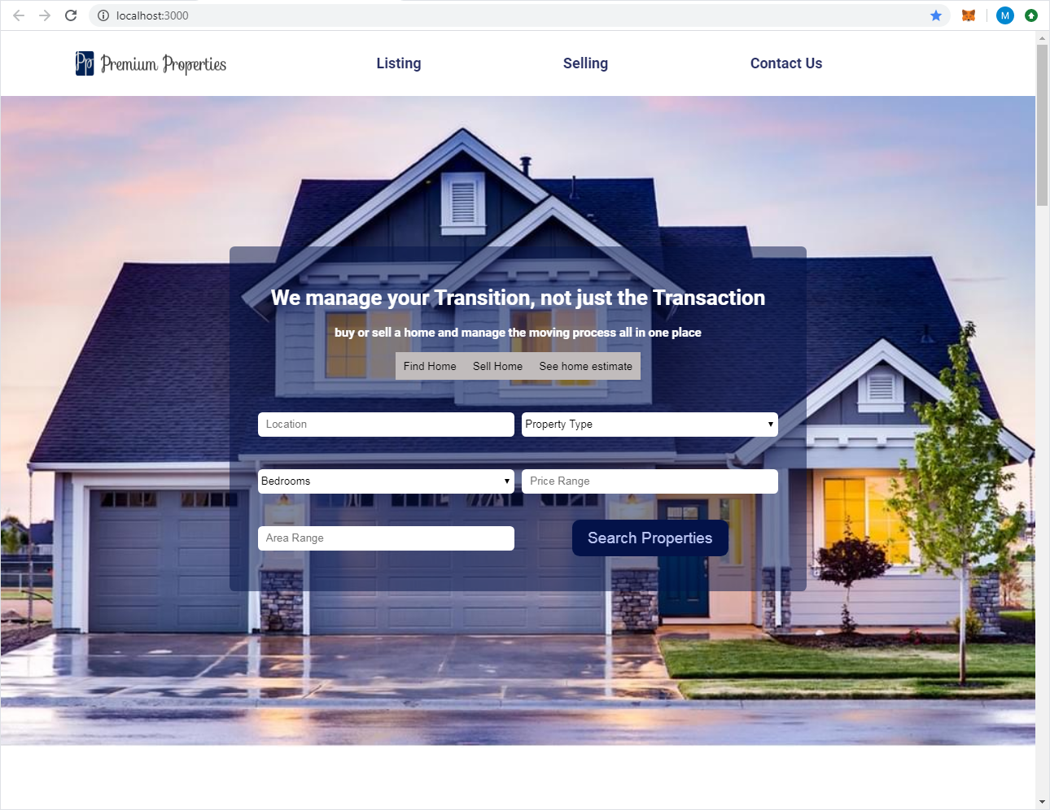

Figure 7.1‑1. Home Page

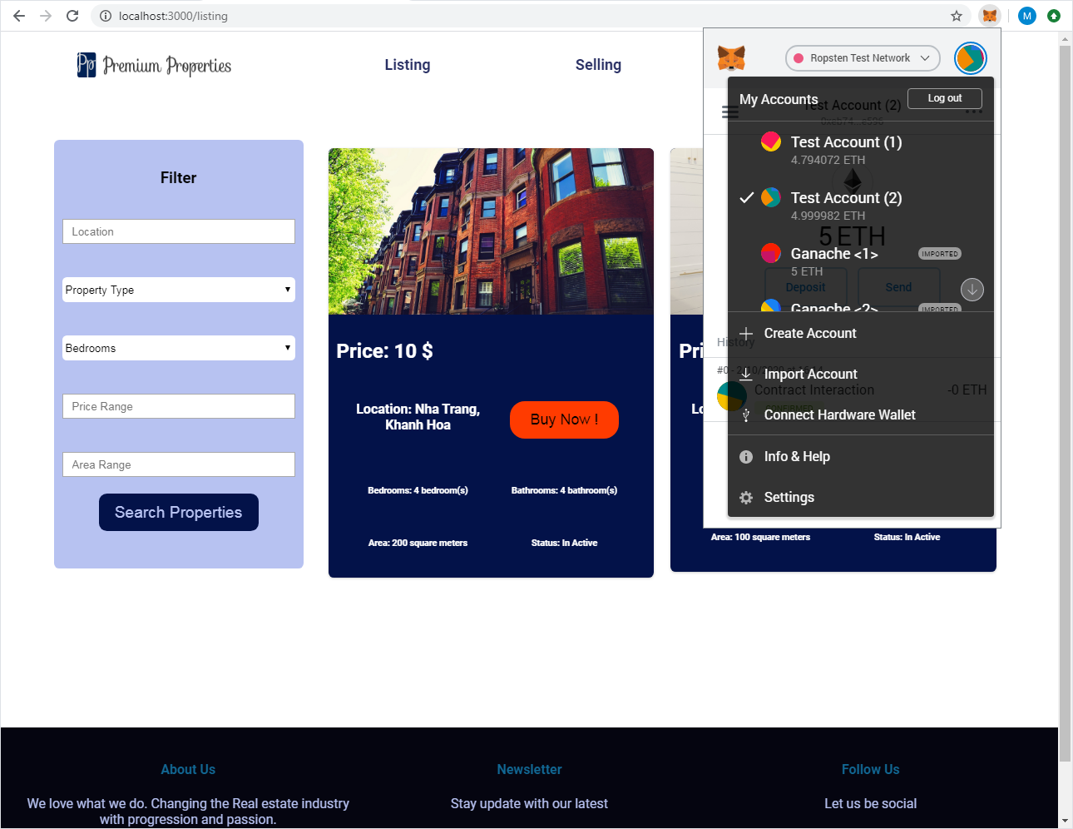

Figure 7.1‑2. Listing Page

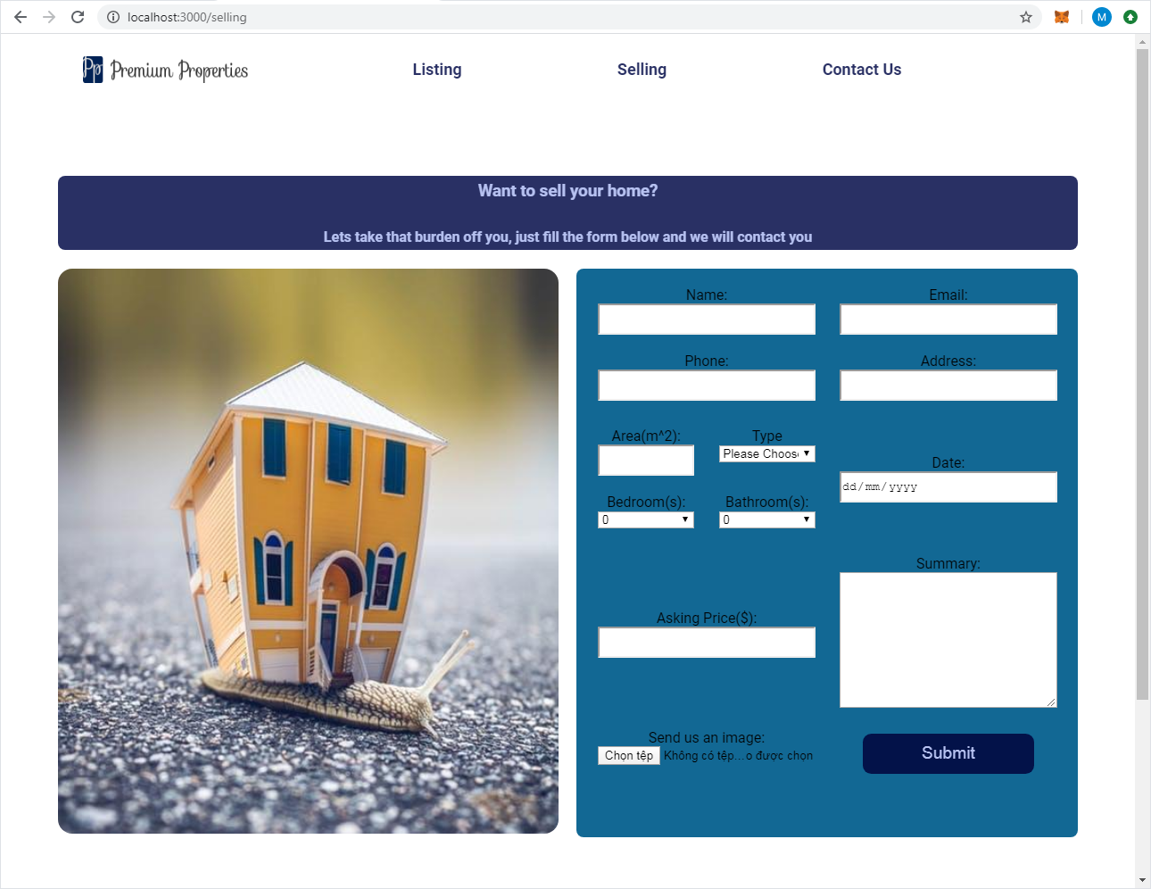

Figure 7.1‑3. Sell Page



Figure 7.1‑4. Contact Page

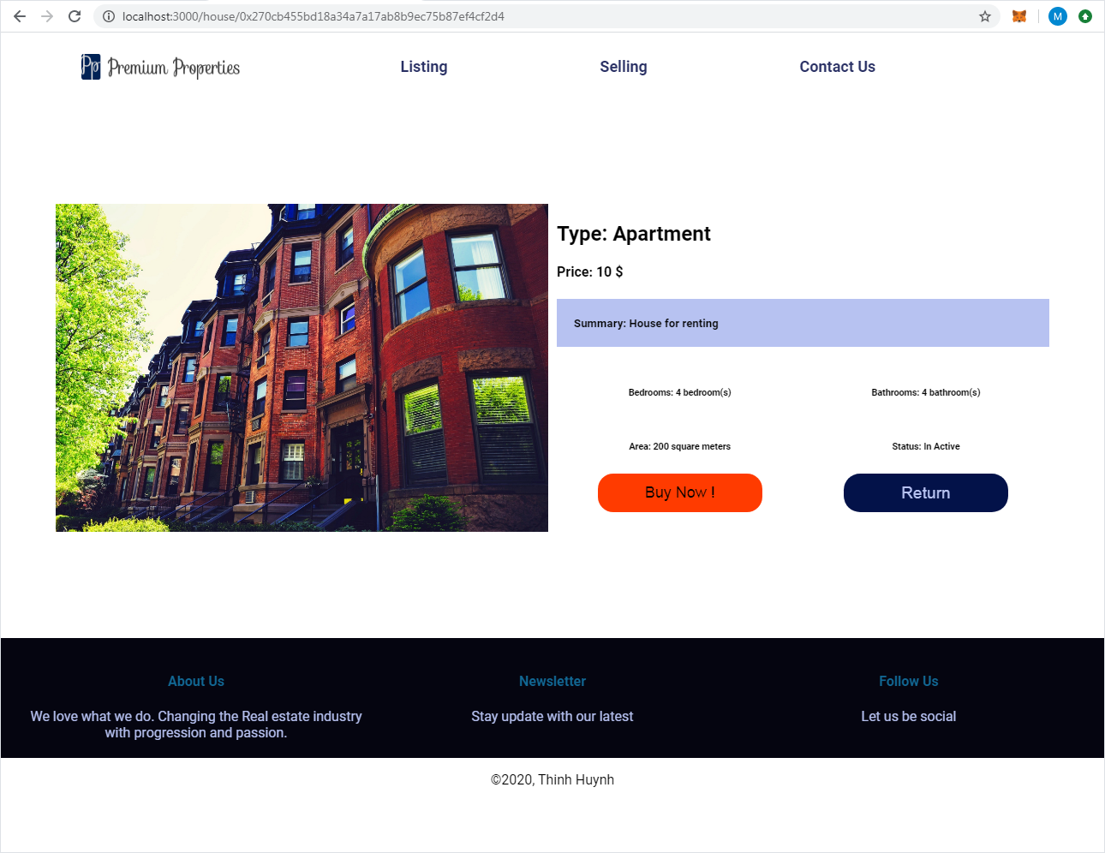

Figure 7.1‑5. House Detail Page

The User Interfaces are friendly and simple for users to manually buying and selling their real-estate properties.

### Conclusion

This thesis paper has already showed the combination between Web2.0 and Web3.0 technology. However, with Ethereum Blockchain Integration into Web2.0 technology even makes the system more reliable and transparent. But how Ethereum Blockchain secures the transactions that are made from users ?

* Once the transactions are mined into the chain of blocks by miners, there's no way to tamper the data even if the attackers are miners. This prevent a transaction to be mined twice (prevent double-spending attack), thus blocking the sellers to sell their house many times !
* Moreover, Ethereum Platform provides Solidity Smart Contracts for developers and users. Are smart contracts trustful ? The answer is totally yes, because they are stored internally on every EVM and managed by transactions stored in Ethereum Blockchain System. Hence, the Solidity Contracts inherit some sophisticated properties.
* Firstly, they are immutable and distributed. Once a smart contract is created, it can never be changed. Hence, no one could go behind the back of the chain of blocks and edit the code of a smart contract.
* Secondly, the output of a smart contract in a blockchain system is validated by every full-node on the network, which means nobody could force one smart contract to release a wanted output because other nodes on the network will spot this attempt and mark it as invalid. This ability is related to smart contract distributed property.

In conclusion, tampering with smart contracts becomes almost impossible with Ethereum Platform. And this eliminate the uses of third party programs for security as in Web2.0 technology, since the Blockchain System itself provides the security due to consensus between each node.

## Future work (Promising improvements)

This thesis paper is based on both Centralized (Web2.0) and Decentralized (Web3.0) infrastructure. However, in the near future, an upgraded version of Real-Estate-Application with fully decentralized system will be released. Taking advantages of Swarm Decentralized Hosting and IPFS Decentralized File Services. See to have an overview of how a Fully Decentralized Application structured.

Blockchain is a promising land for new developers who want to commit their abilities to the community by solving difficult puzzles that can only be adaptive with Blockchain Technology.

Furthermore, in the future some experts predict that the large enterprises will build their own personal blockchain networks. According to the report of the enterprise project, “Suppliers and customers cannot and would not join the private blockchain for every one of their business partners”. And, “The long-term future of the blockchain relies on the ability of companies in order to conduct private business over a public.”

# LIST OF REFERENCES

# **Bibliography**

1. *Overview of Blocking vs Non-Blocking*. URL: https://nodejs.org/en/docs/guides/blocking-vs-non-blocking
2. *The JavaScript Runtime Environment*. URL: https://medium.com/@olinations/the-javascript-runtime-environment-d58fa2e60dd0
3. *Introduction to JavaScript Engine: Call Stack, Event Loop, and Task Queue*. URL: https://medium.com/jsninja/call-stack-event-loop-and-task-queue-d49eff2ec7bb
4. *Introduction to NPM*. URL: https://blog.cloudboost.io/introduction-to-npm-d62b6f6efd08
5. *What is the Ethereum Virtual Machine ?* URL: https://www.bitrates.com/guides/ethereum/what-is-the-unstoppable-world-computer
6. *How does Ethereum Virtual Machine work ?* URL: https://medium.com/mycrypto/the-ethereum-virtual-machine-how-does-it-work-9abac2b7c9e
7. *Getting Deeply Into EVM - How does Ethereum Virtual Machine work ?* URL: https://hackernoon.com/getting-deep-into-evm-how-ethereum-works-backstage-ac7efa1f0015
8. *MetaMask Wallet Review*. URL: https://www.bitdegree.org/tutorials/metamask-wallet-review/
9. *How to Customizing Web3 Http Provider ?* URL: https://ethereum.stackexchange.com/questions/41783/what-are-the-web3-httpprovider-options
10. *What is Hierarchical Deterministic Wallet (HD Wallet)*. URL: https://tiendientu.org/hd-wallet-la-gi
11. *Difference between npx and npm ?* URL: https://stackoverflow.com/questions/50605219/difference-between-npx-and-npm
12. *Ganache CLI Configuration and Its Usability*. URL: https://docs.nethereum.com/en/latest/ethereum-and-clients/ganache-cli
13. *Introduction to React Children*. URL: https://viblo.asia/p/tim-hieu-ve-children-trong-react-oOVlYqWol8W